

AI-POWERED MEDICAL LAB REPORT ANALYSIS AND HEALTH INSIGHTS PLATFORM
LabLens: a web platform that reads lab reports, flags abnormal results, explains them in plain language and tracks them over time
A project report submitted in partial fulfilment of the requirements for the award of the degree of
BACHELOR OF TECHNOLOGY
in
COMPUTER SCIENCE AND ENGINEERING
Submitted by
BANOTH SWAPNA | 23K91A0528
BEKKAM VARSHITHA | 23K91A0535
A NAVADEEP REDDY | 23K91A0502
BUDIGAM MANOJ | 23K91A0546

Batch A8 (CSE-A)
Under the esteemed guidance of
L.G REDDY
[DESIGNATION]
DEPARTMENT OF COMPUTER SCIENCE AND ENGINEERING
TKR COLLEGE OF ENGINEERING AND TECHNOLOGY (AUTONOMOUS)
Medbowli, Meerpet, Balapur, Hyderabad, Telangana - 500 097
Academic year 2026-2027

CERTIFICATE
This is to certify that the project report entitled "AI-Powered Medical Lab Report Analysis and Health Insights Platform" is a bonafide record of the work carried out by BANOTH SWAPNA (23K91A0528), BEKKAM VARSHITHA (23K91A0535), A NAVADEEP REDDY (23K91A0502), BUDIGAM MANOJ (23K91A0546), in partial fulfilment of the requirements for the award of the degree of Bachelor of Technology in Computer Science and Engineering, during the academic year 2026-2027, under my supervision.

Project Guide | Head of the Department | Principal
L.G REDDY | [HOD NAME] | [PRINCIPAL NAME]
[DESIGNATION] | Department of Computer Science and Engineering | TKR College of Engineering and Technology (Autonomous)

External Examiner: [NAME AND SIGNATURE]
Place: Hyderabad
Date: [DATE]

DECLARATION
We hereby declare that the project report entitled "AI-Powered Medical Lab Report Analysis and Health Insights Platform", submitted to the Department of Computer Science and Engineering, TKR College of Engineering and Technology (Autonomous), in partial fulfilment of the requirements for the award of the degree of Bachelor of Technology in Computer Science and Engineering, is a record of original work carried out by us under the guidance of L.G REDDY, [DESIGNATION]. The results embodied in this report have not been submitted to any other university or institution for the award of any degree or diploma.

BANOTH SWAPNA 23K91A0528
BEKKAM VARSHITHA 23K91A0535
A NAVADEEP REDDY 23K91A0502
BUDIGAM MANOJ 23K91A0546

Place: Hyderabad
Date: [DATE]

ACKNOWLEDGEMENT
We express our sincere gratitude to our project guide, L.G REDDY, [DESIGNATION], for valuable guidance, encouragement and constructive suggestions throughout this project.
We thank [HOD NAME], Head of the Department of Computer Science and Engineering, for providing the facilities and support needed to complete this work, and [PRINCIPAL NAME], Principal, TKR College of Engineering and Technology (Autonomous), for the encouragement given to us.
We thank the project coordinators and all faculty and staff members of the department for their help, and our families and friends for their constant support.
We also acknowledge the authors of the base paper on retrieval-augmented analysis of blood test reports, whose work set the starting point of this project, and the developers of the open-source software it relies on (PyMuPDF, OpenCV, Tesseract, scikit-learn, SQLAlchemy, FastAPI, React, Vite and Recharts).

BANOTH SWAPNA
BEKKAM VARSHITHA
A NAVADEEP REDDY
BUDIGAM MANOJ

ABSTRACT
Laboratory reports are written for clinicians. Patients receive pages of test names, numbers and reference ranges that they cannot interpret, and they keep no history that would show whether a value is improving. This project builds LabLens, a web platform that reads a lab report supplied as a PDF or an image, extracts every test with its value, unit and reference range, flags each result as low, normal or high, explains each abnormal result in plain language with a medical disclaimer, and stores the report so that every test can be followed across reports on trend charts and in side-by-side comparisons.
The pipeline reads the text layer of digital PDFs with PyMuPDF and sends scans and photographs through OpenCV clean-up and Tesseract; a line parser recovers the fields and a TF-IDF character n-gram matcher snaps noisy test names to a 55-name dictionary; a rule classifies the result against its own range; rule-based text, with an optional language-model rewrite, produces the explanations; and SQLite, FastAPI and a React interface complete the application. The abstract's PP-OCR, CRF and retrieval-augmented components were replaced by these lighter methods, and the report says where that costs capability.
No labelled real reports were available, so the stages were measured on 120 generated reports with 1,680 known rows in eight layouts. Row-level precision is 0.963, recall 0.874 and F1 0.916; status accuracy on the rows found is 0.999, unit accuracy 0.871. Reports in which every table cell is a separate text line yield no rows at all. A 14-row PDF passes the whole pipeline in a median of 52.7 ms (210 ms through the HTTP upload), and 36 automated tests pass. Scanned-image accuracy and the language-model rewrite were not measured. The system is an educational prototype and not a medical device.
Keywords: medical lab report analysis, OCR, information extraction, health insights, trend tracking, explainable health AI, FastAPI, React.

TABLE OF CONTENTS
CERTIFICATE i
DECLARATION ii
ACKNOWLEDGEMENT iii
ABSTRACT iv
TABLE OF CONTENTS v
LIST OF FIGURES viii
LIST OF TABLES ix
LIST OF ABBREVIATIONS x
CHAPTER 1: INTRODUCTION 1
1.1 Domain overview 1
1.2 Background and motivation 1
1.3 Problem statement 1
1.4 Need for the system 2
1.5 Objectives 2
1.6 Scope 2
1.7 Contributions 3
1.8 Limitations and assumptions 4
1.9 Organisation of the report 5
CHAPTER 2: LITERATURE SURVEY 6
2.1 Overview 6
2.2 Base paper analysis 6
2.3 Related work by theme 7
2.4 Other works in the batch literature survey 9
2.5 Datasets and algorithms used in the literature 9
2.6 Strengths and limitations of the existing approaches 10
2.7 Research gap 10
CHAPTER 3: FEASIBILITY STUDY 11
3.1 Technical feasibility 11
3.2 Economic feasibility 11
3.3 Operational feasibility 12
3.4 Schedule feasibility 12
3.5 Legal and ethical considerations 13
3.6 Advantages and constraints 13
CHAPTER 4: SYSTEM REQUIREMENTS AND ANALYSIS 14
4.1 Existing system and its limitations 14
4.2 Proposed system and its advantages 14
4.3 Functional requirements 14
4.4 Non-functional requirements 15
4.5 Hardware requirements 16
4.6 Software requirements 16
4.7 User roles 16
4.8 Constraints 16
CHAPTER 5: SYSTEM DESIGN 18
5.1 Architecture 18
5.2 High-level workflow 19
5.3 Data flow diagrams 20
5.4 UML diagrams 23
5.5 Database design 27
5.6 Module design 28
5.7 API design 29
5.8 User interface design 30
5.9 Security design 32
CHAPTER 6: METHODOLOGY AND SOFTWARE IMPLEMENTATION 34
6.1 Overall methodology 34
6.2 Data used for development and evaluation 35
6.3 Text extraction and image preprocessing 36
6.4 Row parsing 36
6.5 Test-name normalisation 37
6.6 Result classification 38
6.7 Explanation generation 39
6.8 Choices against the project abstract 40
6.9 Application architecture 40
6.10 API design and the upload route 41
6.11 Security and error handling 41
6.12 Installation and execution 42
CHAPTER 7: SYSTEM TESTING 43
7.1 Testing strategy 43
7.2 Unit and integration tests 43
7.3 API and smoke tests 44
7.4 Randomised check of the status rule 44
7.5 Validation on the generated corpus 45
7.6 Edge cases and defects found 45
7.7 Performance testing 46
7.8 Security tests 47
7.9 Interface checks 48
7.10 User acceptance 48
7.11 Limits of the testing 48
CHAPTER 8: RESULTS AND OUTPUT SCREENS 50
8.1 Output screens 50
8.2 Experimental setup and protocol 55
8.3 Field extraction 56
8.4 Test-name normalisation 58
8.5 Classification 60
8.6 Health insights 61
8.7 Performance 61
8.8 Test results 63
8.9 Success and failure cases 63
8.10 Comparison with the base paper 64
8.11 Objectives against outcomes 65
8.12 What these results do and do not show 65
CHAPTER 9: CONCLUSION 67
9.1 Summary 67
9.2 Objectives achieved 67
9.3 Key findings 67
9.4 Practical applications 68
9.5 Known limitations 68
CHAPTER 10: FUTURE SCOPE 69
10.1 Improvements to the extraction 69
10.2 Better explanations 69
10.3 Evaluation and deployment 69
10.4 Further research 70
REFERENCES 71
APPENDIX A: IMPORTANT CODE 73
A.1 Image clean-up before OCR (`ocr_processor.py`) 73
A.2 Text from a PDF: text layer first, OCR for scanned pages (`ocr_processor.py`) 74
A.3 Unit expression and row patterns (`ner_processor.py`) 74
A.4 Snapping a noisy test name to the dictionary (`ner_processor.py`) 75
A.5 Extracting rows from the text (`ner_processor.py`) 75
A.6 Classification (`result_analyzer.py`) 76
A.7 Explanations with a safe fall-back (`ai_insights.py`) 77
APPENDIX B: INSTALLATION AND USER GUIDE 78
B.1 Requirements 78
B.2 One-click start (Windows) 78
B.3 Manual start (any operating system) 78
B.4 Settings in `.env` 79
B.5 Using the application 79
B.6 Running the tests and the experiments 79
B.7 Troubleshooting 80
APPENDIX C: ADDITIONAL SCREENS 81

LIST OF FIGURES
Figure 1: System architecture of LabLens 18
Figure 2: High-level workflow of one report, from upload to review 19
Figure 3: Data flow diagram, level 0 (context diagram) 20
Figure 4: Data flow diagram, level 1 21
Figure 5: Data flow diagram, level 2: process 2.0 (process uploaded report) expanded 22
Figure 6: UML class diagram (real classes plus modules drawn as classes) 23
Figure 7: Sequence diagram: uploading and analysing one report 24
Figure 8: Use-case diagram 25
Figure 9: Flowchart of the core algorithm: from a text line to a classified row 26
Figure 10: Entity-relationship diagram of the stored data 27
Figure 11: The dashboard: totals, a critical-result banner and the six reports of the demonstration library 31
Figure 12: The report analysis screen: extracted rows with status badges and insight cards (top of the page) 32
Figure 13: Overall workflow of the LabLens pipeline 34
Figure 14: Name-matcher accuracy, false-snap rate and synonym accuracy against the similarity threshold 38
Figure 15: Share of abnormal rows that received test-specific explanation text 39
Figure 16: Kinds of extraction error found on the generated corpus 46
Figure 17: Median latency of each pipeline stage 47
Figure 18: Dashboard: totals across the library, a critical-result banner, the recent-reports table and the status split 50
Figure 19: Upload screen after a successful run: stage tracker, extracted and classified results, and a link to the full analysis 51
Figure 20: Report analysis: result table with status badges and health-insight cards for abnormal results (top of the page) 52
Figure 21: My reports: upload history with status, expandable result tables, a search box and delete buttons 52
Figure 22: Health trends: one test across all reports, with the reference band, the pattern note and a sortable table 53
Figure 23: Compare reports: tests in common, status in each report, signed change and unit-grouped bar charts 54
Figure 24: Health insights: every explanation for every abnormal result in the library, with a Low / High filter and a search box (top of the page) 55
Figure 25: Extraction quality for each report layout (generated corpus, text-layer PDFs) 57
Figure 26: Name accuracy against simulated noise for the shipped matcher and two baselines 59
Figure 27: Trade-off between correcting noisy names and wrongly renaming unseen names as the threshold moves 60
Figure 28: Share of abnormal results that receive test-specific explanation text 61
Figure 29: Median latency of each pipeline stage for a 14-row report 62
Figure 30: Landing page, dark theme: the headline, the accepted formats (PDF, JPG, JPEG, PNG) and the notice that this is an educational tool 81
Figure 31: Sign-in screen with the demo account box and the one-click demo sign-in 81
Figure 32: Upload screen before a file is chosen: drop zone, the disabled LLM switch with its explanation, and the six-stage pipeline list 82
Figure 33: About screen: the five pipeline stages, the technology stack and the stated limitations 82
Figure 34: Dashboard of an empty library: zero totals and the two ways to begin, uploading a report or loading five sample reports 83

LIST OF TABLES
Table 1: Abbreviations used in this report x
Table 2: Organisation of this report 5
Table 3: Base paper compared with this project 7
Table 4: Summary of the literature 9
Table 5: Proposed technology and what was built 11
Table 6: Cost view 12
Table 7: Schedule, from the last-modified dates of the project artefacts 12
Table 8: Functional requirements 14
Table 9: Non-functional requirements and how each is verified 15
Table 10: Hardware 16
Table 11: Software 16
Table 12: Roles 16
Table 13: Table reports 27
Table 14: Table test_results 28
Table 15: Table health_insights 28
Table 16: Modules, sizes and responsibilities 29
Table 17: REST endpoints 29
Table 18: Screens and the screenshots that show them (Chapter 8 and Appendix C) 30
Table 19: Layouts of the evaluation corpus (15 reports each) 35
Table 20: Image preprocessing before Tesseract 36
Table 21: Effect of the snap threshold (55 names x 30 noisy trials; 24 unseen names; 19 synonyms) 38
Table 22: Proposed components and what was built 40
Table 23: Threats, faults and the controls in the code 41
Table 24: Test layers 43
Table 25: Groups of the 36 automated tests 43
Table 26: Smoke-test checks 44
Table 27: Defects found by testing 45
Table 28: Pipeline stage latency (14-row report) 46
Table 29: HTTP endpoint latency on 127.0.0.1 47
Table 30: Security checks 47
Table 31: Evaluation corpus 55
Table 32: Measurement environment 56
Table 33: Extraction results by layout 56
Table 34: Name accuracy under simulated OCR noise 58
Table 35: Effect of the cosine threshold (TF-IDF matcher) 59
Table 36: Latency of the pipeline stages 61
Table 37: API latency on 127.0.0.1 (FastAPI, uvicorn, SQLite) 62
Table 38: Automated test runs 63
Table 39: Failure cases found in the evaluation 63
Table 40: LabLens against the base paper 64
Table 41: Objectives of the project and what was achieved 65
Table 42: Environment variables 79
Table 43: Walk-through 79
Table 44: Common problems 80

LIST OF ABBREVIATIONS
Table 1: Abbreviations used in this report
Abbreviation | Expansion
AI | Artificial Intelligence
API | Application Programming Interface
CORS | Cross-Origin Resource Sharing
CRF | Conditional Random Field
CSS | Cascading Style Sheets
CSV | Comma-Separated Values
DFD | Data Flow Diagram
ER | Entity-Relationship
F1 | Harmonic mean of precision and recall
HbA1c | Glycated haemoglobin
HDL / LDL | High- / Low-Density Lipoprotein
HMAC | Hash-based Message Authentication Code
HTTP | Hypertext Transfer Protocol
JPEG / PNG | Image file formats
JSON | JavaScript Object Notation
LLM | Large Language Model
NER | Named Entity Recognition
OCR | Optical Character Recognition
PDF | Portable Document Format
RAG | Retrieval-Augmented Generation
REST | Representational State Transfer
SPA | Single-Page Application
SQL | Structured Query Language
TF-IDF | Term Frequency - Inverse Document Frequency
TSH | Thyroid-Stimulating Hormone
UI | User Interface
UML | Unified Modeling Language
VLM | Vision-Language Model
WBC | White Blood Cell

CHAPTER 1: INTRODUCTION

1.1 Domain overview
A laboratory report is the main document through which a patient learns about their own health, yet it is written for clinicians. A typical report lists dozens of tests, each with a numeric result, a unit and a reference range, and marks out-of-range values only with a letter or a symbol. Without training, a reader cannot tell whether a flagged value is trivial or urgent, and small deviations are easily mistaken for serious illness [1].
The domain of this project is healthcare artificial intelligence, natural language processing and medical informatics. Three techniques meet in it: optical character recognition (OCR) to turn a PDF or scan into text [12], [13], information extraction to recover the test name, value, unit and range from that text [14], and language generation to explain an abnormal result in plain words [1], [6].

1.2 Background and motivation
Reports reach patients as PDFs from a laboratory portal, as e-mailed scans or as phone photographs. Understanding them normally needs a follow-up consultation, which adds cost and delay. Many people instead search the web for each test name and meet advice that is generic, alarming or wrong. Recent work shows the demand: general-purpose vision-language models are being tried directly on blood report images [4], and a 2026 benchmark turns multimodal check-up reports into patient-oriented action cards [3].
The base paper for this project [1] applies retrieval-augmented generation (RAG) on LLaMA-3 to blood test reports and produces personalised dietary and lifestyle advice, but only for metabolic syndrome. It does not extract values from report files, report extraction accuracy or latency, or compare reports over time. The motivation here is the complementary, general case: any common test, any report layout, with the history of a patient's own reports kept so that improvement or decline becomes visible.

1.3 Problem statement
• Laboratory reports are written for clinicians, leaving patients unable to interpret their own results.
• Manual reading of every parameter is slow and error-prone for both patients and staff.
• Existing tools digitise reports but do not explain what an abnormal value means.
• No history is retained, so a patient cannot see whether a parameter is improving or worsening.
The problem addressed is: given a lab report as a PDF or an image, extract every test with its value, unit and reference range, flag the abnormal ones, explain each in plain language, and keep the report so that each parameter can be followed across reports.

1.4 Need for the system
The need is for a platform that reads a lab report automatically, explains abnormal values in plain language, and tracks them over time. It should be open and inspectable, run on an ordinary computer without a GPU or paid service, and be honest about what it cannot do: a research prototype whose limits are measured and published is more useful to students and developers than a closed tool whose accuracy is asserted.

1.5 Objectives
The project was proposed with the following six objectives. Chapter 8 states, for each, whether it was achieved.
1. Accept lab reports in PDF or scanned image form and extract text using high-speed OCR.
2. Apply named entity recognition to identify test parameters, values, units and reference ranges.
3. Compare each extracted value against its reference range and flag abnormal results.
4. Generate plain-language explanations for abnormal findings, grounded in trusted medical sources.
5. Track parameters across successive reports to display health trends over time.
6. Present results through a dashboard and evaluate extraction accuracy against manually labelled reports.

1.6 Scope
In scope.
• Upload of PDF, JPG, JPEG and PNG reports up to 15 MB. Digital PDFs are read from their text layer; scanned pages and photographs go through OpenCV clean-up and Tesseract OCR.
• Line-oriented extraction of test name, numeric result, unit, reference range (two-sided such as 12 - 16, one-sided such as <100 or >40) and report date.
• Snapping of noisy test names to a dictionary of 55 common tests with a TF-IDF character n-gram matcher (cosine threshold 0.55).
• Classification of every result as LOW, NORMAL, HIGH or UNKNOWN against the reference range printed on the same report (limits inclusive).
• Plain-language insight cards for every LOW or HIGH result: what the test measures, general possible causes and a suggestion to consult a doctor. An optional LLM rewrite is available when an API key is configured.
• A SQLite library of reports, results and insights, with a dashboard, report list, report analysis, health trends, report comparison and insights pages.
• A FastAPI service and a React interface with a demo login, plus the original Streamlit application; five synthetic sample reports for first use; an automated test suite.
Out of scope.
• Diagnosis or treatment advice. The system is an educational aid, not a medical device, and every screen carries a disclaimer.
• The abstract's PP-OCR engine, CRF-based NER model, retrieval-augmented generation over a medical knowledge base, Supabase with row-level security, Tailwind CSS and Google Cloud Functions. None of these was built (Section 3.1 explains why).
• Age- or sex-specific reference ranges. The range printed on the report is used as given.
• Handwritten reports, non-Latin scripts, and layouts in which every table cell is a separate line of text (measured recall 0 on such reports).
• Per-user data separation, registration, HTTPS, encryption at rest and audit logging; only one shared demo account exists.
• Validation on real patient reports or against manually labelled reports. No such data was available to the project.

1.7 Contributions
1. An end-to-end pipeline from an uploaded report to extracted, classified, explained, stored and trended results, in which the LOW / NORMAL / HIGH rule agreed with an independent reference rule on 20,000 random cases.
2. A dictionary-snapping name matcher built on TF-IDF character n-grams, analysed with a noise sweep and a threshold sweep that expose its trade-offs.
3. A rule-based explanation module with a medical disclaimer on every output, an optional LLM rewrite and a silent fall-back to the built-in text.
4. Longitudinal features that the base paper lacks: per-test trends against the reference band, side-by-side comparison of two reports, a dashboard and an insights page, demonstrated on five synthetic reports sent through the real pipeline.
5. A measurement harness: a generated corpus of 120 reports in eight layouts, extraction, name-noise and latency experiments, and 36 pytest tests plus a 31-check smoke test, with the failures reported rather than hidden.
For orientation, on the generated test corpus the extraction stage reached a row-level F1 of 0.916, and a 14-row PDF passes through the whole pipeline, including the database write, in a median of 52.7 ms. Both figures, and their limits, are explained in Chapter 8.

1.8 Limitations and assumptions
Assumptions.
• A report lists one test per line in the order name, result, unit, reference range (or a close variant) and prints a reference range for each test.
• The input is a PDF with a text layer, or a legible scan or photograph in English and Latin script, no larger than 15 MB.
• The reference range printed on the report is the correct range for the patient; the application does not adjust it.
• One trusted user group on one machine. The demo account is a convenience, not an identity system.
• The host has Python 3.11 or newer and Node.js 20 or newer; Tesseract OCR is installed only if images or scans are to be read.
Limitations.
• Layout dependence. On reports where each table cell is a separate text line, the parser extracted no rows at all (recall 0.000 on 210 rows); a date line such as 12-04-2026 was read as a test named "Sample Collected" in every one of the 56 corpus reports that print the date with hyphens.
• Unit gaps. Unit accuracy is 87.1% overall and 57.6% when a flag letter sits between the value and the unit; units such as mg/L, umol/L, ng/dL and uIU/mL are not in the parser's unit list.
• Name matching. The TF-IDF matcher loses accuracy under character noise (89.0% at 10% noise against 98.1% for a plain difflib baseline) and renames some unseen tests, for example Sodium Bicarbonate to Sodium.
• Thin explanation coverage. Only 17 of the 55 dictionary tests (30.9%) have test-specific explanation text; the rest receive a generic paragraph. The explanations are rule-based, with no retrieval and no citations.
• Evaluation data. All accuracy figures come from 120 generated reports (1,680 rows) with generated ground truth, not from real, manually labelled reports. Scanned-image OCR accuracy and latency were not measured because Tesseract was not installed on the test machine, and the optional LLM rewrite was not exercised.
• Trends. Trend direction compares only the first and last values, and the time axis is the upload date, not the date the sample was taken.
• Demonstration-grade security and not a medical device: outputs must not be used as the sole basis for any health decision.

1.9 Organisation of the report
Table 2: Organisation of this report
Chapter | Content
1 Introduction | Domain, motivation, problem, objectives, scope, contributions, limitations.
2 Literature Survey | The base paper in depth, related work by theme, datasets and algorithms, research gap.
3 Feasibility Study | Technical, economic, operational and schedule feasibility.
4 System Requirements and Analysis | Existing and proposed system, requirements, hardware, software, users.
5 System Design | Architecture, workflow, data-flow diagrams, UML, database, modules, API and UI design.
6 Methodology and Software Implementation | Data, extraction, matching, classification, explanation, application, security, installation.
7 System Testing | Strategy and results of unit, integration, functional, security, performance and edge-case tests.
8 Results and Output Screens | Measured performance, comparison with the base paper, output screens, failures, objectives versus outcomes.
9 Conclusion | Summary, achievements, findings, applications, known limitations.
10 Future Scope | Improvements, features, deployment and research directions.
Appendices | A: important code; B: installation and user guide; C: additional screens.

CHAPTER 2: LITERATURE SURVEY

2.1 Overview
This chapter begins with a close reading of the base paper [1], then groups related work by theme: digitising report images, turning reports into patient-facing guidance, retrieval and language models in healthcare, and the OCR and sequence-labelling techniques named in the project abstract. It ends with the research gap. Where a work was checked only at abstract level, or only through the base paper's own summary of it, the text says so. Five works were listed in the batch literature survey; only the first is the base paper. The other four are discussed in Section 2.4.

2.2 Base paper analysis
Reference. A. Karhade, I. Verma, V. Gadaokar and J. Mahajan, "RAG-Based Blood Test Report Analysis to Reverse Metabolic Syndrome," Communications on Applied Nonlinear Analysis, vol. 32, no. 10s, pp. 2771-2779, 2025, doi: 10.52783/cana.v32.5718.

2.2.1 Problem and approach
The paper argues that blood test reports are hard for the general population to interpret, that minor changes are often mistaken for serious problems, and that metabolic syndrome, a cluster of raised glucose, blood pressure, triglycerides, glycated haemoglobin and insulin resistance with low HDL, is a case where understanding the report leads to lifestyle action. It proposes a generative AI system that explains a report and suggests diet and lifestyle changes, and alerts the user when a medical consultation may be needed.

2.2.2 Knowledge base and parameters
The knowledge base holds 20 medical books (text extracted with PyMuPDF and cleaned), 383 YouTube video transcripts (produced with the Whisper model and cleaned) and a parameter document. The parameter document lists 33 blood parameters in the groups complete blood count, glucose, insulin, lipid profile, apolipoproteins, liver, kidney and thyroid function, vitamins, homocysteine and inflammation markers, each with a normal, an optimal and a possible range, separately for men and women where they differ.

2.2.3 Retrieval and generation
Text is split with a recursive character splitter into chunks of 1,024 characters with an overlap of 100, embedded, and stored in the ChromaDB vector store. A user query is embedded in the same way, the top three chunks by cosine similarity are retrieved after a threshold filter, and the chunks are concatenated with the query into a prompt for the LLaMA-3 8-billion-parameter model. Sources are returned with the answer, and a generic answer is given if nothing relevant is retrieved. The authors chose LLaMA-3 over OpenAI and DeepSeek models for cost, open licence and local deployment. Users have accounts, and uploaded reports are stored encrypted and reused in later queries.

2.2.4 Evaluation and what it shows
Evaluation uses 20 responses, each scored from 1 to 100 by GPT-4 on correctness, clarity, helpfulness and completeness, with human monitoring. The conclusion states averages of 92.4, 89.7, 91.1 and 88.9. Recomputing the means from the paper's own Table 4 gives 94.0, 94.9, 90.1 and 88.65, so the stated and tabulated numbers disagree; this report quotes both and relies on neither as a benchmark.
Table 3: Base paper compared with this project
Aspect | Base paper [1] | This project
Scope | Metabolic syndrome; 33 parameters | Any test that appears on a report line; 55-name dictionary for name matching
Input | Report supplied to the chat system (parsed with PyMuPDF) | PDF, JPG, JPEG or PNG; text layer or OpenCV + Tesseract OCR
Explanation | RAG over books and transcripts with LLaMA-3 8B | Rule-based text for 17 tests plus a generic fallback; optional LLM rewrite; no retrieval
Evaluation | 20 responses scored by GPT-4 | 55 names under noise; 1,680 labelled rows in 120 generated reports; latency; 36 tests
Over time | Listed as future scope | Trends, report comparison and dashboard implemented

2.2.5 Strengths and weaknesses
• Strengths: grounding of advice in a curated knowledge base with source citations, a fall-back that avoids unsupported personalised answers, and a clear clinical focus.
• Weaknesses: single condition; no measurement of how accurately values are read from report files; the evaluator is itself an LLM, so the scores measure agreement with GPT-4's judgement; no latency, no comparison with a baseline and no trend analysis; the paper lists haemoglobin in mg/dL where g/dL is the clinical unit.

2.3 Related work by theme

2.3.1 Digitising report images
Ren et al. [2] address a practical situation: in teleconsultation people photograph a laboratory report with a phone, and the content must be turned into structured data. We read this paper at abstract level only, but it confirms the first stage of this project, extraction before explanation, as a problem in its own right. Bakhsheshi and Beigy [4] take the opposite route and skip OCR: they send 100 blood-report images, selected from 426 in a public Kaggle collection, to three vision-language models (Qwen-VL-Max, Gemini 2.5 Pro and Llama 4 Maverick) with patient-style questions, and compare the answers with Sentence-BERT embeddings [18]. Their headline overall similarity is 0.803. This measures how much the models agree with each other, not whether they are right, and the authors themselves warn that the dataset is small. It does show that image-in, explanation-out is plausible, but without values stored in a structured form nothing can be trended.

2.3.2 From reports to patient guidance
Checkup2Action [3] introduces a dataset of 2,000 de-identified real check-up reports and a constrained workflow that generates structured Action Cards, each with an issue, a priority, a recommended department, a follow-up window and a patient-facing explanation. Clinical experts judged 84% of evaluated outputs fully reasonable. Its most useful finding for this project concerns safety: removing the safety constraints raised problem recall from 0.527 to 0.825 but produced more diagnostic overstatement. That trade-off is why this project's explanations avoid diagnosis and always advise consulting a clinician. Medalyze [5] fine-tunes three FLAN-T5-Large models for report summarisation and related tasks and ships web and mobile front ends; we read its abstract only.

2.3.3 Retrieval and language models in healthcare
Retrieval-augmented generation [6] combines a language model with an external knowledge store so that answers rest on retrieved passages. In healthcare, Salvagno et al. [7] assess the feasibility of ChatGPT for clinical and research scenarios and flag privacy and accuracy concerns; Liu et al. [8] study AI-drafted replies in electronic health records and report efficiency gains with personalisation and ethical concerns; Shokrollahi et al. [9] review generative AI in healthcare; and MEDPLAN [10] uses a two-stage RAG design that first assesses and then plans treatment. These four are known to us through the base paper's summaries and their bibliographic records. Kataria et al. [11] review diet and lifestyle modification in metabolic syndrome, the clinical background of the base paper.

2.3.4 OCR and sequence labelling
The abstract names PP-OCR and a conditional random field (CRF). PP-OCR [12] is a practical ultra-lightweight OCR system from the PaddlePaddle ecosystem. Tesseract [13] is the long-established open-source engine; it is the engine this project uses for images because it needs only one executable. A linear-chain CRF [14] labels each token of a sequence given its neighbours and would be trained on annotated report lines; no such annotated corpus exists for this project, so a rule-based parser with a TF-IDF matcher [15], [16] was used instead (Section 3.1).

2.4 Other works in the batch literature survey
The batch survey lists four further titles: a 2025 digitisation method [2], and three items [25], [26], [27] on laboratory health and safety, RT-PCR data from one hospital laboratory and inter-laboratory extraction testing of medical devices. The last three concern laboratory operation, not patient-facing report analysis. Their authors and content could not be verified from the information given, so they are listed in the references but are not used as evidence anywhere in this report.

2.5 Datasets and algorithms used in the literature
Table 4: Summary of the literature
Work | Approach | Data | Reported result | Limitation
Karhade et al., 2025 [1] (base paper) | RAG on LLaMA-3 8B; ChromaDB; chunks 1,024 / overlap 100; top-3 retrieval | 20 medical books, 383 YouTube transcripts, a 33-parameter range document | 20 responses scored 1-100 by GPT-4: correctness 92.4, clarity 89.7, helpfulness 91.1, completeness 88.9 (as stated) | Metabolic syndrome only; no extraction accuracy, latency or trend tracking
Ren et al., 2025 [2] | Serialisation of image-based lab reports into structured data (abstract-level reading) | Phone-photographed lab reports for teleconsultation | Not read beyond the abstract | Full text not reviewed
Xiang et al., 2026 [3] (Checkup2Action) | Constrained LLM workflow producing structured Action Cards | 2,000 de-identified real check-up reports | Experts judged 84% of outputs fully reasonable; removing safety constraints raised recall 0.527 to 0.825 with more diagnostic overstatement | Needs multimodal reports; actions, not value tracking
Bakhsheshi and Beigy, 2025 [4] | Qwen-VL-Max, Gemini 2.5 Pro, Llama 4 Maverick prompted with report images | 100 blood-report images chosen from 426 in a public Kaggle set | Mean pairwise Sentence-BERT similarity 0.803 between the models' answers | Measures agreement between models, not correctness; small set
Nguyen et al., 2025 [5] (Medalyze) | Three fine-tuned FLAN-T5-Large models behind a web and a mobile application | Medical report and conversation text | Not read beyond the abstract | Summarises text; no value extraction from files
Lewis et al., 2020 [6] | Retrieval-augmented generation | Knowledge-intensive NLP benchmarks | Foundation of the RAG approach used in [1] | General-domain; not specific to lab values
Hsu et al., 2025 [10] (MEDPLAN) | Two-stage RAG: assessment, then personalised plan | Electronic health records | As summarised in [1] | Needs clinical notes; not report files
Du et al., 2020 [12] (PP-OCR) | Ultra-lightweight OCR system | General text images | Practical, small models (abstract level) | Needs the PaddlePaddle runtime; not adopted here
Smith, 2007 [13] (Tesseract) | Open-source OCR engine | General documents | Widely deployed baseline engine | Sensitive to scan quality; adopted here for images

Across these works three kinds of data appear: curated text knowledge bases, images of reports, and full multimodal reports. None of them offers a publicly available, labelled set of lab-report rows with value, unit and range that could serve as ground truth for the extraction step. This project therefore generated one (Chapter 6), and says wherever it matters that the corpus is synthetic.

2.6 Strengths and limitations of the existing approaches
• Language-model approaches produce fluent explanations quickly and need little engineering, but they are costly or need local hardware, can overstate findings [3], and give no structured record of the values for later comparison.
• Retrieval-grounded approaches [1] improve trust through citations, but depend on a curated corpus and, in the base paper, on one clinical condition.
• Digitisation approaches [2], [4] address input, but stop at extraction or at free-text answers.
• Classical OCR and parsing are cheap, transparent and fast, but brittle when a layout changes; Section 8 measures exactly how brittle.

2.7 Research gap
The survey shows plenty of work on explaining an already-digital report for one condition, and some on reading report images, but no open pipeline that does all of the following together: accepts a PDF or an image, extracts arbitrary test rows with unit and range, flags them, explains the abnormal ones with a safety disclaimer, and tracks each parameter across successive reports. The base paper itself places personalisation over several reports in future scope. This project addresses that gap with a deliberately light design, and measures it: on a generated corpus the extraction stage reaches a row-level F1 of 0.916, with the failure modes reported in Chapter 8.

CHAPTER 3: FEASIBILITY STUDY

3.1 Technical feasibility
The abstract proposes PP-OCR, a CRF-based named-entity recogniser, retrieval-augmented generation, Supabase, Tailwind CSS and Google Cloud Functions. The project that was built uses lighter tools for each, chosen after checking what each proposed component would need.
Table 5: Proposed technology and what was built
Abstract proposes | Built | Reason and consequence
PP-OCR [12] | PyMuPDF text layer, plus OpenCV clean-up and Tesseract [13] for images | Digital PDFs already contain exact text, read in about 1.5 ms, so OCR is not needed for them. Tesseract is one executable; PP-OCR needs a deep-learning runtime. Consequence: image OCR is implemented but was not measured, because Tesseract was not installed on the test machine.
CRF-based NER [14] | Regular-expression line parser plus a TF-IDF matcher [15], [16] | A CRF needs an annotated corpus of report lines, and none exists for this project. The parser is transparent and fast but layout-dependent (Chapter 8).
RAG over trusted sources [1], [6] | Rule-based knowledge text for 17 tests plus a generic fallback; optional LLM rewrite | A retrieval corpus (the base paper used 20 books and 383 transcripts) was not available. Hand-written text cannot hallucinate but covers only 30.9% of the dictionary tests, and there are no citations.
Supabase (PostgreSQL, row-level security) | SQLite through SQLAlchemy [19] | No account or network needed; consequence: one shared library, no per-user isolation.
React, Tailwind, Recharts | React 18.3, Vite 5.4, Recharts 2.15 [22], hand-written CSS | Same front-end stack except Tailwind.
Google Cloud Functions, under 10 s | FastAPI [21] with Uvicorn on a local machine | Not serverless and not deployed. The 10 s target is met for text-layer PDFs; it is not tested for scans.

Every library used is mature and open source, and the whole stack ran on one ordinary desktop without a GPU. The technical risks found were: the absence of labelled data for evaluation, which was handled by generating a labelled corpus; the lack of Tesseract on the development machine, which leaves the image path unmeasured; and layout sensitivity of the parser, which is measured and reported rather than hidden.

3.2 Economic feasibility
No licence, cloud service or special hardware was bought. Python, PyMuPDF, OpenCV, scikit-learn, SQLAlchemy, FastAPI, React and Vite are open source, and the machine already existed. A report costs only processor time: a median of 52.7 ms for a 14-row PDF. The single optional cost is the LLM rewrite, which calls a paid API [23] only if a key is set and the user turns the switch on; without it nothing is charged and the built-in text is used.
Table 6: Cost view
Item | Cost to the project | Remark
Software and libraries | None | Open-source licences
Training data | None | No model is trained; the evaluation corpus is generated by script
Hardware | None additional | Intel Core i5-12500, 15.7 GB RAM, no GPU
Hosting | None | Runs locally on ports 8308 (API) and 5308 (interface)
Optional LLM rewrite | Pay per call, off by default | Requires ANTHROPIC_API_KEY; not exercised in this work
Clinical validation and certification | Not budgeted | Out of scope (Section 1.6)

3.3 Operational feasibility
A person with no technical background can use the interface: one clear upload action, plain-language result cards, a visible disclaimer and explicit empty, loading and error states. On an empty library the screens offer to load sample reports, so the product can be seen working before any real file is uploaded. Start-up is a single script, run.bat, which builds the Python environment, installs the packages and opens the browser. There is nothing to administer, because the SQLite file is created on first run. The operating limits are a shared demo account and local, unbacked-up storage.

3.4 Schedule feasibility
The work divides into: selecting the base paper and writing the abstract, objectives and survey; the extraction and classification pipeline; the explanation module and database; the web interface; testing and measurement; and documentation. Interfaces between the pipeline modules are narrow, so the web interface could be built over them without changing them. The table below lists the stages with the last-modified dates of the artefacts that record them.
Table 7: Schedule, from the last-modified dates of the project artefacts
Stage | Artefact | Date (2026)
Abstract, base paper record, introduction, survey, objectives | Batch documents 2 to 6 | 31 August
Batch details and team confirmed; first review deck | 1.A8_BATCH_DETAILS.docx, 7.Review_1_PPT.pptx | 19 September
Pipeline modules (OCR, extraction, classification, insights, database) | Python modules in 8.ProjectCode | 14 October
FastAPI layer, React interface, screenshots | backend/, frontend/, docs/screenshots | 24 October
Measurements, tests and report facts | experiments/lablens, tests/, docs/REPORT_FACTS.md | 25 October

The dates are file timestamps, not a project plan. They show that the stages ran in the order above and that measurement came last, which is why the evaluation uses a generated corpus: there was no time budget to collect and hand-label real reports.

3.5 Legal and ethical considerations
Lab reports are personal health information. The system keeps them on the local machine and sends nothing to third parties unless the optional LLM rewrite is switched on, in which case only the test name, its status and the built-in explanation text are sent, not the numeric result, the patient name or the report. All sample data and the evaluation corpus are invented. Because health decisions are involved, every page states that the output is educational, and the explanations avoid diagnosis, in line with the safety trade-off reported for check-up action cards [3].

3.6 Advantages and constraints
• Advantages: open and inspectable code; no GPU or paid service; fast (median 52.7 ms per text-layer report); a complete path from file to trend; automated tests; measured and published failure modes.
• Constraints: parser tied to line-per-test layouts; unit list incomplete; explanations cover 17 of 55 tests; image OCR unmeasured; evaluation on generated data; one shared demo account.

CHAPTER 4: SYSTEM REQUIREMENTS AND ANALYSIS

4.1 Existing system and its limitations
Today a patient receives a report as a PDF or a printout and either waits for a consultation or searches each test name online. Laboratory portals digitise the values but rarely explain them. Research prototypes explain reports with language models [1], [3], [4], [5] but are distributed as papers, not as running applications, and none keeps a patient's history.
• Manual reading: slow, and prone to over- or under-reacting to a flagged value.
• Digitisation without explanation: values are stored but their meaning is not given.
• Explanation without extraction or history: the base paper [1] explains one condition and keeps no record of values across reports.
• The original project code: the Streamlit prototype (app.py) had the pipeline but no login, no API and no tests.

4.2 Proposed system and its advantages
The proposed system, LabLens, keeps the original pipeline modules unchanged and adds a FastAPI service and a React interface over them, a demo login, trends, comparison, an insights page, sample data, measurements and tests.
• One upload turns a PDF or an image into a table of tests with a status for each.
• Every abnormal value gets a plain-language card with a disclaimer.
• Each test can be followed across reports on a chart with its reference band, and two reports can be compared directly.
• The accuracy, speed and failure modes of each stage are measured and reproducible by one script.
• Everything runs locally with open-source software.

4.3 Functional requirements
Table 8: Functional requirements
ID | Requirement | Priority
FR1 | Sign in with the demo account (e-mail and password, or the demo button) and sign out; every route except health, config and login needs a bearer token. | Must
FR2 | Upload a report by file picker or drag and drop; accept PDF, JPG, JPEG and PNG up to 15 MB. | Must
FR3 | Validate the upload and give a readable reason on failure: unsupported type, empty file, oversize file, unreadable PDF, no recognisable test rows. | Must
FR4 | Extract text: PDF text layer first; pages with fewer than 30 characters, and image files, go through OpenCV pre-processing and Tesseract OCR. | Must
FR5 | Extract test name, numeric result, unit, reference range (two-sided and one-sided) and report date from each line, with a confidence score. | Must
FR6 | Normalise noisy test names to the 55-name dictionary and keep unseen names as printed text in title case. | Should
FR7 | Classify each result as LOW, NORMAL, HIGH or UNKNOWN against its own reference range. | Must
FR8 | Generate a plain-language insight (what it measures, general causes, suggestion) for every LOW and HIGH result; offer an optional LLM rewrite when a key is configured. | Must
FR9 | Store every report, its test results, insights, raw text and processing status (Pending, Processing, Completed, Failed) in the database. | Must
FR10 | Show a dashboard: report, test, normal, abnormal and critical counts, recent reports and a status breakdown. | Should
FR11 | List reports with search, sort and delete (after confirmation); open one report with its results table and insight cards. | Must
FR12 | Show the trend of one test across all reports as a chart with the reference band and an overall direction. | Must
FR13 | Compare two different reports test by test and show the change in each value. | Should
FR14 | Show an insights page that covers every abnormal result across all reports. | Should
FR15 | Offer to load five synthetic sample reports when the library is empty, by running them through the real pipeline. | Should
FR16 | Show the medical disclaimer on every screen; offer light and dark themes. | Must
FR17 | Return a clear not-found response for an unknown report id. | Must

4.4 Non-functional requirements
Table 9: Non-functional requirements and how each is verified
Quality | Requirement | Evidence
Performance | A text-layer PDF passes the whole pipeline in well under the 10 s of the abstract. | Median 52.7 ms for a 14-row report including the database write; 209.8 ms median (p95 414.2 ms) through the HTTP upload
Reliability | A failed upload keeps its error message and never breaks the library; every stage failure marks the report Failed. | tests/test_lablens.py (blank, corrupt, oversize, wrong type); smoke checks on failed reports
Security | Signed 12-hour token, tampered token rejected, CORS limited to the local front end, file-type whitelist and size limit. | test_api_requires_login, test_api_tampered_token_rejected; shared demo account only
Usability | Every screen usable from 360 px to 1440 px, by keyboard, in light and dark themes, with reduced motion respected. | scripts/ui_check.py exists; not re-run in the documentation pass
Portability | Windows start-up with one script; manual start on any operating system. | run.bat; docs/03_HOW_TO_RUN.md
Maintainability | Pipeline modules, API layer and front end are separate; behaviour is covered by automated tests. | 36 pytest tests; 24 API and 7 browser smoke checks
Privacy | Reports stay in a local SQLite file; nothing leaves the machine unless the optional LLM switch is used. | Code review of backend/main.py and ai_insights.py
Honesty of output | Insights must not diagnose and must carry a disclaimer; accuracy figures must say how they were measured. | Disclaimer on every output; Chapters 7 and 8

4.5 Hardware requirements
Table 10: Hardware
Item | Used for development and measurement | Suggested minimum (not tested)
Processor | Intel Core i5-12500 (6 cores, 12 threads) | Any recent dual-core x86-64 processor
Memory | 15.7 GB RAM | 4 GB
Graphics | None used | Not required
Storage | A few hundred MB for the Python and Node environments | 2 GB free
Display | 1440 x 900 reference; layout checked down to 360 px | Any modern browser

4.6 Software requirements
Table 11: Software
Layer | Software
Operating system | Windows 11 Pro (development and measurement); any system that runs Python and Node.js
Language and runtime | Python 3.11.9; Node.js 24 used, 20 or newer required
Reading and recognition | PyMuPDF 1.28, OpenCV 4.11 (headless), Pillow, pytesseract with the Tesseract OCR program (optional, for images and scans)
Language processing | scikit-learn 1.5 (TF-IDF matcher), NumPy 1.26; spaCy optional for the patient name; Anthropic SDK optional
Web back end | FastAPI 0.143, Uvicorn 0.54, python-multipart, python-dotenv, SQLAlchemy 2.0 with SQLite; Streamlit for the original interface
Front end | React 18.3, Vite 5.4, React Router 6, Recharts 2.15, Framer Motion, GSAP, Lenis, three.js (landing visual), lucide-react
Testing | pytest, FastAPI TestClient, Playwright for the browser checks, matplotlib for the measurement figures

4.7 User roles
Table 12: Roles
Role | Description | Access
Patient or reader | Signs in with the demo account, uploads reports, reads results, trends and insights | All screens of the web application
Developer | Starts the servers, runs the tests and the measurement scripts | Command line (run.bat, scripts/)

4.8 Constraints
• The parser expects one test per line in name, result, unit, range order or a close variant.
• Inputs are PDF, JPG, JPEG or PNG files of at most 15 MB, in English.
• The reference range printed on the report is trusted as given.
• The system is a research prototype and must not be used for clinical decisions.
• One shared demo account; there is no registration and no per-user separation of data. Through the HTTP interface a PDF upload takes a median of 210 ms.

CHAPTER 5: SYSTEM DESIGN

5.1 Architecture
The design follows three rules: keep the pipeline in plain Python modules that can be tested without a web server, keep the web layer thin, and make every failure visible to the user instead of silent. The original Streamlit project already contained the pipeline and the database, so the FastAPI service and the React interface were added on top without changing them.
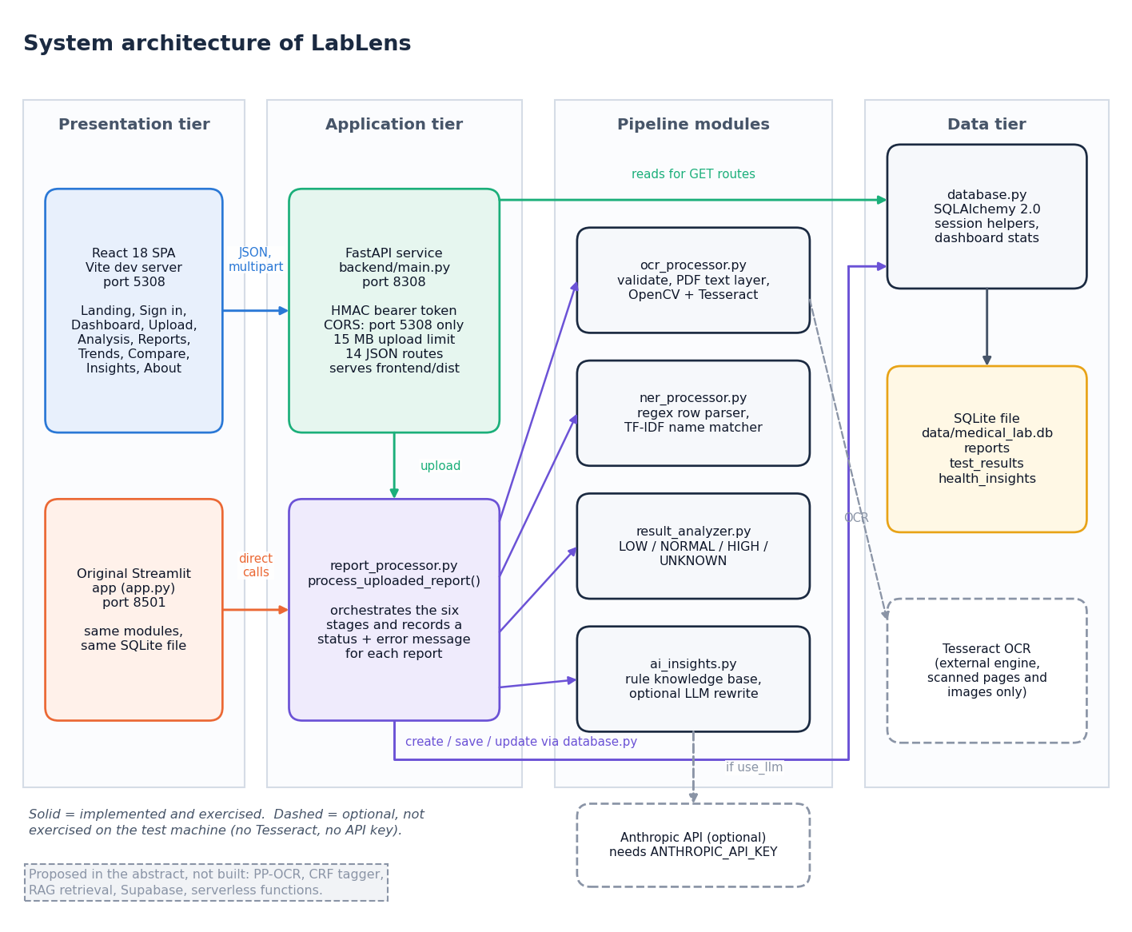
Figure 1: System architecture of LabLens
LabLens has four tiers. In the presentation tier the React single-page application (built with Vite, port 5308) is the main interface, and the original Streamlit application (app.py, port 8501) remains as a second front end that calls the same modules and uses the same SQLite file directly. The application tier holds the FastAPI service in backend/main.py (port 8308), which signs and checks bearer tokens, enforces CORS and the 15 MB upload limit, receives uploads and turns database rows into JSON, and report_processor.py, which coordinates the six pipeline stages and records a status and an error message for each report. The pipeline modules are ocr_processor.py (text extraction), ner_processor.py (row parsing and test-name matching), result_analyzer.py (status rules) and ai_insights.py (explanations). The data tier is the SQLite file data/medical_lab.db, reached through database.py and the ORM classes of models.py. Two services are optional and drawn with dashed outlines: the Tesseract engine, needed only for scanned pages and images, and the Anthropic API, used only to reword explanations; neither was exercised on the test machine. A note on the diagram lists what the abstract proposed but was not built (PP-OCR, a CRF tagger, retrieval, Supabase and serverless functions). After npm run build the API also serves the compiled interface from frontend/dist.

5.2 High-level workflow
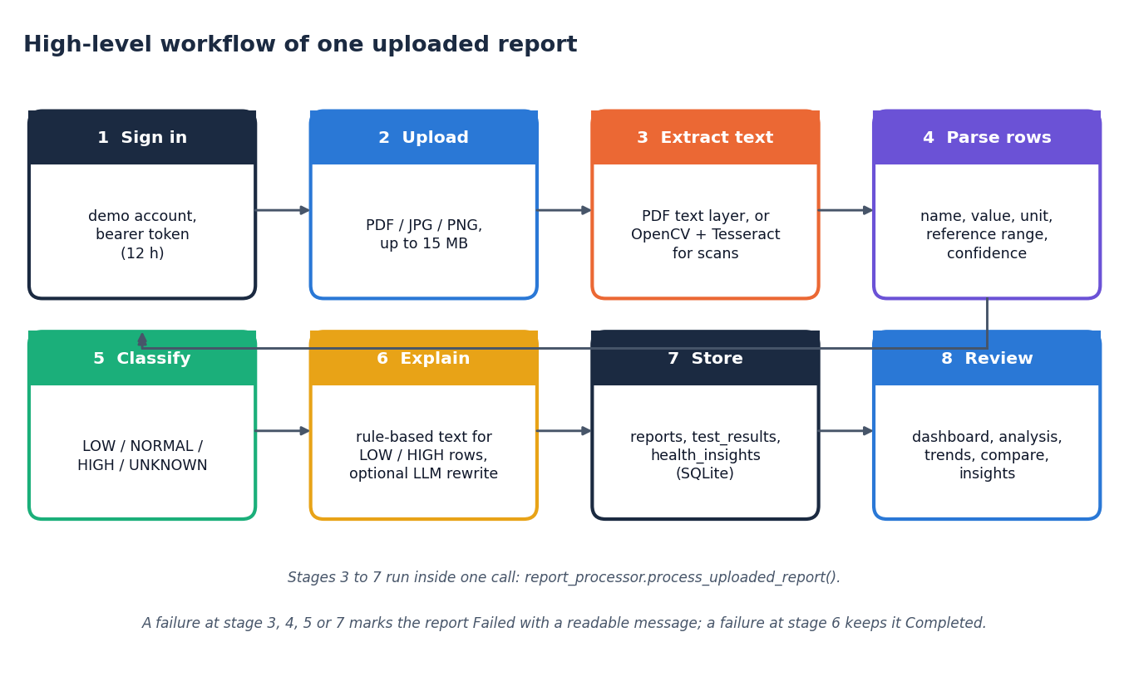
Figure 2: High-level workflow of one report, from upload to review
One report passes through eight steps. The user signs in with the demonstration account (step 1) and uploads a PDF, JPG, JPEG or PNG file of at most 15 MB (step 2). A report row is created at once, so that even a failed upload appears in the report list with its error. Text is then taken from the PDF text layer, or from OpenCV preprocessing followed by Tesseract for scanned pages and images (step 3). The parser turns each line into a candidate row (name, value, unit, reference range, confidence) and snaps the name to a dictionary of 55 test names (step 4). Each row is classified LOW, NORMAL, HIGH or UNKNOWN (step 5), explanations are generated for the LOW and HIGH rows only (step 6), and rows and insights are stored in SQLite (step 7). The user then reviews the results on the dashboard, analysis, trend, comparison and insight screens (step 8). Steps 3 to 7 run inside one call of process_uploaded_report. A failure in the steps that extract, parse, classify or store marks the report Failed with a readable message; a failure in the explanation step leaves the report Completed.

5.3 Data flow diagrams

Level 0
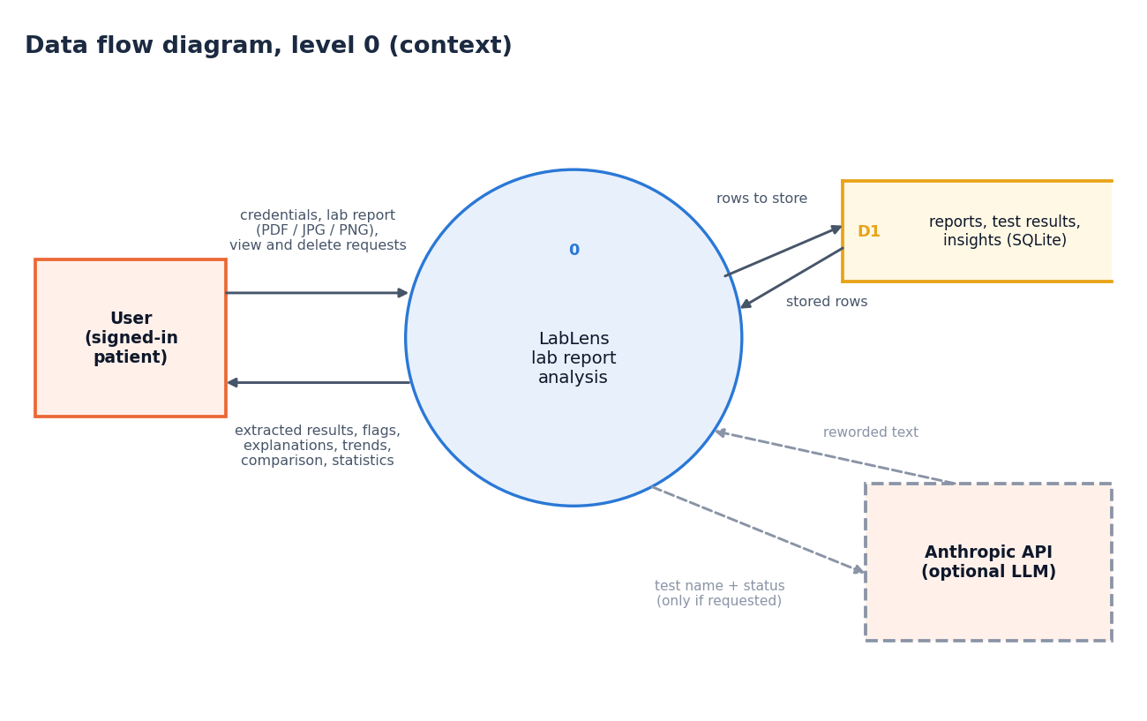
Figure 3: Data flow diagram, level 0 (context diagram)
The context diagram shows LabLens as one process with one external entity, the signed-in user. The user sends credentials, a lab report (PDF, JPG or PNG) and requests to view or delete reports. The system returns the extracted results, their status flags, plain-language explanations, trends, comparisons and statistics. Inside the boundary the process reads and writes one data store, D1, which holds the reports, test results and insights in SQLite. One optional external service, the Anthropic API, receives a test name and status and returns reworded text, but only when the user asks for it and a key is configured. The Tesseract engine is a local program called inside the process and is not drawn at this level.

Level 1
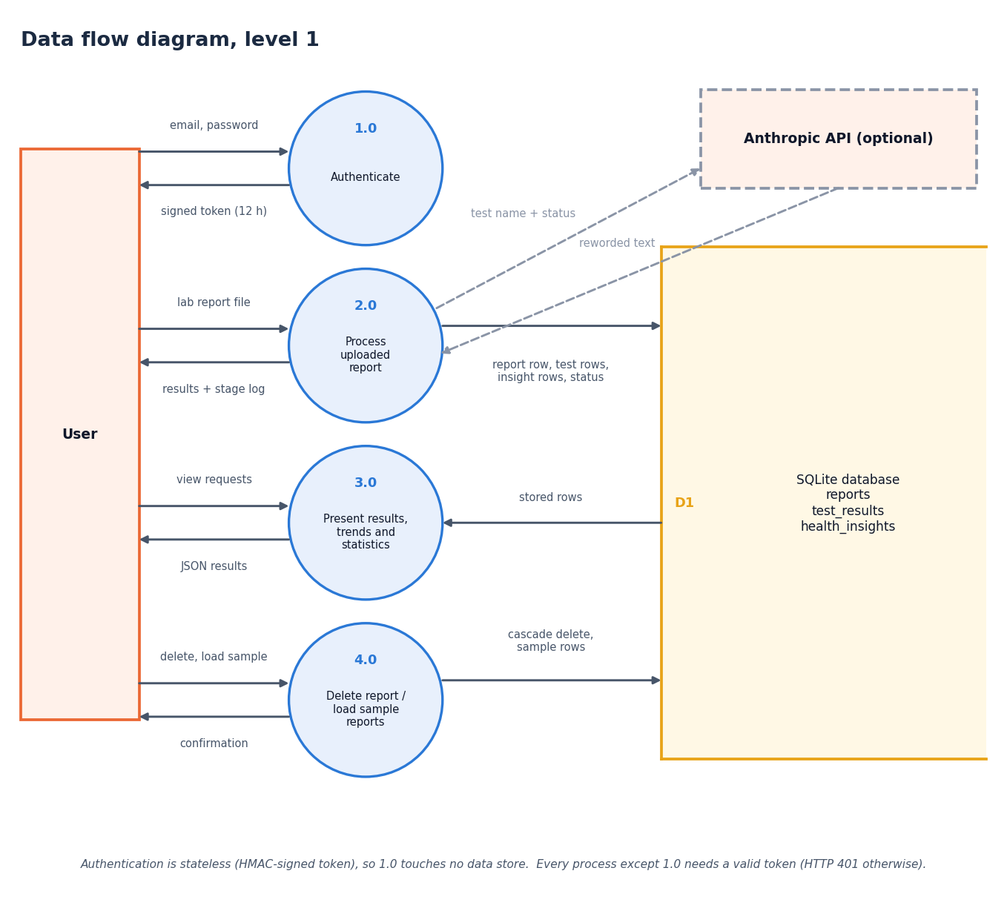
Figure 4: Data flow diagram, level 1
Level 1 splits the system into four processes. Authenticate (1.0) compares the email and password with the configured demonstration account and returns a signed token that is valid for 12 hours. Process uploaded report (2.0) accepts a file and the token, runs the whole pipeline and writes rows to the report, test-result and insight stores (D1, D2, D3); it returns the results and a stage log, and sends a test name and status to the optional Anthropic API only when reworded text was requested. Present results, trends and statistics (3.0) reads the stored rows and returns the dashboard, analysis, trend, comparison and insight data as JSON. Delete or load sample reports (4.0) removes a report with its results and insights by cascade, or adds five synthetic reports. The note under the diagram records that every process except 1.0 needs a valid bearer token and otherwise answers HTTP 401.

Level 2
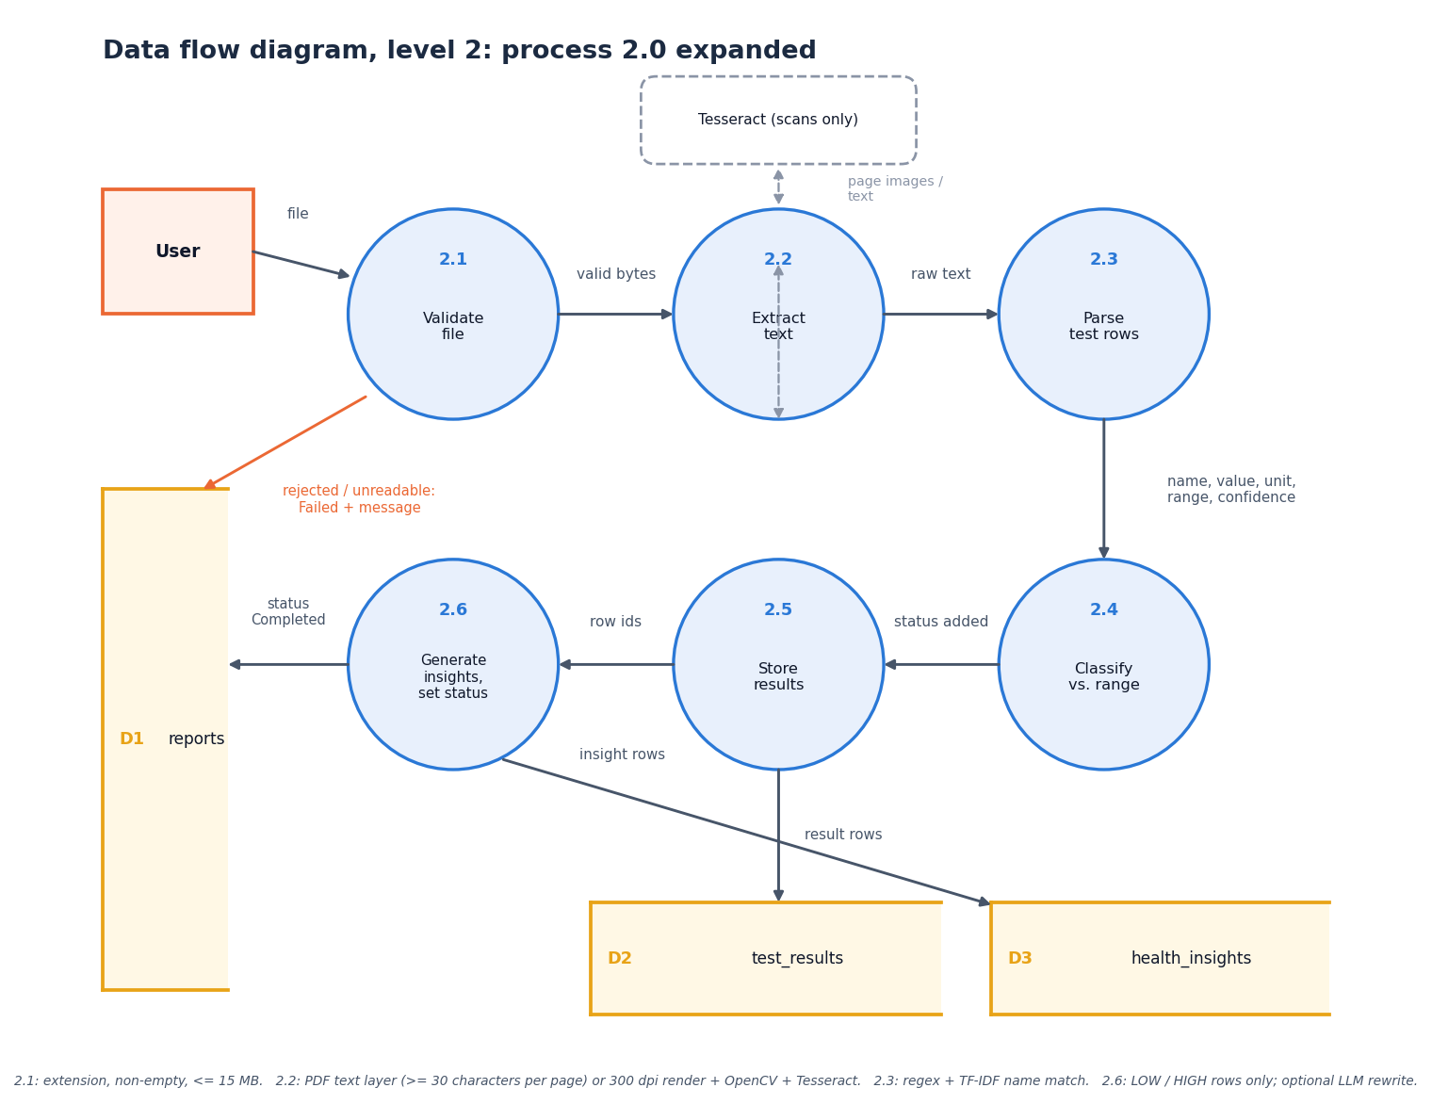
Figure 5: Data flow diagram, level 2: process 2.0 (process uploaded report) expanded
Level 2 expands process 2.0 into the six steps of process_uploaded_report. Validate file (2.1) accepts only pdf, jpg, jpeg and png, a non-empty file and at most 15 MB; a rejected file leads to a Failed report with a message. Extract text (2.2) reads the PDF text layer (at least 30 characters per page) or renders the page at 300 dpi and applies OpenCV preprocessing and Tesseract; an unreadable scan also leads to Failed. Parse test rows (2.3) applies the regular expressions and the TF-IDF name match and yields name, value, unit, range and confidence. Classify against range (2.4) adds the status. Generate insights (2.5) is applied to LOW and HIGH rows only. Store and set status (2.6) writes the result rows (D2), the insight rows (D3) and the report status, raw text and error message (D1).

5.4 UML diagrams

Class diagram
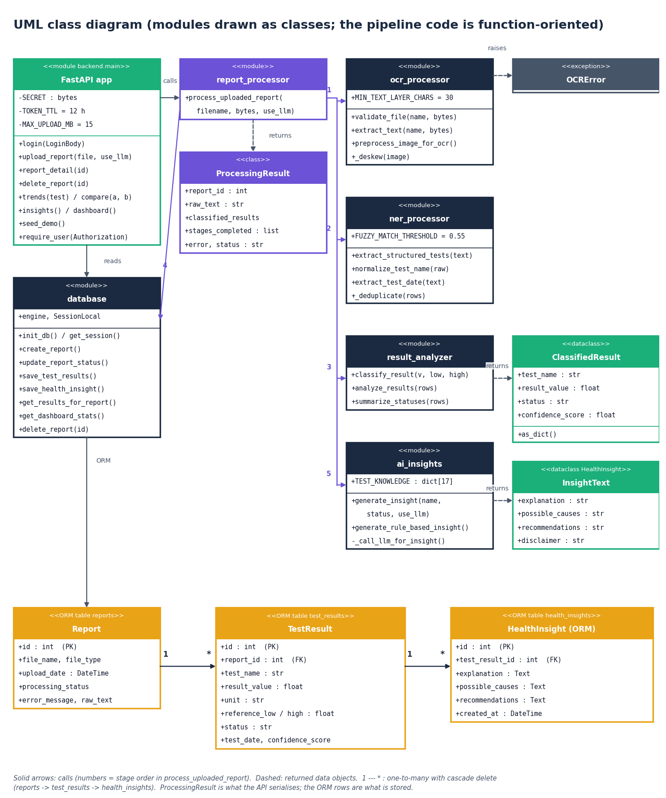
Figure 6: UML class diagram (real classes plus modules drawn as classes)
Most of the pipeline is function-oriented, so the diagram draws each module as a class stereotyped as a module and shows the real classes beside them. The modules are the FastAPI application, report_processor, ocr_processor, ner_processor, result_analyzer, ai_insights and database, each with its constants and public functions. ProcessingResult is the container returned by report_processor; it holds the report identifier, the raw text, the list of classified results, the stages completed, any error and the status. ClassifiedResult is the dataclass returned by result_analyzer. The dataclass HealthInsight of ai_insights.py, which carries the explanation text, is drawn as InsightText so that it is not confused with the ORM class of the same name. The three ORM classes Report, TestResult and HealthInsight (models.py) are linked one to many with cascading delete, and OCRError is the exception raised by the text-extraction stage.

Sequence diagram
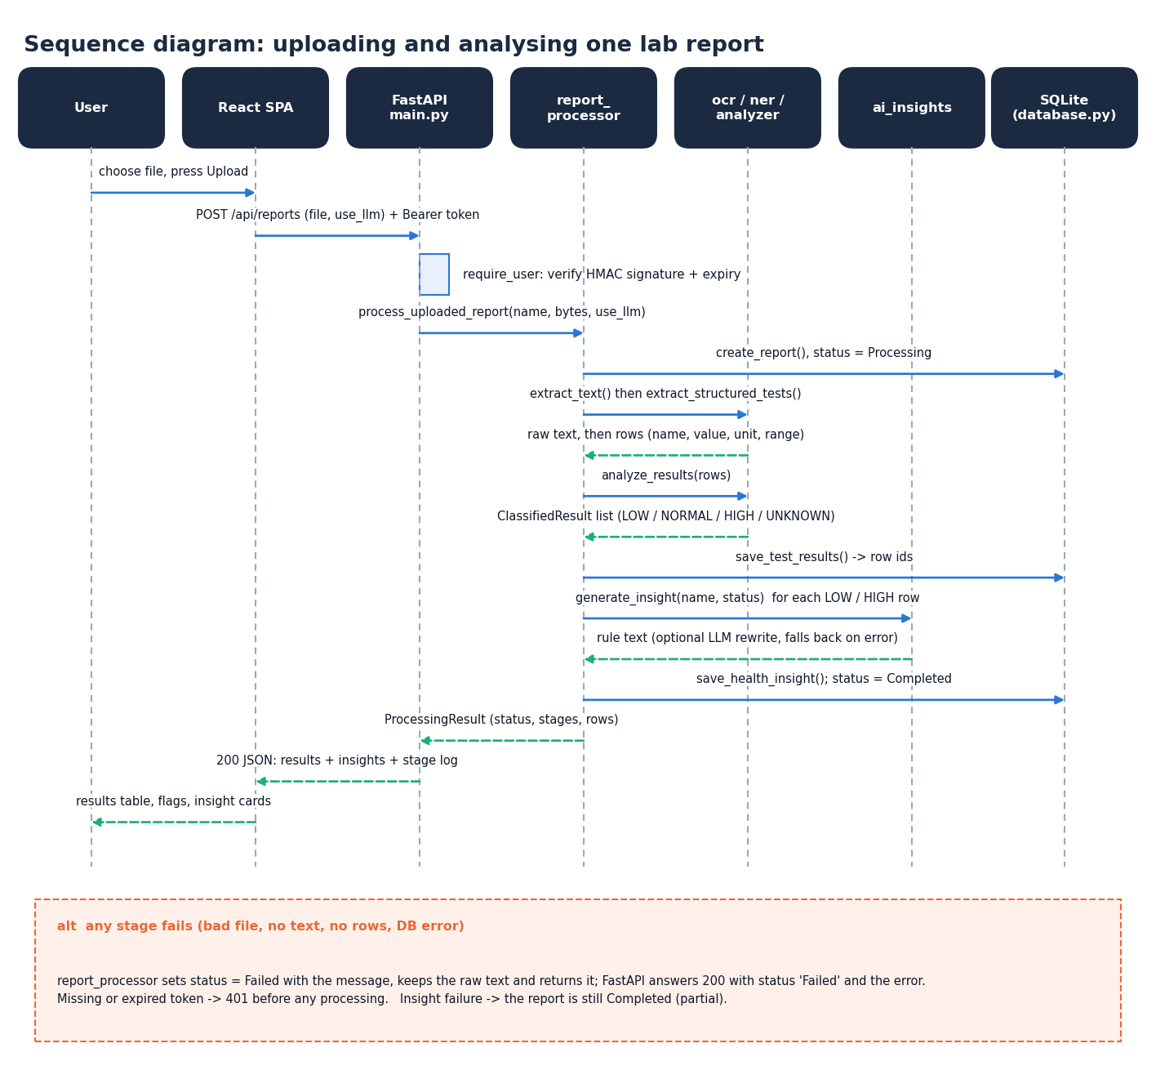
Figure 7: Sequence diagram: uploading and analysing one report
The sequence follows one upload through seven participants. The user chooses a file on the Upload page, which posts it as multipart data to POST /api/reports with the bearer token. The API verifies the HMAC signature and expiry and calls process_uploaded_report, which creates the report row, extracts the text and rows, classifies them, saves them and then asks ai_insights for an explanation of each LOW or HIGH row; the insight is saved and the status becomes Completed. ProcessingResult returns to the API, which answers HTTP 200 with the results, the insights and the stage log, and the page shows the results table, the flags and the insight cards. The alternative box records the failure rules: any failing stage sets the status to Failed with the message and returns it with HTTP 200, a missing or expired token gives 401 before any processing, and an insight failure leaves the report Completed. The whole exchange is one synchronous request.

Use-case diagram
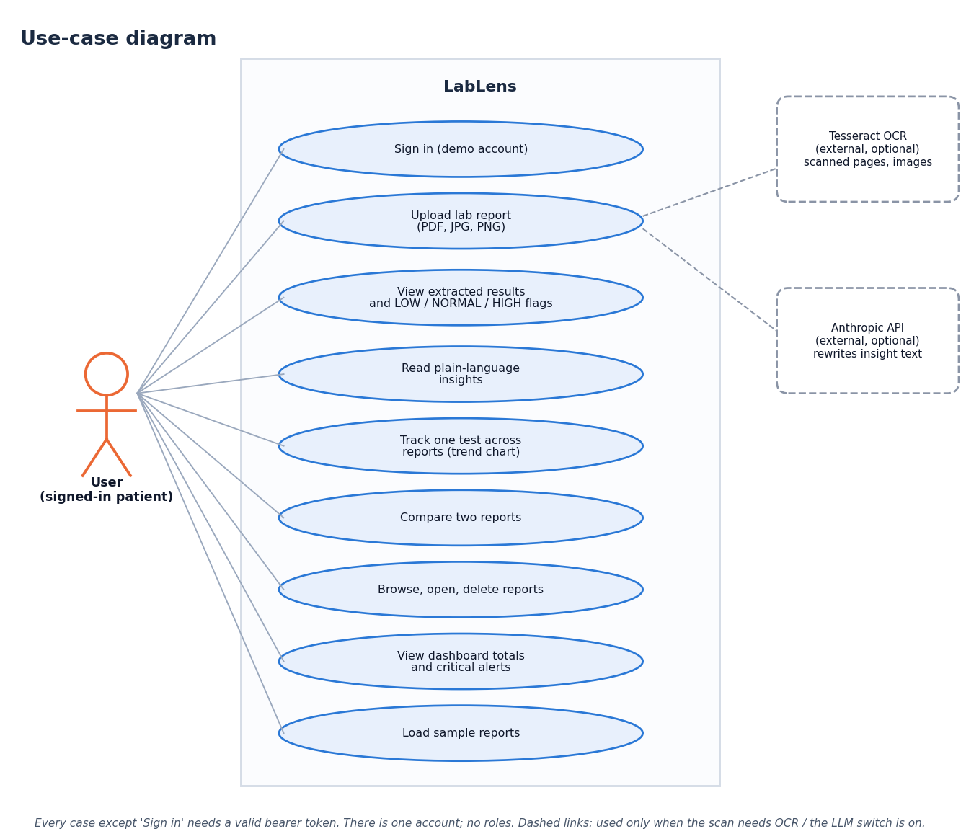
Figure 8: Use-case diagram
There is one actor, the signed-in user, and no roles. The user can sign in with the demonstration account, upload a lab report, view the extracted results with their LOW, NORMAL or HIGH flags, read the plain-language insights, track one test across reports on a trend chart, compare two reports, browse, open and delete reports, view the dashboard totals and critical alerts, and load the five sample reports. Every case except signing in requires a valid token. Two optional external systems appear on the right: the Anthropic API, which extends the insight text when requested, and Tesseract OCR, which the upload case includes for scanned pages and images.

Core algorithm flowchart
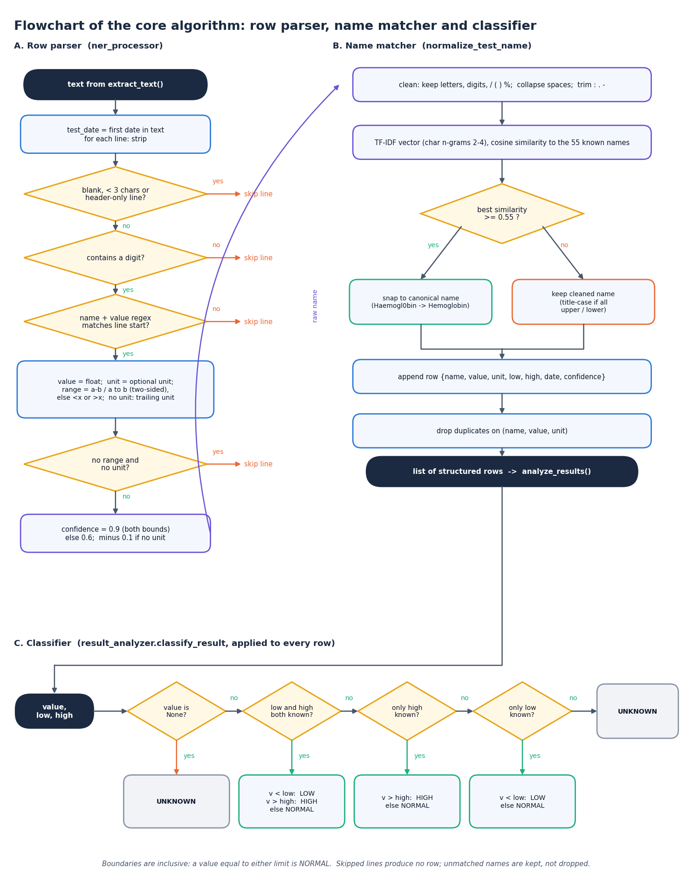
Figure 9: Flowchart of the core algorithm: from a text line to a classified row
The flowchart has three panels that follow the code. Panel A is the row parser of ner_processor.py: the report date is searched once, then each line is skipped if it is blank, shorter than three characters, header-only or without a digit, and must otherwise start with a name followed by a number. The range is searched in the remainder of the line (two-sided first, then one-sided), a unit is taken from the line or from its end, a row with neither range nor unit is skipped, and the others receive a confidence score. Panel B is the name matcher: the name is cleaned, vectorised as character 2-4-grams and compared with the 55 known names; a similarity of at least 0.55 snaps it to the canonical name, otherwise the cleaned name is kept. The row is appended and duplicates on name, value and unit are dropped. Panel C is classify_result: it returns UNKNOWN for a missing value, uses both limits when present, otherwise only the high or only the low limit, and UNKNOWN when there is no limit.

5.5 Database design
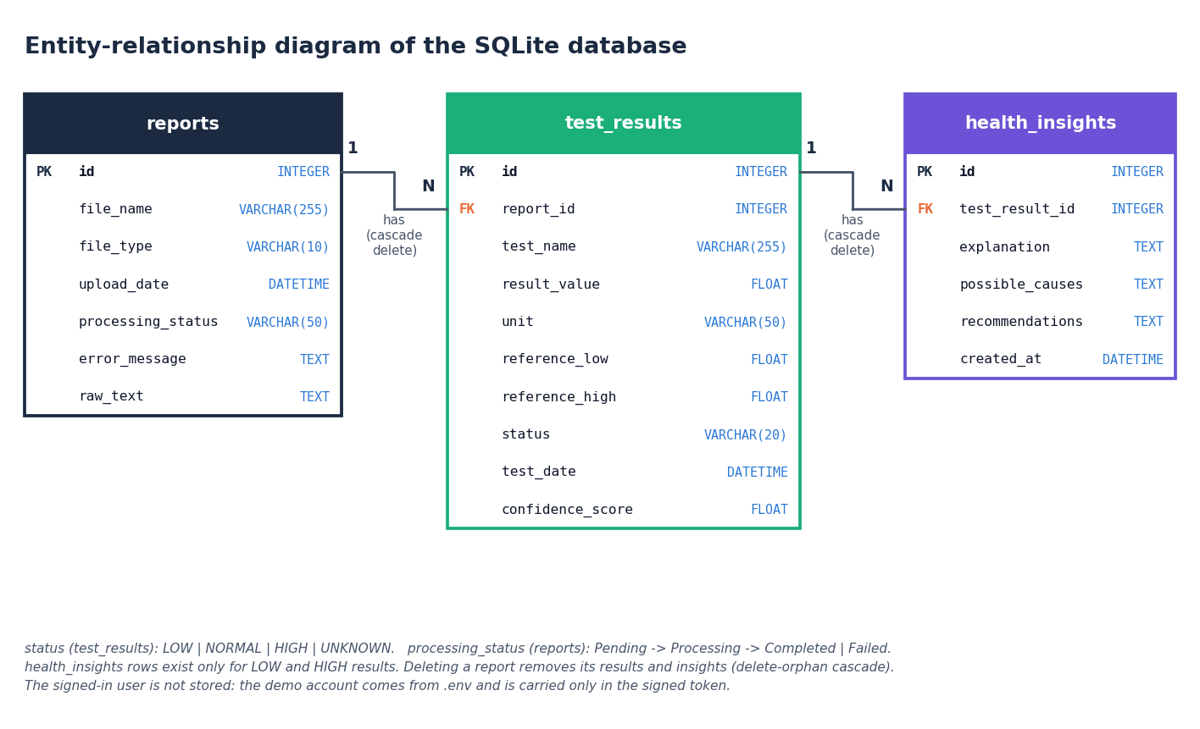
Figure 10: Entity-relationship diagram of the stored data
Persistent data are in three tables. A reports row describes one uploaded file and owns zero or more test_results rows, one for each lab test extracted from it; a test_results row owns zero or more health_insights rows (the code writes one for every LOW or HIGH result). Both relationships are enforced by a foreign key and by the ORM cascade all, delete-orphan, so deleting a report removes its results and their insights. The demo user is not an entity: the account is configured through environment variables and exists only inside the signed token, so the database holds one shared library.
Table 13: Table reports
Column | Type | Constraint | Meaning
id | INTEGER | Primary key, auto-increment | Report number shown in the interface
file_name | VARCHAR(255) | NOT NULL | Name of the uploaded file
file_type | VARCHAR(10) | nullable | pdf, jpg, jpeg or png
upload_date | DATETIME | default UTC now | Upload time (naive UTC); the x-axis of every trend
processing_status | VARCHAR(50) | default Pending | Pending, Processing, Completed or Failed
error_message | TEXT | nullable | Reason shown to the user when the status is Failed
raw_text | TEXT | nullable | Full extracted text, kept so a failure can be inspected

Table 14: Table test_results
Column | Type | Constraint | Meaning
id | INTEGER | Primary key, auto-increment | Result identifier
report_id | INTEGER | Foreign key to reports.id, NOT NULL | Owning report
test_name | VARCHAR(255) | NOT NULL | Normalised test name; trends match on this exact string
result_value | FLOAT | nullable | Measured value
unit | VARCHAR(50) | nullable | Unit as printed, or null if none was recognised
reference_low | FLOAT | nullable | Lower limit; null for a one-sided upper limit
reference_high | FLOAT | nullable | Upper limit; null for a one-sided lower limit
status | VARCHAR(20) | nullable | LOW, NORMAL, HIGH or UNKNOWN
test_date | DATETIME | nullable | Date found in the report text, if any
confidence_score | FLOAT | default 0.0 | Extraction confidence, 0.1 to 0.9

Table 15: Table health_insights
Column | Type | Constraint | Meaning
id | INTEGER | Primary key, auto-increment | Insight identifier
test_result_id | INTEGER | Foreign key to test_results.id, NOT NULL | The abnormal result explained
explanation | TEXT | nullable | What the test measures and how the result was flagged
possible_causes | TEXT | nullable | General, non-diagnostic possible causes
recommendations | TEXT | nullable | Suggestion to discuss the result with a clinician
created_at | DATETIME | default UTC now | Creation time; the newest insight per result is read

The tables are created by init_db() with Base.metadata.create_all, so a fresh checkout needs no migration. Access goes through SQLAlchemy sessions that commit on success and roll back on any exception, which removes string-built SQL and with it injection through file names or test names. There are no secondary indexes and no unique constraint: the volumes of a personal library are small, and a repeated upload simply creates a second report. The schema has no user column, because the product keeps one shared library.

5.6 Module design
Each pipeline stage is one module with one public entry point, and each module imports only the stages before it. This is what lets the unit tests of Chapter 7 call extract_structured_tests or classify_result directly with no database and no server.
Table 16: Modules, sizes and responsibilities
Module | Lines | Responsibility | Key functions
ocr_processor.py | 225 | Upload validation, PDF text layer, OpenCV preprocessing, Tesseract | validate_file, extract_text, preprocess_image_for_ocr
ner_processor.py | 289 | Row parsing, test-name matching, date and patient name | extract_structured_tests, normalize_test_name, extract_test_date
result_analyzer.py | 100 | Status rules and summary counts | classify_result, analyze_results, summarize_statuses
ai_insights.py | 270 | Knowledge base, rule-based and optional LLM explanations | generate_insight, generate_rule_based_insight
report_processor.py | 148 | Pipeline coordination and failure handling | process_uploaded_report
database.py | 251 | Engine, sessions, CRUD helpers, dashboard totals | create_report, save_test_results, get_results_by_test_name, get_dashboard_stats
models.py | 97 | ORM tables | Report, TestResult, HealthInsight
backend/main.py | 352 | FastAPI routes, token authentication, JSON serialisers | 14 routes (Section 5.7)
backend/demo_data.py | 98 | Five synthetic sample reports drawn as PDFs | render_pdf, seed_demo_reports
app.py | 523 | Original Streamlit interface | Upload, analysis, history, trends, comparison pages
frontend/src/pages/ | 1,756 | Eleven React pages | Landing, Login, Dashboard, Upload, Analysis, Reports, Trends, Compare, Insights, About, NotFound

5.7 API design
The API is JSON over HTTP. Errors use the FastAPI body {"detail": "message"}; the interface shows the message as it is, so every message was written for the user: for example "Please select two different reports." The status codes are 401 for a missing, forged or expired token, 404 for an unknown report, 400 when the two reports to compare are the same, 409 when sample reports are requested for a non-empty library, and 422 for a malformed request. A report that cannot be processed is not an HTTP error: POST /api/reports answers 200 with status set to Failed and the reason in error, because the failure is a normal outcome of a user-supplied file and the report is kept in the list.
Table 17: REST endpoints
Method | Path | Token | Purpose
GET | /api/health | No | Liveness check; returns {"status": "ok"}
GET | /api/config | No | Disclaimer, accepted extensions, dictionary names, size limit, LLM availability, demo e-mail and password
POST | /api/auth/login | No | Checks the demo account; returns a signed token and the user
GET | /api/auth/me | Yes | The signed-in user, used to restore a session
GET | /api/dashboard | Yes | Totals and the ten most recent reports with test and abnormal counts
GET | /api/reports | Yes | All reports, newest first, with counts
POST | /api/reports | Yes | Multipart file and use_llm; runs the pipeline and returns status, stages, results and insights
GET | /api/reports/{id} | Yes | One report with its results, insights and the first 5,000 characters of raw text
DELETE | /api/reports/{id} | Yes | Deletes the report, its results and insights
GET | /api/tests | Yes | Distinct test names on file, for the trend selector
GET | /api/trends?test= | Yes | Values of one test across reports in upload order, with direction
GET | /api/compare?a=&b= | Yes | Tests common to two reports, with the change (second minus first)
GET | /api/insights | Yes | Every LOW or HIGH result with its insight, newest report first
POST | /api/demo/seed | Yes | Loads five synthetic reports through the real pipeline, only into an empty library

5.8 User interface design
The interface follows the Depth Studio design kit: layered dark surfaces with soft elevation, an emerald accent, the Sora, Inter and JetBrains Mono typefaces, and a light theme chosen with a toggle whose choice is stored in the browser (ll-theme). Status carries meaning through colour and text: green for Normal, amber for Low and red for High, each badge spelling the word, so colour is never the only signal. Every page repeats the reminder "Educational tool - not a medical device" in the header, and pages that show results end with the full medical disclaimer returned by /api/config.
The shell is a fixed sidebar with eight entries and a link back to the landing page; on narrow screens it becomes a drawer. Routes are code-split and loaded lazily, with a skeleton shown while a page loads. Every list has an empty state that says what to do next, and the empty dashboard offers to load the sample reports. Every request that can fail shows an error panel naming the problem (for example that the backend on port 8308 cannot be reached) with a Try again button.
Table 18: Screens and the screenshots that show them (Chapter 8 and Appendix C)
Screen and route | Screenshot nos. | Content
Landing / | 01, 02 | Public introduction with a three-dimensional hero scene (static image when motion is reduced), how it works, disclaimer
Sign in /login | 03 | Demo credentials with a one-click sign-in button
Dashboard /app | 04, 13 | Report, test, normal, abnormal and critical totals, critical alert banner, recent reports, results by status; empty state with a button to load sample reports
Upload /app/upload | 05, 06 | Drop area, accepted formats and size, optional LLM switch, six-step progress, results table after processing
Analysis /app/analysis/:id | 07 | Report selector, counts, filterable results table, insight cards for abnormal results, raw text, disclaimer
My reports /app/reports | 08 | Searchable list with status, counts, expandable results and a confirmed delete
Trends /app/trends | 09 | Test selector, line chart with reference band, direction note, table of all values
Compare /app/compare | 10 | Two report selectors, tests in common, change column, bar chart grouped by unit
Insights /app/insights | 11 | Every abnormal result with its explanation, status tabs and search
About /app/about | 12 | What the product does, pipeline, limits, disclaimer

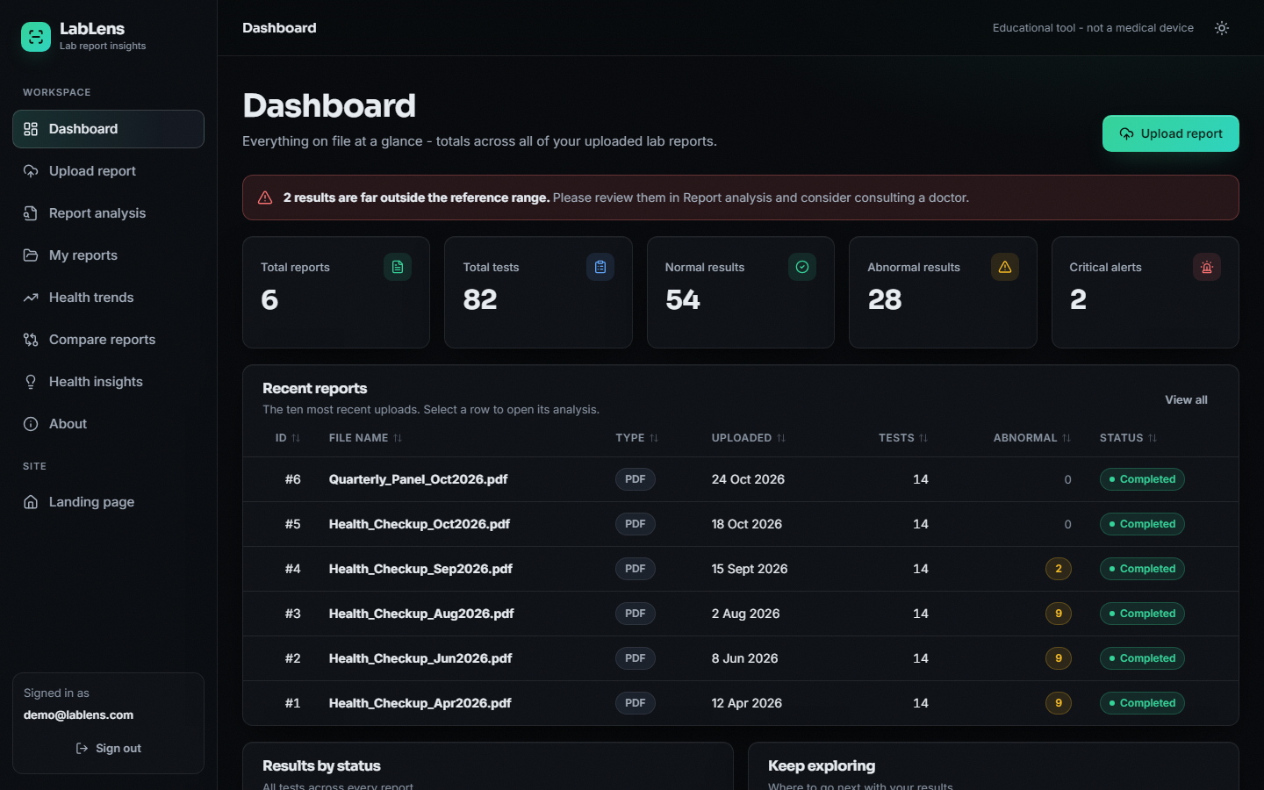
Figure 11: The dashboard: totals, a critical-result banner and the six reports of the demonstration library
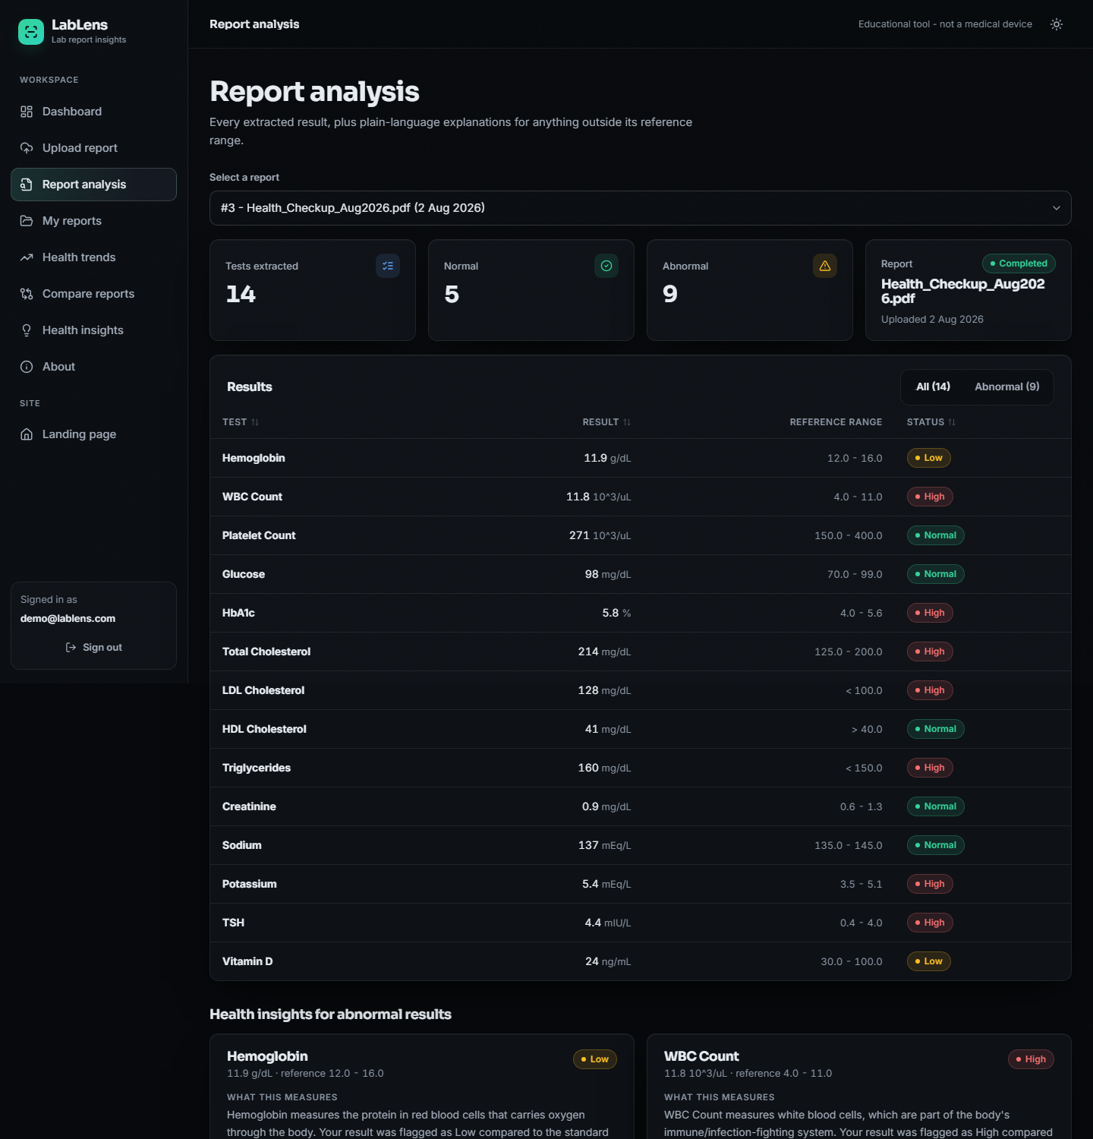
Figure 12: The report analysis screen: extracted rows with status badges and insight cards (top of the page)
Accessibility was designed in: a skip link is the first tab stop, every control has a visible focus ring and a label, the navigation drawer closes with the Escape key, loading regions are marked busy, and motion is reduced when the operating system asks for it (the landing page then shows a static image instead of the three-dimensional scene). Chapter 7 lists the automated checks.

5.9 Security design
The product handles health data, so the design states what it protects and what it does not. Access is gated by a signed token (HMAC-SHA256, 12 hours) sent in the Authorization header; every route except health, configuration and login requires it. Uploads are limited to four extensions and 15 MB, all SQL goes through the ORM, and cross-origin requests are accepted only from the two local interface origins. The design does not provide per-user data separation, HTTPS, password hashing (there is one configured demonstration account) or an audit log, and the configuration route returns the demonstration password so that the sign-in page can offer a one-click button. These are limits of a demonstration build; Chapter 6 gives the controls in detail and Chapter 10 the steps needed for real use.

CHAPTER 6: METHODOLOGY AND SOFTWARE IMPLEMENTATION

6.1 Overall methodology
LabLens is a pipeline of deterministic stages, not a trained model. A report file enters, text comes out of it, the text is parsed into rows, each row is compared with its own reference range, and a plain-language note is attached to every abnormal row. No stage learns from data: the only fitted object is the term-weighting of a 55-name dictionary, computed when the module is loaded. This keeps every decision inspectable (a row is flagged because a number is outside a printed range) and keeps the whole system runnable on a laptop without a GPU or a download of model weights.
Figure 13: Overall workflow of the LabLens pipeline
1. Validate the upload: extension in {pdf, jpg, jpeg, png}, not empty, at most 15 MB (ocr_processor.validate_file).
2. Extract text: the PDF text layer for digital reports; OpenCV preprocessing and Tesseract for scanned pages and photographs.
3. Parse rows: a line-level regular-expression parser finds the name, value, unit and reference range of each result.
4. Normalise names: a TF-IDF character n-gram matcher snaps noisy test names to a dictionary of 55 canonical names.
5. Classify: LOW, NORMAL, HIGH or UNKNOWN by comparison with the row's own reference range.
6. Explain: a curated knowledge base (and optionally a language model) writes what the test measures, general possible causes and a suggestion to consult a clinician, for LOW and HIGH rows only.
7. Store and trend: rows go to SQLite; later reports of the same test form a trend, and any two reports can be compared.

6.2 Data used for development and evaluation
The project ships no dataset, and no real patient report was available for the evaluation. All measurements therefore use generated data with known ground truth, and this limit applies to every number in Chapters 7 and 8. Two generated sources exist.
Demonstration reports. backend/demo_data.py draws five one-page PDFs with an embedded text layer (14 tests each, an invented patient, dates from April to October 2026) and sends them through the unchanged pipeline. They provide the data behind every screenshot and the latency measurements; their values are chosen so that haemoglobin rises and cholesterol falls across the five reports.
Evaluation corpus. scripts/run_experiments.py generates 120 PDF reports with a fixed random seed of 42: eight layouts of 15 reports. Each report lists 14 tests: 12 drawn from a pool of 40 tests that are in the dictionary and 2 drawn from a pool of 8 that are not (for example lipase and cortisol), together with header lines that look like data (a phone number, a registration number) and a collection-date line. Values are drawn so that about 55 % lie inside the range, 25 % below and 20 % above. The corpus holds 1,680 labelled rows. The ground-truth status uses the same comparison rule as the code, so the status accuracy reported later measures whether errors in parsing propagate, not whether the rule is clinically right.
Table 19: Layouts of the evaluation corpus (15 reports each)
Layout | Example of one row as it appears in the text layer
plain | Hemoglobin 10.8 g/dL 12 - 16
paren | Hemoglobin 10.8 g/dL (12 - 16)
flag | Hemoglobin 10.8 L g/dL 12 - 16 (a flag letter after the value)
colon | Hemoglobin: 10.8 g/dL Ref: 12 - 16
unit_last | Hemoglobin 10.8 12 - 16 g/dL
mixed_sep | Hemoglobin 10.8 g/dL 12 to 16 (separator -, to or no spaces)
tabular | name, value, unit and range as four separate text cells, one per line when extracted
ocr_noise | Hemogl0bin 10.8 g/dL 12 - 16 (10 % of name characters corrupted, simulated)

Two simplifications must be stated. The ocr_noise layout corrupts characters in a text-layer PDF, so it imitates the effect of OCR noise on names but does not exercise Tesseract or the OpenCV stage; and no layout of the corpus comes from a real laboratory. The performance of the OCR path on scanned reports is therefore not measured (Tesseract is not installed on the test machine).

6.3 Text extraction and image preprocessing
For a PDF, PyMuPDF [20] reads the text layer of every page. A page whose layer holds fewer than 30 characters is treated as scanned: it is rendered at 300 dpi (zoom 300/72), preprocessed and recognised by Tesseract [13]. This is the same decision rule for a mixed document, so a report that combines digital and scanned pages is handled page by page. A JPG or PNG upload is decoded with Pillow and goes straight to the image branch. The preprocessing parameters are those of preprocess_image_for_ocr:
Table 20: Image preprocessing before Tesseract
Step | OpenCV call and parameters | Purpose
1 Grayscale | cvtColor BGR to gray | Colour carries no information for printed text
2 Denoise | fastNlMeansDenoising, h = 10 | Removes scanner noise while keeping stroke edges
3 Threshold | adaptiveThreshold, Gaussian, block size 31, C = 15 | Copes with uneven lighting and shadows better than one global threshold
4 Deskew | minAreaRect of the foreground pixels, rotation by the estimated angle with cubic interpolation | Straightens a tilted page; skipped when fewer than 20 foreground pixels or an angle below 0.5 degrees
5 Recognise | image_to_string, --psm 6 | Page segmentation mode 6 assumes one uniform block of text, which suits line-by-line result tables

Tesseract is an optional dependency. If it is missing, an image upload fails with an OCR error message, the report is kept as Failed and digital PDFs are unaffected. The base paper [1] describes PDF parsing of the uploaded report and no image or scan branch; the survey paper [2] addresses reports photographed with a phone.

6.4 Row parsing
A laboratory report is semi-structured: most rows follow the pattern name, value, unit, range. The parser therefore works line by line with regular expressions in two stages, so that the range can be written in any common way without one giant pattern having to match the whole line.
Stage 1 anchors at the start of the line: a name (a letter followed by letters, digits and ()/,.- and spaces, lazily up to 60 characters), an optional : or -, whitespace, a signed decimal value, and an optional unit chosen from a fixed list of 23 patterns (for example %, g/dL, mg/dL, mmol/L, IU/L, ng/mL, U/L, mEq/L, fL, pg, mm/hr, 10^3/uL). Stage 2 searches the remainder of the line for a two-sided range (low and high separated by -, to, an en dash or an em dash) and, failing that, for a one-sided limit: <5 becomes an upper limit of 5 and >40 a lower limit of 40. If no unit was found in stage 1, a unit at the very end of the remainder is accepted.
_NAME_VALUE_PATTERN = re.compile(
r"^\s*(?P<name>[A-Za-z][A-Za-z0-9()/,.\- ]{1,60}?)\s*[:\-]?\s+"
r"(?P<value>-?\d+\.?\d*)\s*(?P<unit>" + _UNIT_RE + r")?", re.IGNORECASE)
_TWO_SIDED_RANGE_PATTERN = re.compile(r"(?P<low>-?\d+\.?\d*)\s*(?:-|to|–|—)\s*(?P<high>-?\d+\.?\d*)")
_ONE_SIDED_RANGE_PATTERN = re.compile(r"([<>])\s*(-?\d+\.?\d*)")

Before parsing, a line is skipped if it is shorter than three characters, matches a header word on its own (patient, name, age, date, sample, result, reference, unit and similar) or contains no digit. After parsing, a row is dropped if it has neither a range nor a unit, because a bare name and number is more likely a header or a phone number than a result. Each kept row receives a confidence score:
c = 0.9 if both limits are present, else 0.6; c ← c − 0.1 if no unit; c ← max(c, 0.1) (1)
The report date is the first match of three patterns (dd/mm/yyyy and dd-mm-yyyy, yyyy-mm-dd, dd Month yyyy) that parses with one of eight formats. Finally exact duplicates (same lower-cased name, value and unit) are removed, which repairs the doubled lines that OCR sometimes produces.
Because the parser is a set of fixed patterns, its failure modes are predictable and were found by the experiments of Chapter 7: a date such as 12-04-2026 on a line that starts with a word is read as a row with value 12 and a range of -4 to 2026; a layout in which every table cell is on its own line yields no row at all; and a unit outside the fixed list (for example mg/L, umol/L or ng/dL) is left empty.

6.5 Test-name normalisation
OCR corrupts names ("Hemogl0bin"), laboratories spell them differently ("Haemoglobin") and the same test is the key of every trend, so names are matched to a dictionary of 55 canonical names. Each name is represented by its character n-grams of length 2 to 4 inside word boundaries (scikit-learn TfidfVectorizer with analyzer="char_wb" [16]) and weighted with TF-IDF [15]. With n dictionary entries and df(t) the number of entries that contain n-gram t, the smoothed inverse document frequency and the weight of t in a name d are
idf(t) = ln((1 + n) / (1 + df(t))) + 1, w(t, d) = tf(t, d) · idf(t), vectors scaled to unit length (2)
A cleaned query name q (non-alphanumeric characters removed) is compared with every dictionary vector k by cosine similarity, which for unit-length vectors is the dot product, and is snapped to the best entry when the similarity reaches the threshold of 0.55:
cos(q, k) = (q · k) / (‖q‖ ‖k‖); name = K[argmax cos(q, k)] if max cos ≥ 0.55, else the cleaned query (3)
A name that matches nothing is kept, upper- or lower-case names being converted to title case, so a test outside the dictionary is still extracted. The threshold is a compromise that the experiments make visible. At 0.55 the matcher recovers 96.1%, 89.0% and 73.1% of the names at 5 %, 10 % and 20 % simulated character noise, but a simple edit-distance baseline (difflib, ratio 0.60) recovers 99.4%, 98.1% and 94.5%. Raising the threshold removes false matches of unseen names but loses noisy ones:
Table 21: Effect of the snap threshold (55 names x 30 noisy trials; 24 unseen names; 19 synonyms)
Threshold | Accuracy, 10 % noise | Accuracy, 20 % noise | Unseen names wrongly snapped | Synonyms resolved
0.35 | 96.3% | 88.8% | 33.3% | 73.7%
0.45 | 94.3% | 82.4% | 29.2% | 73.7%
0.55 (shipped) | 89.0% | 71.8% | 16.7% | 52.6%
0.65 | 83.6% | 59.5% | 8.3% | 52.6%
0.75 | 76.8% | 47.1% | 4.2% | 47.4%

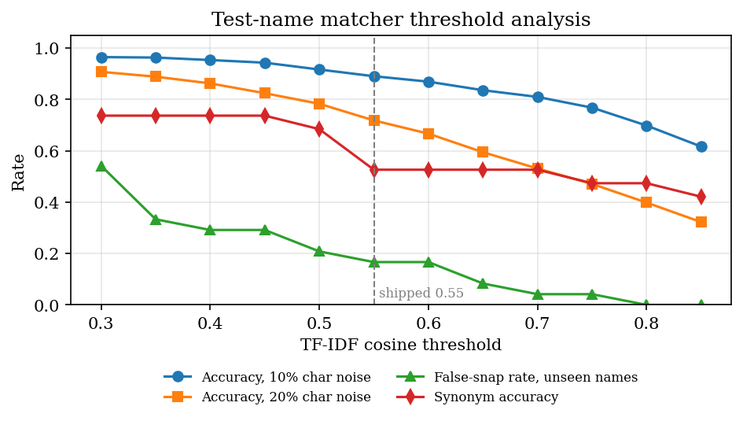
Figure 14: Name-matcher accuracy, false-snap rate and synonym accuracy against the similarity threshold
The method was kept because it needs no training data, is fast (about 0.6 ms per row) and handles inserted, missing and substituted letters; its documented weaknesses are abbreviations and synonyms ("Hb", "TLC", "LDL" are not matched at 0.55) and names that contain a dictionary name ("Sodium Bicarbonate" becomes "Sodium").

6.6 Result classification
Classification compares the value v with the reference limits ℓ (low) and h (high) printed on the same row, so the result follows the laboratory's own range for that patient and method instead of a generic table:
status(v) = LOW if v < ℓ; HIGH if v > h; NORMAL if ℓ ≤ v ≤ h; with only h: HIGH if v > h else NORMAL; with only ℓ: LOW if v < ℓ else NORMAL; with neither: UNKNOWN (4)
The bounds are inclusive. A value of exactly 5 or 10 against a range of 5 to 10 is NORMAL, and a missing value is UNKNOWN. The dashboard separately counts a result as critical when it is far outside its range, using a fixed heuristic:
critical = (LOW and v < 0.5 ℓ) or (HIGH and v > 1.5 h) (5)
This is a screening heuristic for ordering attention, not a clinical severity score, and the interface says so by phrasing the alert as results "far outside the reference range".

6.7 Explanation generation
For each LOW or HIGH row ai_insights.generate_insight returns an explanation, possible causes and a recommendation. The text comes from a curated knowledge base of 17 tests (TEST_KNOWLEDGE), each entry holding what the test measures and a sentence for a low and a high result, worded as "can generally be associated with". Tests outside the knowledge base get a generic sentence ("a number of general, non-specific causes"). The recommendation is always the same sentence: discuss the result with a doctor, especially if it is far outside the range, if there are symptoms or if it is a new change. The design rules are written into the module header: never diagnose, never say a value confirms a condition, always show the disclaimer.
An optional second path rewrites the explanation in friendlier wording. When the use_llm switch is on and ANTHROPIC_API_KEY is set, the Anthropic Messages API [23] is called with the configured model identifier and a limit of 300 output tokens, with a prompt that asks for 3 to 4 plain sentences, forbids diagnosis and forbids new medical facts. Any exception, including a missing key, an outage or an empty reply, silently keeps the rule-based text, so the report never fails because of the language model. No key was available during development, so this path was not executed or measured.
Coverage is limited: the knowledge base covers 17 of the 55 dictionary tests (30.9%); in the evaluation corpus 202 of 565 abnormal dictionary rows (35.8%) received test-specific text and the rest the generic sentence.
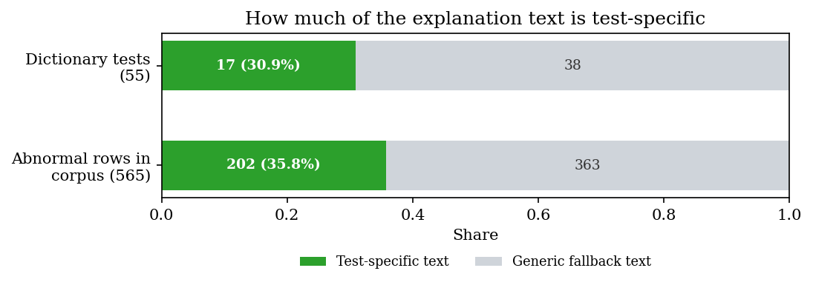
Figure 15: Share of abnormal rows that received test-specific explanation text

6.8 Choices against the project abstract
The abstract proposed PP-OCR, a conditional random field tagger and retrieval-augmented generation [1], [6], [12], [14]. The delivered system uses simpler components, and the reasons and the cost are stated here.
Table 22: Proposed components and what was built
Proposed in the abstract | Built | Reason | Consequence
PP-OCR text extraction [12] | PyMuPDF text layer, with OpenCV and Tesseract for scans | Digital PDFs need no OCR; Tesseract is free, widely available and has a Python wrapper | Scanned-image accuracy not measured; PP-OCR is untested here
CRF-based named-entity tagging [14] | Regular-expression row parser and TF-IDF name matcher | No labelled lab-report corpus existed to train a tagger; the rows are tabular, so patterns are exact and inspectable | Fails on layouts the patterns do not cover (cell-per-line tables score 0)
Retrieval-augmented explanations from trusted sources [1], [6] | Curated rule-based text, optional LLM rewording | A small vetted text is safer than free generation for health content and works offline | No retrieval and no citations; 31 % of dictionary tests have specific text
Supabase (PostgreSQL, row-level security) | SQLite through SQLAlchemy [19] | Zero set-up for a local demonstration | No per-user isolation
Serverless Cloud Functions | FastAPI [21] on one process | Runs on a laptop; same code can later be containerised | Not deployed to a cloud
React, Tailwind CSS, Recharts | React, hand-written CSS kit, Recharts [22] | A design kit gave consistent theming without a utility framework | Tailwind not used

On the generated corpus the delivered parser reaches a row precision of 0.963, a recall of 0.874 and an F1 of 0.916; Chapter 8 breaks this down by layout and field.

6.9 Application architecture
backend/main.py creates the FastAPI application [21] and calls db.init_db() at import, which creates the tables if they do not exist. It adds the CORS middleware, defines the token helpers and the fourteen routes, and imports process_uploaded_report from the pipeline; there is no pipeline logic in the web layer. The Streamlit application app.py still runs against the same SQLite file. If frontend/dist exists (after npm run build) the API also serves the compiled single-page application and falls back to index.html for any non-API path, so the product can run as one process on port 8308.
The interface is a React 18 single-page application built with Vite 5, react-router 6 and Recharts [22]. During development the Vite server on port 5308 proxies /api to port 8308, so the browser sees one origin. Pages are loaded lazily. lib/api.js wraps fetch, turns every error response into an ApiError that carries the server's message, and uses an XMLHttpRequest for uploads because fetch cannot report upload progress. A 401 anywhere clears the stored token and returns the user to the sign-in page. A small hook, useAsync, gives every page the same loading, error and retry behaviour.
The upload route runs the whole pipeline inside the request. This is simple and, for a one-page report, fast: the end-to-end pipeline including the database takes a median of 53 ms and the HTTP upload a median of 210 ms. A long scanned report would block the worker for as long as OCR takes, which is why a job queue is listed as future work.

6.10 API design and the upload route
Section 5.7 lists the routes. The upload route accepts file and use_llm, calls the pipeline, and returns the status, the stages completed, the error text, the first 5,000 characters of extracted text and, for a completed report, every result with its insight. The trend route returns the points of one test in upload order and a direction: increasing, decreasing or stable by comparing only the last value with the first. The compare route intersects the test names of two reports and returns the change as the second value minus the first, rounded to two decimals.
@app.post("/api/reports")
def upload_report(file: UploadFile = File(...), use_llm: bool = Form(False), _: str = Depends(require_user)):
data = file.file.read()
result = process_uploaded_report(file.filename or "upload", data, use_llm_insights=use_llm)
out = {"status": result.status, "report_id": result.report_id,
"stages_completed": result.stages_completed, "error": result.error,
"raw_text": result.raw_text[:5000], "results": []}
if result.status == "Completed" and result.report_id is not None:
out["results"] = [result_dict(r, with_insight=True) for r in db.get_results_for_report(result.report_id)]
return out

6.11 Security and error handling
Table 23: Threats, faults and the controls in the code
Threat or fault | Control
Anonymous access | Every route except health, configuration and login depends on require_user, which reads the bearer token and answers 401
Token forgery or tampering | Token = base64url(JSON with subject and expiry) + "." + base64url(HMAC-SHA256 of that body with JWT_SECRET), compared with hmac.compare_digest; expires after 12 hours
Credential guessing by timing | E-mail and password are compared with hmac.compare_digest
Hostile uploads | Extension whitelist (pdf, jpg, jpeg, png), empty-file check and a 15 MB limit in validate_file; undecodable files raise OCRError and the report is marked Failed
SQL injection | All access through the SQLAlchemy ORM with bound parameters
Cross-site requests | CORS allows only http://localhost:5308 and http://127.0.0.1:5308
Failure at any pipeline stage | The report row is created first; each stage is wrapped so that a failure sets status Failed with a readable message and keeps the raw text; an insight failure only shortens the stage list
Secrets in source control | .env is ignored by git; .env.example documents JWT_SECRET, the ports and the optional API key
Missing optional services | No Tesseract: a clear message for images, PDFs unaffected. No API key: the LLM switch is disabled and rule-based text is used

Weaknesses that remain: the token is kept in the browser's localStorage, which a script injected into the page could read; the default signing secret is a published placeholder until .env is edited; there is one shared account and one shared library; the configuration route returns the demonstration password for the sign-in page; and traffic is plain HTTP on the local machine.

6.12 Installation and execution
run.bat reads BACKEND_PORT (8308) and FRONTEND_PORT (5308) from .env, checks that Python and Node.js are on the path, creates backend\.venv and installs backend\requirements.txt when the environment is missing or cannot import the required packages, runs npm install in frontend on first use, warns if Tesseract is absent, starts the API with uvicorn and the interface with npm run dev, and opens the browser. Closing the two console windows stops the product. Appendix B gives the manual commands and the troubleshooting table.

CHAPTER 7: SYSTEM TESTING

7.1 Testing strategy
The pipeline is a chain of pure functions around one database, so the strategy is to test each stage on its own with small inputs, then the chain with the database, then the HTTP layer, and finally the running product in a browser. Every test that touches storage points SQLAlchemy at a temporary SQLite file, so the real library in data/medical_lab.db is never read or changed. Input documents are generated on the fly as PDFs with PyMuPDF, which keeps the tests free of any real patient data.
Table 24: Test layers
Layer | Tool | Scope | Result
Unit and integration | pytest (tests/test_lablens.py) | status rule, parser, name matcher, upload validation, explanations, pipeline with database | 31 passed
HTTP API | pytest with the FastAPI test client | authentication, upload, detail, trend, compare, insights, sample seeding | 5 passed
Randomised property check | scripts/run_experiments.py | 20,000 random value and range combinations against an independently written rule | 0 disagreements
End-to-end smoke test | scripts/smoke_test.py | temporary copy of the product served on a spare port; API flow, then a browser flow | 24 API and 7 browser checks passed
Corpus experiments | scripts/run_experiments.py | 120 generated reports in 8 layouts, 1,680 labelled rows | Chapter 8
Interface checks | scripts/ui_check.py (Playwright) | three widths, two themes, drawer, keyboard, reduced motion, error states | script provided; not re-run for this report

7.2 Unit and integration tests
python -m pytest tests -q collects 36 tests and all pass in about 3 seconds. They are written against behaviour that the interface depends on, not against implementation details, and each group is listed below.
Table 25: Groups of the 36 automated tests
Group | What is checked | Tests
Status rule | classify_result at the boundaries (5 and 10 inside 5-10, 4.99, 10.01), one-sided limits, missing value or range; summarize_statuses | 11
Row parsing | two-sided range, one-sided limits (<100, >40), header lines skipped, duplicate rows dropped, report date, patient-name label | 6
Name matching | OCR-style noise ("Haemogl0bin") snapped to Hemoglobin; an unseen name kept in title case | 2
Upload validation and OCR entry | text layer of a generated PDF read, unsupported extension, empty file, oversize file, corrupt PDF | 5
Explanations | disclaimer present and wording non-diagnostic, generic text for an unseen test, fall-back when no API key is set | 3
Pipeline and database | full pipeline stores LOW/NORMAL/HIGH correctly and an insight for every abnormal row; unreadable report marked Failed; cascade delete; dashboard totals and the critical heuristic | 4
HTTP API | login required and wrong password refused; tampered token refused; upload, detail, trend, compare and insights end to end; bad upload and missing report; sample seeding only into an empty library | 5

One test expectation was wrong and was corrected. The dashboard test first expected one critical result for a report with a creatinine of 2.4 mg/dL; the run reported two, because the LDL cholesterol of 152 mg/dL is also above 1.5 times its upper limit of 100. The expectation was changed to two and the reason written beside it. A second finding concerns the test data, not the product: an en dash written into a generated PDF with the built-in font came back from text extraction as a middle dot, so the mixed_sep layout uses a hyphen, the word to or no spaces. The parser's en-dash and em-dash patterns were therefore never exercised on a real file.

7.3 API and smoke tests
The smoke test copies the product modules into a temporary folder, starts its own server on port 8398 and never touches the real database. Its API part makes 24 checks in the order below, and it prints "All smoke checks passed." when all pass.
Table 26: Smoke-test checks
Area | Checks
Service and configuration | health; configuration holds the disclaimer and formats
Access control | protected route refuses an anonymous call; wrong password refused; demo login; current user
Empty library | empty dashboard; trend and compare empty states
Sample data | five sample reports seeded through the real pipeline; seeding twice refused
Reading | dashboard totals; report list newest first; report detail with insights; unknown report gives 404
Analysis | trend ordered by upload and increasing; comparison change equals second minus first; comparing a report with itself refused; insights cover every abnormal result
Upload and failure | PDF upload processed; unsupported file, empty file give readable errors; a failed report keeps its error message
Deletion | delete; deleting twice gives 404
Browser (7 checks) | an anonymous visit is sent to the sign-in page; the trend chart renders from the API; the comparison chart renders; insight cards render; a wrong file type is rejected in the browser; Escape closes the delete dialog; no console errors

7.4 Randomised check of the status rule
The rule that decides LOW, NORMAL and HIGH is the core of the product, so it was checked beyond hand-picked cases. 20,000 random combinations of a value and a range were generated, with each limit independently present or absent and values from -5 to 250, and the status from classify_result was compared with an independently written rule. There were 0 disagreements. The boundaries behave as documented: with a range of 5 to 10, the values 5 and 10 are NORMAL, 4.99 is LOW and 10.01 is HIGH. This shows that the code implements the stated rule; it does not show that the rule is clinically sufficient.

7.5 Validation on the generated corpus
Chapter 8 reports the full results. For testing purposes the corpus acts as a regression suite with known answers: of 1,680 labelled rows the parser returns 1,525 rows with a precision of 0.963 and a recall of 0.874; of the rows it finds, the range is right in 99.9% and the status in 99.9%. Only 72.9% of all labelled rows are completely right (name, unit, range and status together) because of the defects below.

7.6 Edge cases and defects found
The experiments exposed five defects in the product. They are reported here as test findings; the product code was not changed during the documentation work, so each one is still present and is listed as a limitation in Chapter 10.
Table 27: Defects found by testing
No. | Defect | Evidence | Effect
D1 | A collection date written dd-mm-yyyy on a line that starts with a word is parsed as a result row ("Sample Collected", value 12, range -4 to 2026) | read as a row in all 56 reports that carry a dd-mm-yyyy date (the dd/mm/yyyy form is dropped because it has no range or unit); the 57 false-positive rows are 55 date-line rows plus 2 others (in one report the date value 12 equalled a real RDW value of 12, so the date row was matched to RDW and the real RDW row counted as extra; the other is a mis-read name row) | A meaningless row appears with status NORMAL and pollutes the test list
D2 | A table whose cells are extracted one per line yields no row | tabular layout: precision 0.000, recall 0.000; 212 missed rows in all, 210 of them from this layout | The report is marked Failed ("no recognizable lab test rows")
D3 | The unit list is incomplete and a flag letter between value and unit hides the unit | 189 unit errors; unit accuracy 57.6% in the flag layout against 93.8% in plain; missed units include mg/L, umol/L, ng/dL, uIU/mL | Unit shown empty; range and status are still right
D4 | A name that contains a dictionary name is snapped to it | "Sodium Bicarbonate" becomes "Sodium"; 64 name errors; unseen-test name accuracy 77.1% against 98.7% for dictionary tests | Wrong test name, so the row joins the wrong trend
D5 | Heavy name noise defeats the matcher | ocr_noise layout: name accuracy 82.2%; at 20 % character noise 73.1% against 94.5% for an edit-distance baseline | Corrupted names stay unmatched or snap to a wrong test

Other edge cases that were tested and handled correctly: a value of exactly a range limit (NORMAL), a result with only an upper or only a lower limit, a result with neither (UNKNOWN), duplicate lines, an empty or oversize file, an unsupported extension, a corrupt PDF (Failed with a message), a PDF without any lab row (Failed with a message), deleting a report that was already deleted (404) and comparing a report with itself (400).
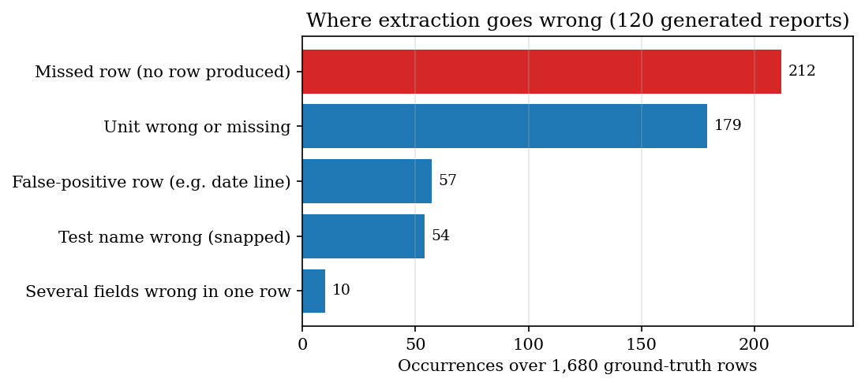
Figure 16: Kinds of extraction error found on the generated corpus

7.7 Performance testing
Timings were taken on the development machine (Intel Core i5-12500 (6 cores / 12 threads), 15.7 GB RAM, Windows 11, no GPU) with a one-page, 14-row text PDF of 4,356 bytes. Stage times are medians of 100 runs; the end-to-end pipeline, which includes the SQLite writes, is the median of 40 runs. HTTP timings use 127.0.0.1, because a hostname lookup of localhost adds seconds on this machine.
Table 28: Pipeline stage latency (14-row report)
Stage | Median (ms) | 95th percentile (ms) | Maximum (ms)
PDF text layer (PyMuPDF) | 1.37 | 1.56 | 1.93
Row parsing and name matching | 7.16 | 10.13 | 11.43
Classification | 0.02 | 0.02 | 0.03
Explanations for all abnormal rows | 0.01 | 0.01 | 0.04
End to end with database writes | 52.7 | 61.0 | 85.4

Parsing time grows linearly with the number of rows: 7.9 ms for 14 rows, 29.3 ms for 50, 58.1 ms for 100 and 113.0 ms for 200, about 0.6 ms per row, mostly the TF-IDF transform of the name. The abstract asks for less than 10 seconds per report; for a digital PDF the pipeline needs a median of 53 ms, so the target is met by a wide margin. For scanned images the time depends on Tesseract and was not measured.
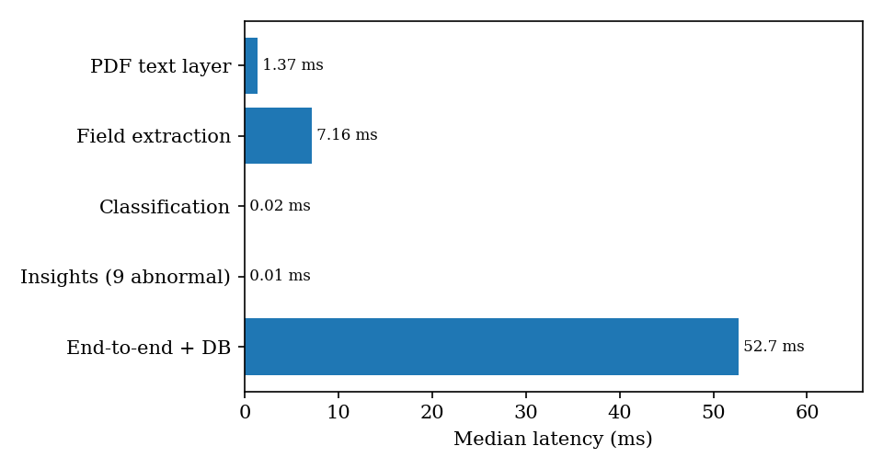
Figure 17: Median latency of each pipeline stage
Table 29: HTTP endpoint latency on 127.0.0.1
Endpoint | Median (ms) | 95th percentile (ms) | Runs
GET /api/health | 0.9 | 1.2 | 100
POST /api/auth/login | 1.0 | 1.2 | 100
GET /api/dashboard | 4.7 | 5.8 | 100
GET /api/reports | 2.9 | 3.2 | 100
GET /api/reports/{id} | 7.2 | 8.5 | 100
GET /api/trends | 2.1 | 2.5 | 100
GET /api/compare | 4.4 | 5.1 | 100
GET /api/insights | 16.4 | 19.2 | 100
POST /api/reports (PDF upload) | 209.8 | 414.2 | 30

Reads take between 0.9 and 16.4 ms; the upload, which runs the pipeline, takes a median of 210 ms. The insights route is the slowest read because it loads every abnormal result and its insight one query at a time. Loading the five sample reports takes 1.05 s. No test with many simultaneous users was run.

7.8 Security tests
Table 30: Security checks
Check | Expected | Result
Call a protected route with no token | 401 | Passed (pytest and smoke test)
Call a protected route with the last characters of a valid token changed | 401 | Passed (pytest)
Sign in with a wrong password | 401 and a message | Passed (pytest and smoke test)
Upload a .txt file | Failed report with the message "Unsupported file format" | Passed
Upload an empty file and a file above 15 MB | Readable error, nothing stored as results | Passed
Upload a corrupt PDF | Failed report, no crash | Passed
Read or delete a report that does not exist | 404 with a message | Passed

These tests cover the controls of Section 6.11. They are functional checks of the code paths, not a penetration test, and expiry of the token after 12 hours was not exercised by a test.

7.9 Interface checks
The browser part of the smoke test was run and passed (Section 7.3). The separate script scripts/ui_check.py drives the running product in Playwright and checks that no page overflows horizontally at 360, 768 and 1440 pixels in both themes; that the navigation drawer opens, closes with Escape and closes after a link is chosen; that the light theme survives a reload through localStorage; that the landing page shows a static hero and no WebGL canvas when reduced motion is requested; that the first tab stop is the skip link, a focused control has a visible ring and every input has a label; and that a stopped backend produces an error message with a Try again button that recovers. The script was written during the interface build; it was not re-run while preparing this report, so its results are not quoted.

7.10 User acceptance
No acceptance test with real users, patients or clinicians was carried out. The interface was exercised only by the developers. A usability study with people who do not know laboratory reports, and a review of the explanation texts by a clinician, are the most important missing evidence and are listed as future work.

7.11 Limits of the testing
• Synthetic data. All reports are generated or invented; no real laboratory report, and no manually labelled set of real reports, was tested, so the extraction figures describe the parser on the layouts the generator can produce, not on reports in general.
• OCR path untested. Tesseract is not installed on the test machine, so scanned images and scanned PDFs, and the OpenCV preprocessing in front of them, were not run end to end.
• Language-model path untested. No API key was available, so the optional rewording of explanations was never exercised.
• Ground truth shares the rule. The expected status of a corpus row is computed with the same comparison as the code, so status accuracy shows propagation of parsing errors only.
• One machine, one user. Timings are from one computer with no other load; concurrent access and a large database were not tested.
• No clinical validation. The tests show that the software does what its rules say; they say nothing about whether the explanations are medically adequate.

CHAPTER 8: RESULTS AND OUTPUT SCREENS

8.1 Output screens
The screens in this section are captures of the running application at 1440 x 900 pixels, taken by scripts/capture_screens.py in a real browser. Every report in the library was produced by the unchanged extraction pipeline: five synthetic sample reports (invented patient, invented values, dated April to October 2026) were rendered as PDFs with a text layer and uploaded through the same code path as a genuine file, and a sixth PDF, Quarterly_Panel_Oct2026.pdf, was uploaded through the Upload screen. All values on these screens are synthetic; no real patient data was available or used.
The dashboard screen summarises the library: 6 reports, 82 extracted tests, 54 normal and 28 abnormal results, and 2 critical alerts. A result is critical under a simple rule in database.get_dashboard_stats: LOW below half the lower limit, or HIGH above one and a half times the upper limit.
Figure 18: Dashboard: totals across the library, a critical-result banner, the recent-reports table and the status split
The next screen is the Upload screen after Quarterly_Panel_Oct2026.pdf (4.2 KB) was processed. The six pipeline stages are ticked and the table lists the 14 extracted tests with value, unit, reference range and status. The LLM switch is disabled because no ANTHROPIC_API_KEY is configured.
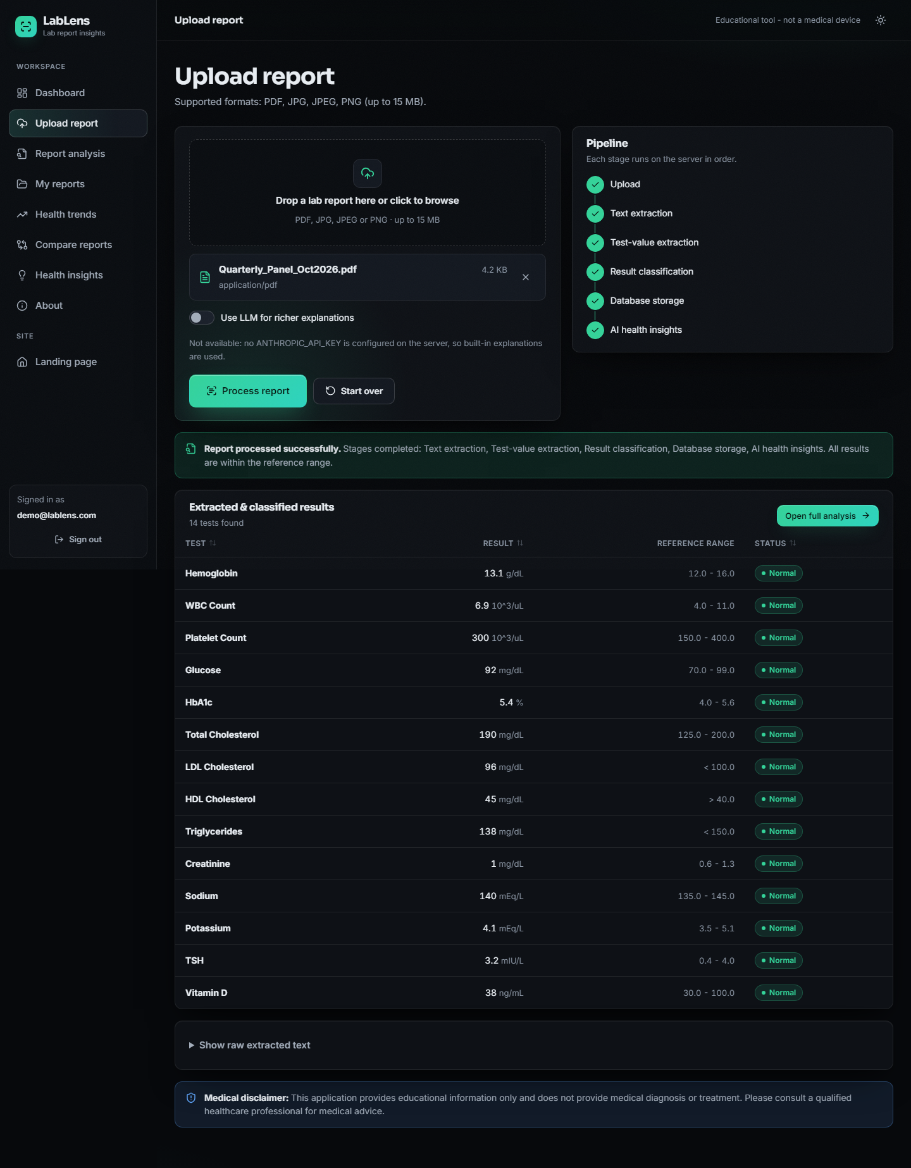
Figure 19: Upload screen after a successful run: stage tracker, extracted and classified results, and a link to the full analysis
The report analysis screen below is for Health_Checkup_Aug2026.pdf: 14 tests, 5 normal and 9 abnormal. Each abnormal row has a card: what the test measures, possible general causes and a suggestion to consult a professional. Potassium has no specific text, so its card shows the generic wording.
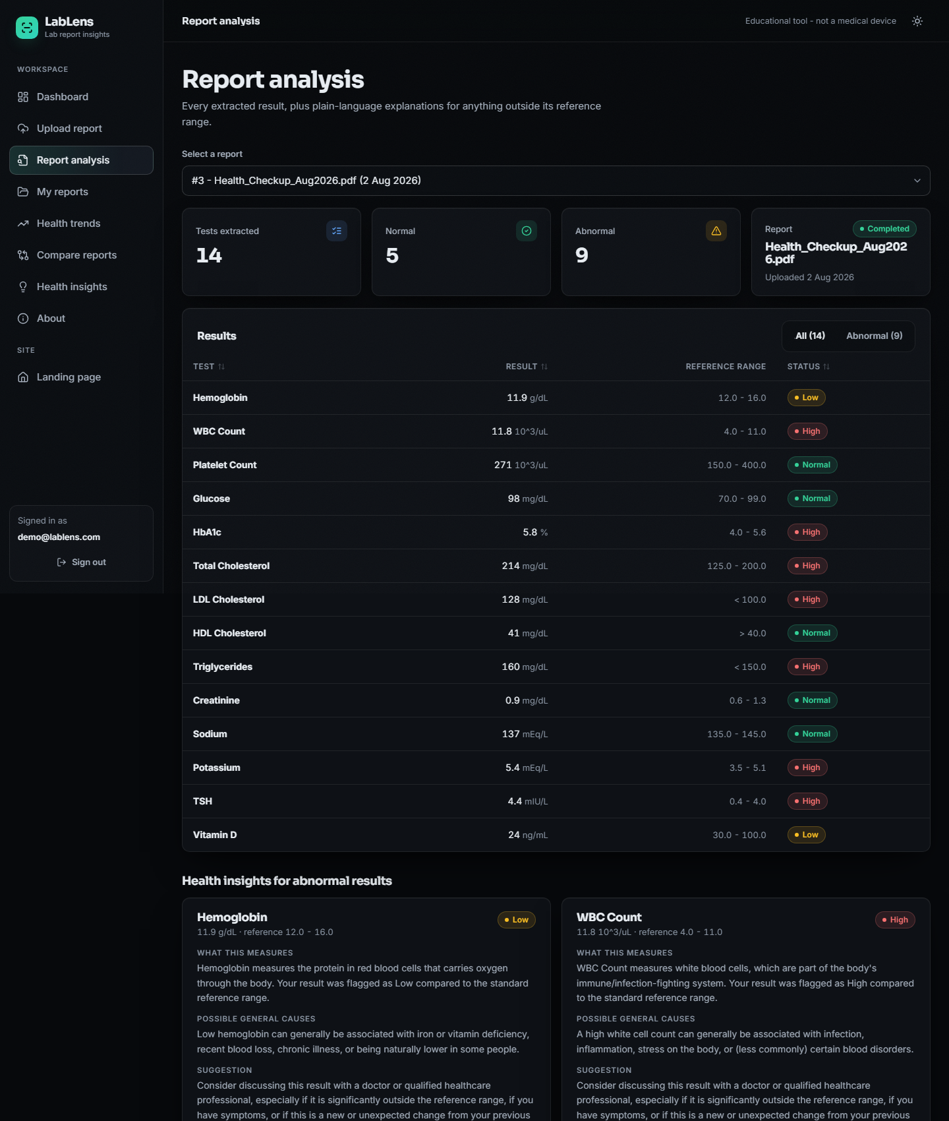
Figure 20: Report analysis: result table with status badges and health-insight cards for abnormal results (top of the page)
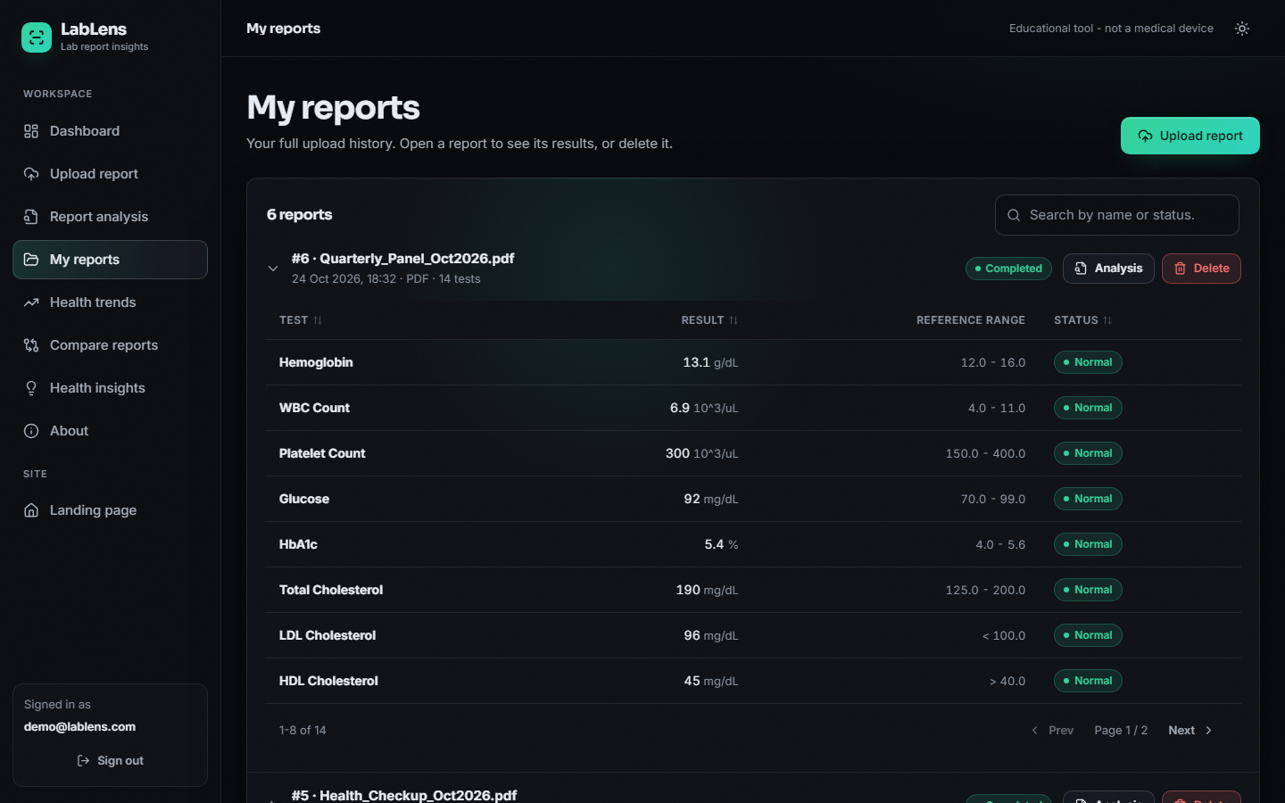
Figure 21: My reports: upload history with status, expandable result tables, a search box and delete buttons
The trend screen for haemoglobin across the six reports: 10.8, 11.2, 11.9, 12.6, 13.1 and 13.1 g/dL, drawn against the shaded reference band 12 to 16 g/dL. The first three points are LOW and the last three NORMAL; the pattern note (increasing) uses the first and last value only.
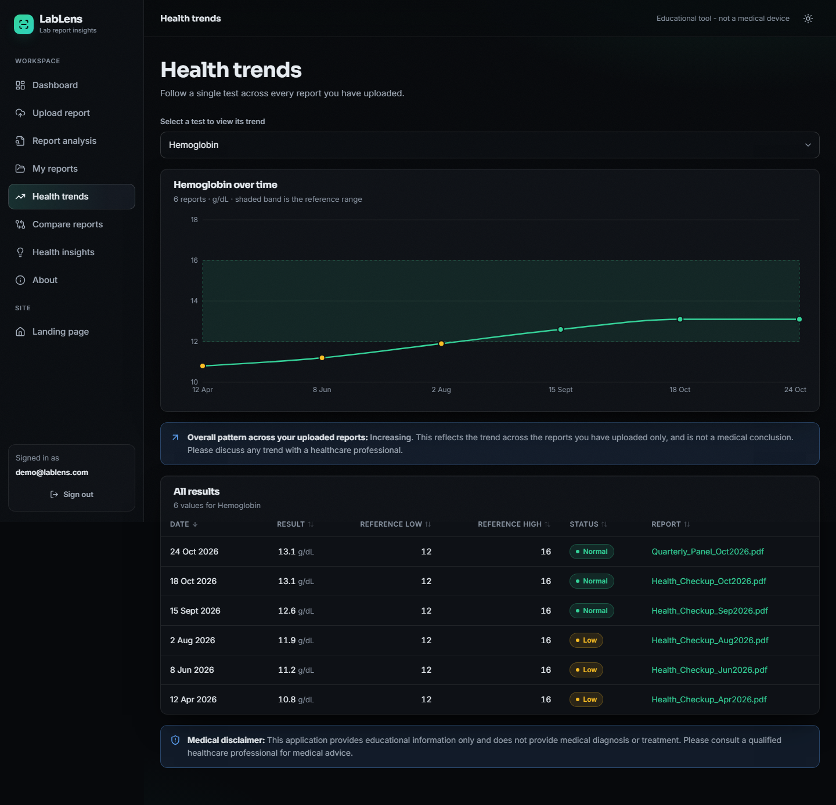
Figure 22: Health trends: one test across all reports, with the reference band, the pattern note and a sortable table
The compare screen puts report 1 (April) beside report 5 (October). 14 tests are common to both. Changes are report 2 minus report 1: LDL cholesterol falls by 56 mg/dL, haemoglobin rises by 2.3 g/dL and vitamin D rises by 24 ng/mL.
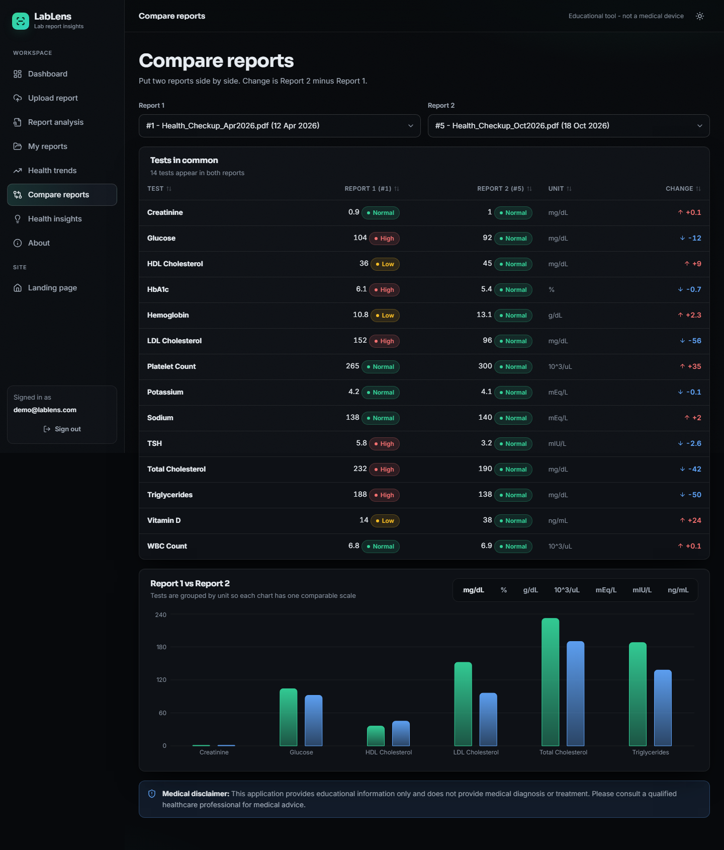
Figure 23: Compare reports: tests in common, status in each report, signed change and unit-grouped bar charts
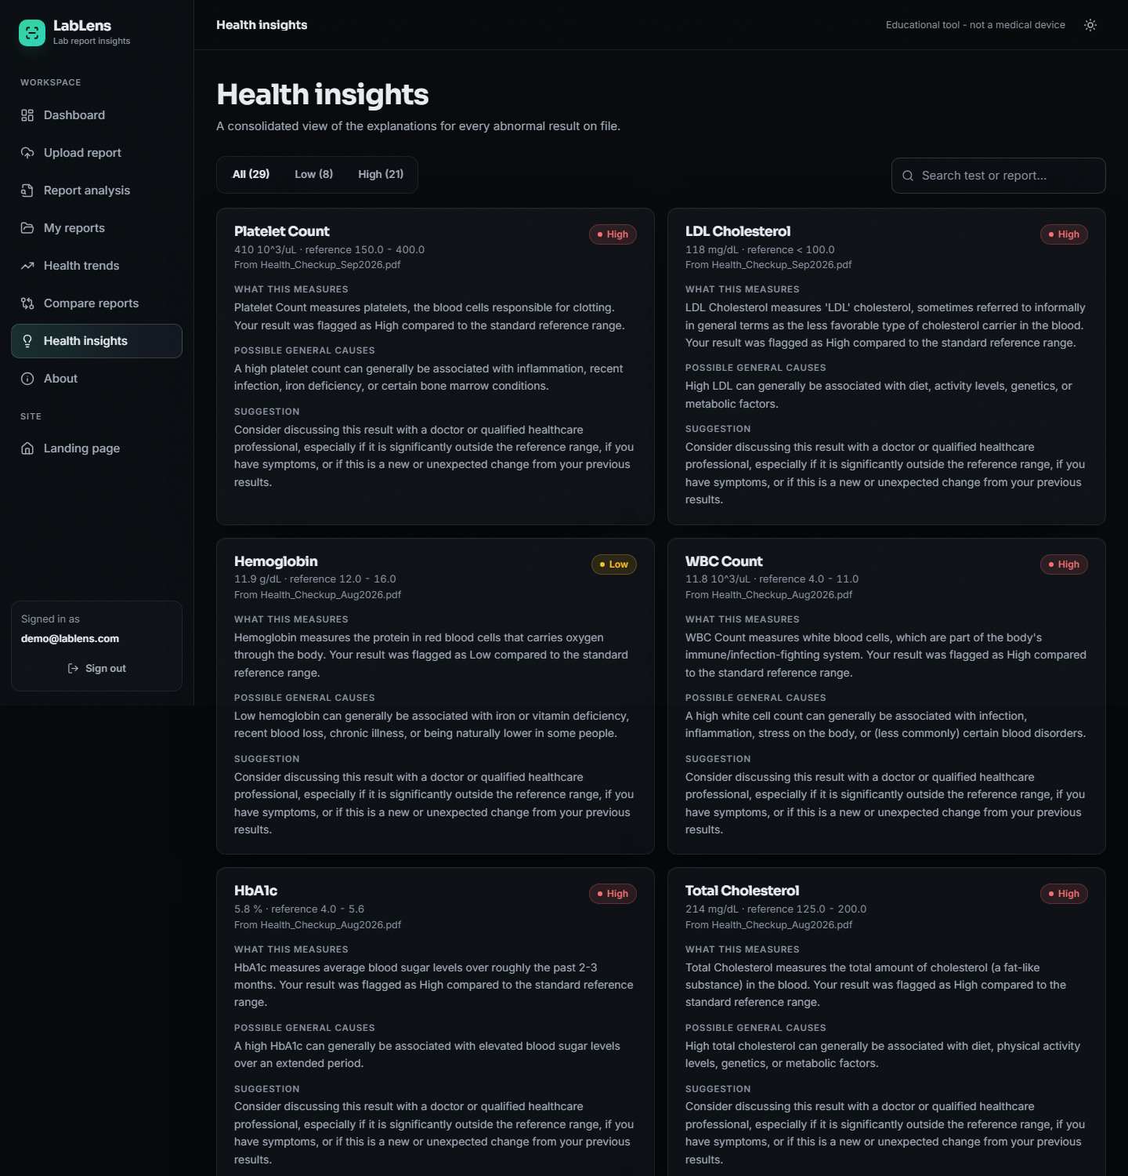
Figure 24: Health insights: every explanation for every abnormal result in the library, with a Low / High filter and a search box (top of the page)

8.2 Experimental setup and protocol
The project did not ship any evaluation data, and no real laboratory report was available for labelling. The measurements below are therefore made on a generated corpus with known ground truth, built by scripts/run_experiments.py (random seed 42) and pushed through the unchanged ocr_processor, ner_processor, result_analyzer and ai_insights modules. The corpus is not real patient data and the labels are not manual annotations; Section 8.12 explains what this means for the conclusions.
Table 31: Evaluation corpus
Property | Value
Reports | 120 PDFs with a text layer, rendered with PyMuPDF (8 layouts x 15 reports)
Rows per report | 14: 12 tests from a 40-test pool covered by the name dictionary, plus 2 tests from an 8-test pool that is not in the dictionary
Ground-truth rows | 1,680
Values | about 55% inside the range, 25% below, 20% above; one-sided limits (<, >) for LDL, HDL, triglycerides, CRP and PSA
Distractors | two header lines per report drawn from five (patient name, age/sex, registration number, referring doctor, phone) and a Sample Collected date line
Layouts | plain, range in brackets, L/H flag column, colon with Ref:, unit after range, mixed range separators (-, to, - without spaces), one cell per line (table), noisy test names
Scope | text-layer PDFs only: no scanned page, no photograph, so the OpenCV and Tesseract path is not exercised

Table 32: Measurement environment
Item | Value
Processor / memory | Intel Core i5-12500 (6 cores / 12 threads), 15.7 GB RAM, no GPU
Operating system | Windows 11 Pro
Python and libraries | Python 3.11.9, scikit-learn 1.5.0, PyMuPDF 1.28.2, OpenCV 4.11.0, SQLAlchemy 2.0.30, FastAPI 0.143.3, uvicorn 0.54.0
Front end | Node 24.19.0, React 18.3.1, Vite 5.4.21, Recharts 2.15.4
Database | temporary SQLite file for every run; data/medical_lab.db is never touched

Scoring
For every ground-truth row the scorer takes the first unused predicted row whose value equals the true value. That row is a detection. A detected row is then compared field by field: the test name (case-insensitive), the unit (after mapping the micro sign to u and lower-casing), both range limits, and the status. A predicted row that is never matched is a false positive. With TP the detected rows, P the predicted rows and G the ground-truth rows:
precision = TP / P, recall = TP / G, F1 = 2 x precision x recall / (precision + recall) (6)
exact-row rate = (rows detected with name, unit, range and status all correct) / G (7)
Field accuracies are quoted over detected rows. The exact-row rate is the strictest figure because it is taken over all ground-truth rows, so a missed row counts against it.

8.3 Field extraction
Across all 120 reports the parser predicted 1,525 rows for 1,680 true rows. Row precision is 0.963, recall 0.874 and F1 0.916. Among detected rows the range limits are almost always right (99.9%) and so is the derived status (99.9%); the test name is right in 95.6% and the unit in 87.1%. Only 72.9% of all true rows come out with all four fields correct.
Table 33: Extraction results by layout
Layout | Precision | Recall | F1 | Name | Unit | Range | Exact row
plain | 0.968 | 1.000 | 0.984 | 0.991 | 0.938 | 1.000 | 0.929
range in brackets | 0.968 | 1.000 | 0.984 | 0.981 | 0.881 | 0.995 | 0.867
L/H flag column | 0.968 | 1.000 | 0.984 | 0.976 | 0.576 | 1.000 | 0.562
colon + Ref: | 0.968 | 1.000 | 0.984 | 0.976 | 0.909 | 1.000 | 0.886
unit after range | 0.968 | 1.000 | 0.984 | 0.971 | 0.943 | 1.000 | 0.914
mixed range separators | 0.968 | 1.000 | 0.984 | 0.976 | 0.933 | 1.000 | 0.909
one cell per line | 0.000 | 0.000 | 0.000 | n/a | n/a | n/a | 0.000
noisy test names | 0.963 | 0.991 | 0.977 | 0.822 | 0.918 | 0.995 | 0.767
All 120 reports | 0.963 | 0.874 | 0.916 | 0.956 | 0.871 | 0.999 | 0.729

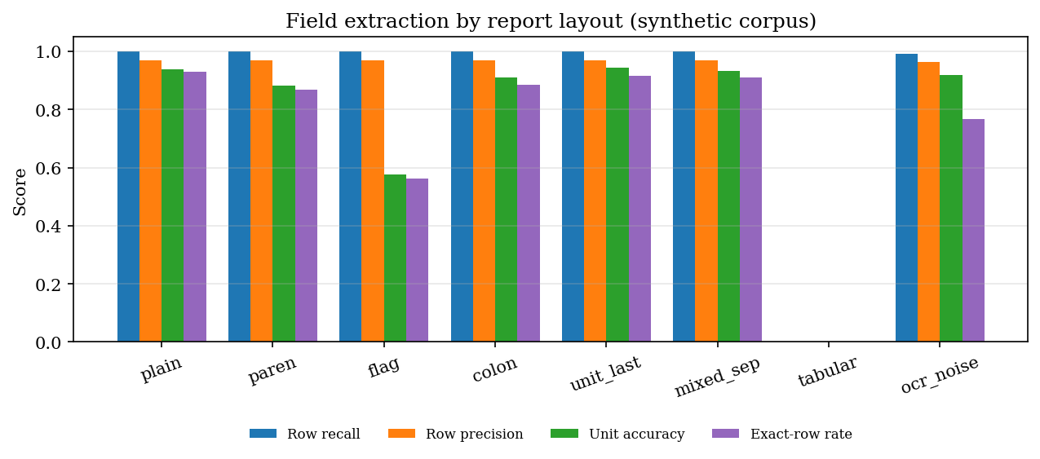
Figure 25: Extraction quality for each report layout (generated corpus, text-layer PDFs)
Three things stand out.
1. The cell-per-line table layout is not supported at all. When a PDF stores each cell as a separate text object, PyMuPDF returns one cell per line (ESR, 13.3, mm/hr, 0 - 20), and the line parser, which needs a name, a value and a range on one line, finds nothing. All 210 rows of the 15 tabular reports were missed. 212 rows were missed in total, so the other layouts together lose only 2. Because predicted rows for this layout number exactly 7, which is the number of dash-dated reports, 7 of the 15 reports would 'complete' with a single bogus row (next point) and the other 8 would be marked Failed with the message that no recognizable rows were found; the first case is the worse one because nothing signals the failure.
2. A dash-formatted date is read as a test result. A line such as Sample Collected: 12-04-2026 10:30 matches the name-value pattern (name Sample Collected, value 12) and the range pattern (-04-2026, read as -4 to 2026), so a row named Sample Collected with range -4 to 2026 is created. This happened in every one of the 56 reports whose date used dashes (7 per layout, 8 layouts). The 57 false-positive rows are 55 of these date rows plus two others: in paren_03 the date value 12 equalled a real RDW result of 12, so the scorer matched the date row to RDW and counted the genuine RDW row as the extra one, and in ocr_noise_03 a mis-read name produced a row that matched no true result. The row is classified NORMAL, so it is harmless to the status counts but it inflates the test count on the dashboard. The slash-formatted dates (12/04/2026) were rejected because they contain neither a unit nor a range.
3. The unit list is incomplete and a flag letter hides the unit. The unit expression has a fixed list (g/dL, mg/dL, U/L, mEq/L, ...). Units outside it (uIU/mL, mg/L, umol/L, ng/dL) are dropped, and a one-letter flag between value and unit (Sodium 134 L mEq/L) stops the unit from being read, which is why unit accuracy in the flag layout is only 57.6%. 179 rows have a wrong unit and nothing else wrong; the value, range and status of those rows are still correct, so the clinical flag survives.
The remaining field errors are name errors: 62 rows, most of them a test outside the dictionary (Sodium Bicarbonate) that was renamed Sodium, the rest noisy names that were not repaired. On the 12 dictionary tests per report the name is correct in 98.7% of detected rows; on the 2 unseen tests it is correct in only 77.1%.

8.4 Test-name normalisation
The matcher snaps a noisy test name to one of the 55 dictionary names when the TF-IDF cosine similarity (character 2- to 4-grams) is at least 0.55. To isolate this component, every dictionary name was corrupted 30 times at several per-character noise rates (a character is replaced by a look-alike, dropped, or has a letter inserted) and the corrected name was compared with the true one. The standard-library difflib ratio matcher (threshold 0.60) and plain exact matching are included as baselines.
Table 34: Name accuracy under simulated OCR noise
Per-character noise | TF-IDF (shipped, 0.55) | difflib ratio (0.60) | Exact match
0% | 1.000 | 1.000 | 1.000
5% | 0.961 | 0.994 | 0.686
10% | 0.890 | 0.981 | 0.493
20% | 0.731 | 0.946 | 0.237

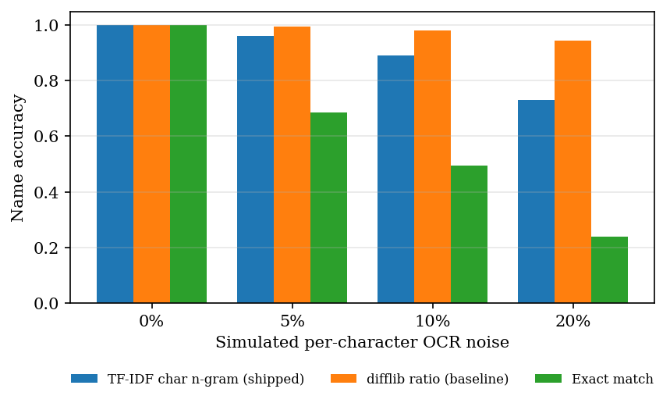
Figure 26: Name accuracy against simulated noise for the shipped matcher and two baselines
The result is not flattering to the shipped design. Both fuzzy matchers are far better than exact matching, but the difflib baseline is more accurate than the TF-IDF matcher at every non-zero noise rate (0.981 against 0.890 at 10% noise and 0.946 against 0.731 at 20%). The TF-IDF choice was not tested against this baseline when it was made; its advantage is only that the dictionary vectors are computed once.

Threshold analysis
Table 35: Effect of the cosine threshold (TF-IDF matcher)
Threshold | Accuracy at 10% noise | Accuracy at 20% noise | Unseen names wrongly snapped | Synonym accuracy
0.30 | 0.965 | 0.907 | 0.542 | 0.737
0.40 | 0.953 | 0.862 | 0.292 | 0.737
0.50 | 0.916 | 0.783 | 0.208 | 0.684
0.55 (shipped) | 0.890 | 0.718 | 0.167 | 0.526
0.60 | 0.869 | 0.667 | 0.167 | 0.526
0.70 | 0.810 | 0.531 | 0.042 | 0.526
0.80 | 0.698 | 0.398 | 0.000 | 0.474

Figure 27: Trade-off between correcting noisy names and wrongly renaming unseen names as the threshold moves
Lowering the threshold recovers more noisy names but renames more tests the dictionary does not know; raising it does the opposite. The shipped 0.55 lies in the middle: it wrongly renames 16.7% of the 24 unseen names and recovers 71.8% of names at 20% noise. No threshold removes both problems, because the score cannot distinguish a corrupted known name from a different real name that shares letters.

Synonyms and unseen names
A dictionary built from character n-grams does not know abbreviations. Of 19 common synonyms, 10 were mapped correctly at the shipped threshold (Haemoglobin, Platelets, SGPT (ALT), Serum Creatinine, Cholesterol Total, Triglyceride, and others) and 9 were not: Hb, Hgb, Blood Sugar Fasting, Total Leucocyte Count, TLC, LDL, HDL, Glycosylated Hemoglobin. Glycosylated Hemoglobin was mapped to Hemoglobin, which is a different test. Unseen names that were wrongly renamed: Sodium Bicarbonate to Sodium, Lipoprotein (a) to Total Protein, Apolipoprotein B to Total Protein, Insulin Fasting to Fasting Glucose. A renamed test is dangerous in this product because the trend screen groups results by name: Sodium Bicarbonate values would be plotted on the Sodium trend.

8.5 Classification
classify_result was checked against an independently written reference rule on 20,000 random cases (two-sided, one-sided and missing limits, negative values included): 0 disagreements. The boundaries are inclusive: a value equal to either limit is NORMAL (5 and 10 in a 5-10 range both give NORMAL), 4.99 is LOW and 10.01 is HIGH. In the extraction experiment the status was correct for 99.93% of detected rows; the few errors come from rows whose range was misread, not from the rule. Because the ground truth uses the same rule, this is a check that the status is propagated correctly, not a clinical validation.

8.6 Health insights
The explanation text comes from a curated knowledge base with 17 test entries, which covers 17 of the 55 tests in the name dictionary (30.9%). In the evaluation corpus 202 of 565 abnormal dictionary rows (35.8%) received test-specific text; the rest received the generic wording (A result above the reference range can have a number of general, non-specific causes), as the Potassium card in the analysis screen shows. Every card carries the same suggestion to consult a professional and the disclaimer; none names a disease. The optional LLM rewrite could not be exercised because no API key was configured, so its quality and latency are not reported.
Figure 28: Share of abnormal results that receive test-specific explanation text

8.7 Performance
Timings use a 14-row, one-page text-layer PDF of 4,356 bytes. Each stage was repeated 100 times (the end-to-end run 40 times) in one Python process on the machine described in Section 8.2.
Table 36: Latency of the pipeline stages
Stage | Median (ms) | Mean (ms) | p95 (ms) | Max (ms) | Runs
PDF text layer (PyMuPDF) | 1.37 | 1.26 | 1.56 | 1.93 | 100
Field extraction (14 rows) | 7.16 | 7.55 | 10.13 | 11.43 | 100
Classification | 0.02 | 0.02 | 0.02 | 0.03 | 100
Insight generation, all abnormal rows | 0.01 | 0.01 | 0.01 | 0.04 | 100
End to end, with SQLite writes | 52.71 | 53.70 | 60.96 | 85.36 | 40

Figure 29: Median latency of each pipeline stage for a 14-row report
A report is processed end to end in a median of 52.7 ms, far below the 10-second target stated in the project abstract. That target concerns scanned reports processed with OCR, which could not be timed here; the figure above is for text-layer PDFs only. Field extraction dominates the extraction work and grows linearly with the number of rows: 7.9 ms for 14 rows, 29.3 ms for 50, 58.1 ms for 100 and 113.0 ms for 200, which is about 0.6 ms per row (the TF-IDF transform for each name).
Table 37: API latency on 127.0.0.1 (FastAPI, uvicorn, SQLite)
Endpoint | Median (ms) | p95 (ms) | Max (ms) | Runs
GET /api/health | 0.9 | 1.2 | 1.8 | 100
POST /api/auth/login | 1.0 | 1.2 | 1.6 | 100
GET /api/dashboard | 4.7 | 5.8 | 41.6 | 100
GET /api/reports | 2.9 | 3.2 | 4.1 | 100
GET /api/reports/{id} | 7.2 | 8.5 | 10.1 | 100
GET /api/trends | 2.1 | 2.5 | 3.2 | 100
GET /api/compare | 4.4 | 5.1 | 6.0 | 100
GET /api/insights | 16.4 | 19.2 | 23.7 | 100
POST /api/reports (PDF upload) | 209.8 | 414.2 | 585.8 | 30

Reads take under 17 ms; the slowest read is the library-wide insights list (16.4 ms), which loads every abnormal result with its explanation. A PDF upload takes a median of 210 ms (p95 414 ms), of which about 53 ms is the pipeline itself; the rest is request parsing, the multipart upload and response building. Seeding the five sample reports takes 1.05 s. Calls must use 127.0.0.1: on the test machine localhost added about two seconds per call. Many simultaneous users were not tested.

8.8 Test results
Table 38: Automated test runs
Suite | Command | Result
Unit and API tests (tests/test_lablens.py) | python -m pytest tests -q | 36 passed, 0 failed, 3.2 s
End-to-end smoke test (scripts/smoke_test.py) | python scripts/smoke_test.py | 24 API checks and 7 browser checks passed: "All smoke checks passed."
UI check (scripts/ui_check.py) | python scripts/ui_check.py | script exists (360, 768 and 1440 px, light and dark theme, drawer, keyboard, reduced motion); not re-run for this report

The 36 pytest cases cover classification boundaries, line extraction, name normalisation, input validation, insight wording and fallback, the full pipeline with persistence, failed reports, cascading delete, dashboard statistics and the API (authentication, tampered token, upload, trend, compare, insights, seeding), all on a temporary SQLite file. The smoke test starts its own server on a spare port against a copy of the code; its browser part checks the login redirect, the charts, the insight cards, rejection of a wrong file type and the absence of console errors. Chapter 7 describes the strategy.

8.9 Success and failure cases

A success: a plain single-line report
For the sample report Health_Checkup_Aug2026.pdf the text layer contains one line per test, for example Hemoglobin 11.9 g/dL 12 - 16 and LDL Cholesterol 128 mg/dL <100. All 14 rows were extracted with name, unit and range, 9 were classified abnormal (haemoglobin LOW, WBC count HIGH, HbA1c HIGH, total cholesterol HIGH, LDL HIGH, triglycerides HIGH, potassium HIGH, TSH HIGH, vitamin D LOW) and each received an explanation card (see the report analysis screen in Section 8.1). On the generated corpus the plain layout reached recall 1.000 and F1 0.984, the remaining precision loss being the date row.

Failures with real examples
Table 39: Failure cases found in the evaluation
Report | Text in the report | What the system produced | Cause
tabular_00 | ESR / 13.3 / mm/hr / 0 - 20 on four separate lines | no row; 14 of 14 rows missed | line parser needs the whole row on one line
paren_03 | Sample Collected: 12-04-2026 10:30 (and a real RDW 12 % 11.5 - 14.5) | test Sample Collected, value 12, range -4 to 2026, NORMAL | date matches the value and range patterns; its value equals the RDW result, so the scorer pairs the two
plain_11 | Sodium Bicarbonate 27.3 mEq/L 22 - 29 | test Sodium, same value and range | name not in dictionary; cosine above 0.55
flag_12 | Sodium Bicarbonate 19.6 L mEq/L 22 - 29 | test Sodium, unit missing, status LOW | as above, and the flag letter hides the unit
plain_03 | Free T4 0.9 ng/dL 0.8 - 1.8 | unit missing | ng/dL not in the unit list
plain_04 | TSH 2.5 uIU/mL 0.4 - 4 | unit missing | uIU/mL not in the unit list
ocr_noise_00 | CR 4.4 mg/L <5 (true name CRP) | test Cr, unit missing | too far from CRP to snap; mg/L not in the unit list
ocr_noise_03 | a garbled Free T4 row | test Bilirubin Total, NORMAL | wrong dictionary entry above the threshold

The last row is the most serious kind of error: a different test with a plausible range and a NORMAL status. The status itself is rarely wrong when the range is read correctly; the errors that matter are those that attach a result to the wrong test name, because trends and comparisons are keyed on the name.

8.10 Comparison with the base paper
The base paper [1] (Karhade, Verma, Gadaokar and Mahajan, 2025) builds a question-answering assistant: a user uploads a blood test report and asks a question, and a LLaMA-3 8B model with retrieval over a knowledge base of 20 medical books and 383 video transcripts (ChromaDB, chunks of 1,024 characters with 100 overlap, top-3 retrieval) answers about metabolic syndrome. It reports no extraction accuracy, no latency and no trend analysis (personalisation over time is listed as future scope). Its only quantitative result is a rating of 20 generated responses from 1 to 100 on correctness, clarity, helpfulness and completeness by GPT-4 under human monitoring. The two evaluations measure different things on different data and cannot be compared numerically.
Table 40: LabLens against the base paper
Aspect | Base paper [1] | LabLens (this project)
Task | answer questions about a blood report for metabolic syndrome | read any lab report, flag results, explain, track and compare
Parameters | 33 metabolic-syndrome parameters | 55-name dictionary; unseen names are kept as read
Explanation | retrieval-augmented LLaMA-3 8B; sources cited | curated rules (17 tests) with generic fallback; optional LLM rewrite; no retrieval, no citations
Input handling | PDF text parsing | PDF text layer, OpenCV + Tesseract path for scans and photos (not measured here)
Trends over time | future scope | implemented: trend chart, report comparison
Evaluation data | 20 responses, rated by GPT-4 | 1,680 generated rows in 120 synthetic PDFs, known ground truth
Reported result | mean ratings 92.4 / 89.7 / 91.1 / 88.9 (correctness, clarity, helpfulness, completeness) | row F1 0.916, status accuracy 99.9%, 52.7 ms per report

One discrepancy in the base paper is worth recording. Its conclusion states mean scores of 92.4, 89.7, 91.1 and 88.9, but averaging the 20 rows of its own Table 4 gives 94.0, 94.9, 90.1 and 88.65. We use neither set as a benchmark. LabLens explanations were not rated by any model or person, so nothing in this chapter says whether they are good; they are deterministic and conservative by construction, and their coverage is limited (Section 8.6).

8.11 Objectives against outcomes
Table 41: Objectives of the project and what was achieved
No. | Objective | Outcome | Evidence
1 | Accept PDF or scanned image and extract text with high-speed OCR | Partly met. Text-layer PDFs work (median 1.4 ms for a one-page report). The OpenCV + Tesseract path for scans and photos is implemented but could not be run or measured here (Tesseract is not installed). PP-OCR is not used. | Section 8.7; code review
2 | Identify test name, value, unit and reference range with NER | Partly met. A regex line parser with a TF-IDF name matcher, not a trained NER or CRF model. Row F1 0.916 on the generated corpus; 0 on cell-per-line tables. | Sections 8.3, 8.4
3 | Compare each value with its range and flag abnormal results | Met. Rule verified on 20,000 random cases with 0 disagreements; status accuracy 99.93% on detected rows. | Section 8.5
4 | Plain-language explanations grounded in trusted sources | Partly met. Curated, non-diagnostic text for 17 of 55 tests, generic otherwise. There is no retrieval and no citation of sources; the optional LLM rewrite is untested. | Section 8.6
5 | Track parameters across reports to show trends | Met. Trend chart with reference band, pattern note, and two-report comparison. The pattern uses only the first and last value, and the x-axis is upload date. | Section 8.1 (trend and compare screens)
6 | Present results in a dashboard and evaluate extraction accuracy against manually labelled reports | Dashboard met; evaluation not met as stated. The evaluation used generated, not manually labelled, real reports. | Section 8.1 (dashboard); Section 8.2

8.12 What these results do and do not show
• The corpus is synthetic and was written by the same team that wrote the parser. The layouts are plausible, but they are the layouts the authors thought of. Real reports will contain multi-line cells, merged columns, footnotes and scanning artefacts that the corpus lacks, so the F1 values above are likely to be optimistic for real documents.
• Status accuracy is nearly circular. The ground-truth status is computed with the same rule as the system, so 99.9% shows that ranges are propagated correctly, not that the flags agree with a clinician.
• Scanned reports were not evaluated. The project's central promise of reading photographs and scans rests on Tesseract and OpenCV code that was not run for this report.
• The name-noise experiment is simulated, and explanation quality was not rated: coverage was counted, helpfulness and correctness were not.
• All timings are for a single user on one desktop processor with text-layer PDFs.
What the results do show is that the downstream stages (classification, storage, trends, comparison, API and interface) behave correctly and quickly, and that the extraction stage is dependable for single-line layouts but brittle in three specific, fixable ways listed in Section 8.3.

CHAPTER 9: CONCLUSION

9.1 Summary
The project set out to turn a laboratory report into something a patient can read. It delivers a working system in which an uploaded PDF or image is read, its test rows are extracted, each result is compared with the reference range printed beside it, abnormal results receive a plain-language and non-diagnostic explanation, and everything is stored so that values can be followed over time and two reports compared. A FastAPI service, a React interface, the original Streamlit application, an automated test suite and a reproducible evaluation harness complete the work.

9.2 Objectives achieved
Two of the six objectives were fully met: flagging abnormal results (objective 3) and tracking parameters across reports (objective 5). Four were met in part. Text extraction works for digital PDFs, but the scanned-image path could not be run (objective 1). Field extraction is a regex-and-TF-IDF parser, not the trained NER model the abstract names (objective 2). Explanations are curated rules for 17 tests without retrieval or citations (objective 4). The dashboard exists, but extraction accuracy was measured on generated reports, not on manually labelled real ones (objective 6). Section 8.11 gives the evidence.

9.3 Key findings
• On single-line layouts the parser extracts rows well (F1 about 0.98) and, once a row is read, the range and status are almost always right (99.9% and 99.9%); over all eight layouts of the generated corpus the F1 is 0.916.
• The weak points are specific and fixable: cell-per-line tables (recall 0), a hyphenated date read as a test, a short unit list, and names outside the dictionary that are renamed.
• A plain difflib matcher beat the shipped TF-IDF matcher on noisy names (0.981 against 0.890 at 10% noise), so the choice of TF-IDF is not justified by accuracy.
• The pipeline is fast: a median of 53 ms per text-layer report and about 210 ms for an HTTP upload, far below the 10-second target, although the target was set for scanned input.
• The system is verified by 36 pytest cases and 31 smoke checks (API and browser), all passing.

9.4 Practical applications
• A patient-facing reader that explains in everyday words what a report lists and which values lie outside their range, with a clear disclaimer.
• A library that lets a person keep several reports together and see a test move over months, as the sample data does for haemoglobin and LDL cholesterol.
• A teaching and research scaffold for report digitisation: the generated corpus, the scoring script and the failure analysis can be reused to test a better parser.

9.5 Known limitations
• Layout dependence. On reports where each table cell is a separate text line, the parser extracted no rows at all (recall 0.000 on 210 rows); a date line such as 12-04-2026 was read as a test named "Sample Collected" in every one of the 56 corpus reports that print the date with hyphens.
• Unit gaps. Unit accuracy is 87.1% overall and 57.6% when a flag letter sits between the value and the unit; units such as mg/L, umol/L, ng/dL and uIU/mL are not in the parser's unit list.
• Name matching. The TF-IDF matcher loses accuracy under character noise (89.0% at 10% noise against 98.1% for a plain difflib baseline) and renames some unseen tests, for example Sodium Bicarbonate to Sodium.
• Thin explanation coverage. Only 17 of the 55 dictionary tests (30.9%) have test-specific explanation text; the rest receive a generic paragraph. The explanations are rule-based, with no retrieval and no citations.
• Evaluation data. All accuracy figures come from 120 generated reports (1,680 rows) with generated ground truth, not from real, manually labelled reports. Scanned-image OCR accuracy and latency were not measured because Tesseract was not installed on the test machine, and the optional LLM rewrite was not exercised.

CHAPTER 10: FUTURE SCOPE

10.1 Improvements to the extraction
• A table-aware parser. Use word coordinates from the PDF (PyMuPDF can return them) to rebuild rows from cell-per-line tables, closing the 210-row gap measured in Chapter 8.
• Reject date rows. Discard candidate rows whose range holds a year or whose name is a header word, which removes almost every false positive found.
• A full unit table (mg/L, umol/L, ng/dL, uIU/mL and others), and unit detection that tolerates a flag letter between value and unit.
• A synonym table and a safer matcher. Add abbreviations (Hb, TLC, LDL), test a difflib or learned matcher against the TF-IDF one, and refuse to rename names that merely extend a dictionary name.
• Trained entity recognition [14] and a layout-aware OCR engine such as PP-OCR [12] once labelled reports exist, compared with the current parser on the same corpus.

10.2 Better explanations
• Retrieval with citations: a curated, licensed knowledge base with retrieval [6] so that each explanation names its source, as the base paper does [1].
• More tests covered: extend the 17-test knowledge base to the whole dictionary, then rate the text with a clinician.
• Optional LLM rewrite: test it with an API key for quality, cost and failure behaviour.
• Multilingual output for users who read the report in one language and need the explanation in another.

10.3 Evaluation and deployment
• Real, labelled reports. With consent and de-identification, build a small manually labelled set and repeat the extraction experiment on it; evaluate scanned reports and photographs with Tesseract and with PP-OCR.
• Per-user accounts with registration, row-level separation of data and audit logging, replacing the single demo account.
• Deployment: containers, HTTPS, a server database in place of SQLite, and monitoring of failed reports and unmatched names.
• Load and accessibility testing with many users and assistive technology.

10.4 Further research
• Comparing general vision-language models, as in [4], with the parser on the same photographed reports.
• Turning a report into a short list of follow-up actions, as in [3], with safeguards against unsupported claims.
• Trend analysis beyond first-versus-last: slopes, variability and alerts, with the sample date rather than the upload date on the time axis.
• A study of how readers understand and act on the explanations.

REFERENCES
[1] A. Karhade, I. Verma, V. Gadaokar, and J. Mahajan, "RAG-based blood test report analysis to reverse metabolic syndrome," Commun. Appl. Nonlinear Anal., vol. 32, no. 10s, pp. 2771-2779, 2025, doi: 10.52783/cana.v32.5718.
[2] X. Ren, D. Dou, X. He, F. Cui, and J. Zhao, "A serialization method for digitizing the image-based medical laboratory report," Digital Health, 2025, doi: 10.1177/20552076251334431.
[3] S. Xiang, S. Chen, K. Q. Lin, J. Yu, Y. Sun, P. Torr, and A. Atapour-Abarghouei, "Checkup2Action: A multimodal clinical check-up report dataset for patient-oriented action card generation," arXiv:2605.11533, 2026.
[4] N. Bakhsheshi and H. Beigy, "Analysis of blood report images using general-purpose vision-language models," arXiv:2509.06033, 2025.
[5] V.-T. Nguyen, H.-D. Pham, T.-H. To, C.-T. H. Do, T.-T.-T. Dong, V.-T. D. Le, and V.-P. Hoang, "Medalyze: Lightweight medical report summarization application using FLAN-T5-Large," arXiv:2505.17059, 2025.
[6] P. Lewis et al., "Retrieval-augmented generation for knowledge-intensive NLP tasks," in Advances in Neural Information Processing Systems, vol. 33, 2020, pp. 9459-9474.
[7] M. Salvagno, F. S. Taccone, and A. G. Gerli, "Evaluating the feasibility of ChatGPT in healthcare: An analysis of multiple clinical and research scenarios," J. Med. Syst., vol. 47, no. 1, p. 33, 2023.
[8] V. X. Liu, C. A. Sinsky, S. Lin et al., "AI-generated draft replies integrated into health records and physicians' electronic communication," JAMA Netw. Open, vol. 7, no. 3, p. e2417615, 2024.
[9] Y. Shokrollahi, S. Yarmohammadtoosky, M. M. Nikahd et al., "A comprehensive review of generative AI in healthcare," arXiv:2310.00795, 2023.
[10] H.-L. Hsu, C.-T. Dao, L. Wang et al., "MEDPLAN: A two-stage RAG-based system for personalized medical plan generation," arXiv:2503.17900, 2025.
[11] I. Kataria, R. Chadha, and R. Pathak, "Dietary and lifestyle modification in metabolic syndrome: A review of randomized control trials in different population groups," Rev. Health Care, vol. 6, no. 3, pp. 97-103, 2015.
[12] Y. Du, C. Li, R. Guo, X. Yin, W. Liu, J. Zhou, Y. Bai, Z. Yu, Y. Yang, Q. Dang, and H. Wang, "PP-OCR: A practical ultra lightweight OCR system," arXiv:2009.09941, 2020.
[13] R. Smith, "An overview of the Tesseract OCR engine," in Proc. 9th Int. Conf. Document Analysis and Recognition (ICDAR), 2007, pp. 629-633.
[14] J. Lafferty, A. McCallum, and F. Pereira, "Conditional random fields: Probabilistic models for segmenting and labeling sequence data," in Proc. 18th Int. Conf. Machine Learning (ICML), 2001, pp. 282-289.
[15] G. Salton and C. Buckley, "Term-weighting approaches in automatic text retrieval," Inf. Process. Manag., vol. 24, no. 5, pp. 513-523, 1988.
[16] F. Pedregosa et al., "Scikit-learn: Machine learning in Python," J. Mach. Learn. Res., vol. 12, pp. 2825-2830, 2011.
[17] G. Bradski, "The OpenCV library," Dr. Dobb's Journal of Software Tools, 2000.
[18] N. Reimers and I. Gurevych, "Sentence-BERT: Sentence embeddings using Siamese BERT-networks," in Proc. EMNLP-IJCNLP, 2019, pp. 3982-3992.
[19] M. Bayer, "SQLAlchemy," in The Architecture of Open Source Applications, vol. 2, A. Brown and G. Wilson, Eds. 2012.
[20] Artifex Software, "PyMuPDF documentation." [Online]. Available: https://pymupdf.readthedocs.io
[21] S. Ramirez, "FastAPI framework documentation." [Online]. Available: https://fastapi.tiangolo.com
[22] Recharts contributors, "Recharts: A composable charting library built on React components." [Online]. Available: https://recharts.org
[23] Anthropic, "Messages API reference." [Online]. Available: https://docs.anthropic.com
[24] M. Honnibal and I. Montani, "spaCy 2: Natural language understanding with Bloom embeddings, convolutional neural networks and incremental parsing," 2017. [Online]. Available: https://spacy.io
[25] "P-025 Health and safety in medical analysis laboratory," Occupational Medicine, 2024. (Listed in the batch literature survey; authors and details not verified.)
[26] "Analysis of laboratory data of RT-PCR testing for SARS-CoV-2 in SVRDL at Government Medical College, Nagpur," Himalayan J. Community Med. Public Health, 2024. (Listed in the batch literature survey; authors and details not verified.)
[27] "Inter-laboratory study for extraction testing of medical devices," J. Pharm. Biomed. Anal., 2025. (Listed in the batch literature survey; authors and details not verified.)

APPENDIX A: IMPORTANT CODE
The listings below are extracted from the repository by the document build script, so they are the code that was tested and measured. File paths are relative to 8.ProjectCode.

A.1 Image clean-up before OCR (`ocr_processor.py`)
def preprocess_image_for_ocr(image: np.ndarray) -> np.ndarray:
"""
Apply a standard OpenCV preprocessing pipeline to improve OCR accuracy:
grayscale -> denoise -> adaptive threshold -> deskew.
Accepts a BGR or grayscale numpy array, returns a cleaned grayscale array.
"""
if image is None:
raise OCRError("Could not read image data for preprocessing.")

if len(image.shape) == 3:
gray = cv2.cvtColor(image, cv2.COLOR_BGR2GRAY)
else:
gray = image.copy()

# Denoise while preserving edges/text strokes
denoised = cv2.fastNlMeansDenoising(gray, h=10)

# Adaptive threshold handles uneven lighting/scan shadows better than a
# single global threshold.
thresh = cv2.adaptiveThreshold(
denoised,
255,
cv2.ADAPTIVE_THRESH_GAUSSIAN_C,
cv2.THRESH_BINARY,
blockSize=31,
C=15,
)

deskewed = _deskew(thresh)
return deskewed

def _deskew(image: np.ndarray) -> np.ndarray:
"""Estimate and correct small rotation angles using the minAreaRect of text pixels."""
coords = np.column_stack(np.where(image < 255))
if coords.shape[0] < 20:
return image # not enough foreground pixels to estimate skew safely

angle = cv2.minAreaRect(coords)[-1]
if angle < -45:
angle = -(90 + angle)
else:
angle = -angle

# Ignore negligible skew to avoid introducing artifacts
if abs(angle) < 0.5:
return image

(h, w) = image.shape[:2]
center = (w // 2, h // 2)
matrix = cv2.getRotationMatrix2D(center, angle, 1.0)
rotated = cv2.warpAffine(
image, matrix, (w, h), flags=cv2.INTER_CUBIC, borderMode=cv2.BORDER_REPLICATE
)
return rotated

A.2 Text from a PDF: text layer first, OCR for scanned pages (`ocr_processor.py`)
def extract_text_from_pdf_bytes(file_bytes: bytes, ocr_dpi: int = 300) -> str:
"""
Extract text from a PDF.

1. Try the embedded text layer for every page (fast, accurate — works
for digitally-generated lab report PDFs).
2. For any page with little/no embedded text (i.e. a scanned page),
render it to an image and OCR it instead.
"""
if fitz is None:
raise OCRError(
"PyMuPDF (fitz) is not installed. Install it with `pip install pymupdf`."
)

try:
doc = fitz.open(stream=file_bytes, filetype="pdf")
except Exception as exc:
raise OCRError(f"Could not open PDF file: {exc}") from exc

if doc.page_count == 0:
raise OCRError("The PDF has no pages.")

all_text_parts = []
for page_index in range(doc.page_count):
page = doc.load_page(page_index)
layer_text = page.get_text("text") or ""

if len(layer_text.strip()) >= MIN_TEXT_LAYER_CHARS:
all_text_parts.append(layer_text)
else:
# Likely a scanned page -> render to image and OCR it
try:
zoom = ocr_dpi / 72.0
matrix = fitz.Matrix(zoom, zoom)
pix = page.get_pixmap(matrix=matrix, colorspace=fitz.csRGB)
img_bytes = pix.tobytes("png")
pil_image = Image.open(io.BytesIO(img_bytes)).convert("RGB")
image_np = cv2.cvtColor(np.array(pil_image), cv2.COLOR_RGB2BGR)
ocr_text = _ocr_image_array(image_np)
all_text_parts.append(ocr_text)
except OCRError:
raise
except Exception as exc:
raise OCRError(f"Failed to OCR scanned page {page_index + 1}: {exc}") from exc

doc.close()
full_text = "\n".join(all_text_parts)

if not full_text or not full_text.strip():
raise OCRError("No text could be extracted from this PDF (empty or unreadable).")

return full_text

A.3 Unit expression and row patterns (`ner_processor.py`)
# Matches unit tokens commonly found in lab reports.
_UNIT_RE = r"(?:%|g/dL|mg/dL|mmol/L|IU/L|mIU/L|ng/mL|pg/mL|µg/dL|ug/dL|" \
r"U/L|mEq/L|cells/cumm|/cumm|10\^\d+/[uµ]L|x10\^\d+/L|fL|pg|" \
r"mm/hr|sec|K/uL|M/uL|/uL)"

# Stage 1: mandatory name + value (+ optional unit) at the start of the line.
# The rest of the line (the "remainder") is handed to the stage-2 range
# search below, so the range can appear in any common format without
# forcing one giant anchored pattern to match the whole line at once.
_NAME_VALUE_PATTERN = re.compile(
r"^\s*(?P<name>[A-Za-z][A-Za-z0-9()/,.\- ]{1,60}?)\s*[:\-]?\s+"
r"(?P<value>-?\d+\.?\d*)\s*"
r"(?P<unit>" + _UNIT_RE + r")?",
re.IGNORECASE,
)

# Stage 2a: two-sided numeric range, e.g. "12-16", "12 - 16", "12 to 16".
_TWO_SIDED_RANGE_PATTERN = re.compile(
r"(?P<low>-?\d+\.?\d*)\s*(?:-|to|–|—)\s*(?P<high>-?\d+\.?\d*)"
)

# Stage 2b: one-sided range, e.g. "<5", ">10", "< 200".
_ONE_SIDED_RANGE_PATTERN = re.compile(r"([<>])\s*(-?\d+\.?\d*)")

# Trailing unit that may appear after the range, e.g. "12-16 g/dL".
_TRAILING_UNIT_PATTERN = re.compile(r"(" + _UNIT_RE + r")\s*\)?\s*$", re.IGNORECASE)

A.4 Snapping a noisy test name to the dictionary (`ner_processor.py`)
_TEST_NAME_VECTORIZER = TfidfVectorizer(analyzer="char_wb", ngram_range=(2, 4))
_KNOWN_NAME_VECTORS = _TEST_NAME_VECTORIZER.fit_transform(KNOWN_TEST_NAMES)

FUZZY_MATCH_THRESHOLD = 0.55

def normalize_test_name(raw_name: str) -> str:
"""
Clean an OCR-extracted test name and, if it's a close match to a known
lab test, snap it to the canonical spelling/casing. Otherwise return
the cleaned raw name unchanged (extraction still succeeds for tests
outside our reference dictionary).
"""
cleaned = re.sub(r"[^A-Za-z0-9/() %]", " ", raw_name)
cleaned = re.sub(r"\s+", " ", cleaned).strip(" :.-")
if not cleaned:
return raw_name.strip()

try:
vec = _TEST_NAME_VECTORIZER.transform([cleaned])
sims = cosine_similarity(vec, _KNOWN_NAME_VECTORS)[0]
best_idx = sims.argmax()
if sims[best_idx] >= FUZZY_MATCH_THRESHOLD:
return KNOWN_TEST_NAMES[best_idx]
except Exception:
pass

# Title-case fallback for unmatched-but-plausible test names
return cleaned.title() if cleaned.isupper() or cleaned.islower() else cleaned

A.5 Extracting rows from the text (`ner_processor.py`)
for raw_line in text.splitlines():
line = raw_line.strip()
if not line or len(line) < 3:
continue
if _NOISE_LINE_RE.match(line):
continue
# Skip lines with no digit at all -- can't be a result row
if not re.search(r"\d", line):
continue

match = _NAME_VALUE_PATTERN.match(line)
if not match:
continue

name_raw = match.group("name")
try:
value = float(match.group("value"))
except (TypeError, ValueError):
continue

unit = match.group("unit") or ""
remainder = line[match.end():]

# A bare "Test 220" line with nothing else after it isn't useful
# enough to trust unless it at least has a unit -- otherwise it's
# likely a mis-parsed header/noise line.
low_val = high_val = None

range_match = _TWO_SIDED_RANGE_PATTERN.search(remainder)
if range_match:
low_val = float(range_match.group("low"))
high_val = float(range_match.group("high"))
else:
low_val, high_val = _parse_one_sided_range(remainder)

if not unit:
trailing_unit_match = _TRAILING_UNIT_PATTERN.search(remainder)
if trailing_unit_match:
unit = trailing_unit_match.group(1)

confidence = 0.9 if (low_val is not None and high_val is not None) else 0.6
if not unit:
confidence -= 0.1
if low_val is None and high_val is None and not unit:
# Too little structure to be confident this is a real test row
continue

results.append({
"test_name": normalize_test_name(name_raw),
"result_value": value,
"unit": unit.strip() if unit else None,
"reference_low": low_val,
"reference_high": high_val,
"test_date": test_date,
"confidence_score": round(max(confidence, 0.1), 2),
})

return _deduplicate(results)

A.6 Classification (`result_analyzer.py`)
def classify_result(result_value, reference_low, reference_high) -> str:
"""Pure classification function -- returns one of LOW/NORMAL/HIGH/UNKNOWN."""
if result_value is None:
return "UNKNOWN"

if reference_low is not None and reference_high is not None:
if result_value < reference_low:
return "LOW"
if result_value > reference_high:
return "HIGH"
return "NORMAL"

if reference_high is not None: # only an upper bound is known
return "HIGH" if result_value > reference_high else "NORMAL"

if reference_low is not None: # only a lower bound is known
return "LOW" if result_value < reference_low else "NORMAL"

return "UNKNOWN"

A.7 Explanations with a safe fall-back (`ai_insights.py`)
def generate_rule_based_insight(test_name: str, status: str) -> HealthInsight:
"""Build an explanation purely from the local knowledge base (no network calls)."""
knowledge = _lookup_knowledge(test_name)

if status == "LOW":
cause_text = knowledge["low"]
elif status == "HIGH":
cause_text = knowledge["high"]
else:
cause_text = "This value falls within the expected range for this test."

explanation = (
f"{test_name} measures {knowledge['measures']} "
f"Your result was flagged as {status.title()} compared to the standard reference range."
if status in ("LOW", "HIGH")
else f"{test_name} measures {knowledge['measures']}"
)

return HealthInsight(
test_name=test_name,
status=status,
explanation=explanation,
possible_causes=cause_text,
recommendations=GENERAL_RECOMMENDATION if status in ("LOW", "HIGH") else
"No specific action is typically needed for results within the normal range.",
)

def generate_insight(test_name: str, status: str, use_llm: bool = False) -> HealthInsight:
"""
Public entry point used by report_processor.py. Always returns a valid
HealthInsight -- LLM enrichment is attempted only if requested and
configured, and any failure silently falls back to the rule-based text.
"""
base_insight = generate_rule_based_insight(test_name, status)

if use_llm and status in ("LOW", "HIGH"):
try:
enriched_text = _call_llm_for_insight(test_name, status, base_insight)
base_insight.explanation = enriched_text
except Exception:
# Fall back silently to the rule-based explanation -- an LLM
# outage must never break report processing.
pass

return base_insight

APPENDIX B: INSTALLATION AND USER GUIDE

B.1 Requirements
• Python 3.11 or newer and Node.js 20 or newer (LTS) on the PATH.
• Tesseract OCR (optional): needed only for scanned PDFs and photographs. Text-based PDFs work without it. Windows: install from the UB Mannheim build and add tesseract.exe to the PATH; macOS: brew install tesseract; Ubuntu: sudo apt-get install tesseract-ocr.
• A modern browser. About 1 GB of disk space for the Python environment and the front-end packages.

B.2 One-click start (Windows)
1. Open the folder 8.ProjectCode and double-click run.bat (or run it from a terminal in that folder).
2. On the first run it creates backend\.venv, installs backend\requirements.txt (a few minutes) and runs npm install in frontend\. It rebuilds the environment automatically if it is missing or broken.
3. Two console windows open (the API on port 8308 and the web app on port 5308) and the browser opens http://localhost:5308.
4. Close the two console windows to stop the application.
The ports, the token signing key and the optional API key are set in .env; copy .env.example to .env if it does not exist. The original Streamlit interface still runs separately with streamlit run app.py on port 8501 and shares the same database.

B.3 Manual start (any operating system)
# terminal 1, from 8.ProjectCode
python -m venv backend/.venv
backend/.venv/Scripts/python -m pip install -r backend/requirements.txt
backend/.venv/Scripts/python -m uvicorn backend.main:app --port 8308

# terminal 2
cd frontend
npm install
npm run dev # http://localhost:5308, proxies /api to port 8308

On macOS or Linux use backend/.venv/bin/python. For a production-style run, npm run build in frontend/ and start only the backend: it serves the built front end itself at http://localhost:8308.

B.4 Settings in `.env`
Table 42: Environment variables
Variable | Purpose
BACKEND_PORT, FRONTEND_PORT | fixed at 8308 and 5308 for this project so several products can run side by side
JWT_SECRET | signs login tokens; change it on first run
DEMO_EMAIL, DEMO_PASSWORD | override the demo account (default demo@lablens.com / Demo@1234)
ANTHROPIC_API_KEY | enables the "Use LLM for richer explanations" switch; without it the built-in explanations are used

B.5 Using the application
Table 43: Walk-through
Step | Action | Result
1 | Open http://localhost:5308 and choose Sign in, then Sign in as demo user | The dashboard opens
2 | On an empty library choose Load sample reports | Five synthetic reports are rendered as PDFs and processed by the real pipeline
3 | Open Upload report, drop a PDF, JPG or PNG (up to 15 MB) and press Process report | A stage tracker runs and the extracted results appear with their status
4 | Open Report analysis and pick a report | Result table and explanation cards for every abnormal result
5 | Open My reports; search by name or status, expand a report, or delete it | History with a confirmation dialog on delete
6 | Open Health trends and pick a test | Chart against the reference band, the overall pattern and a table of every value
7 | Open Compare reports and pick two reports | Tests in common with signed change, and bar charts grouped by unit
8 | Open Health insights; filter by Low or High, or search | Every explanation for every abnormal result in the library

Every page carries the notice that LabLens is an educational tool and not a medical device. Rows in a report should look like Hemoglobin 13.5 g/dL 12 - 16; reports whose table cells are separate lines of text are not supported.

B.6 Running the tests and the experiments
python -m pytest tests -q # 36 tests, a few seconds, temporary database
python scripts/smoke_test.py # API + browser flow in a temporary copy
python scripts/ui_check.py # needs a running app and Playwright
python scripts/capture_screens.py # refreshes docs/screenshots
python -X utf8 scripts/run_experiments.py # generated corpus -> experiments/lablens/metrics.json and docs/figures
python -X utf8 scripts/measure_api.py # API latency -> experiments/lablens/api_latency.json

smoke_test.py needs a built front end for its browser part (cd frontend && npm run build); ui_check.py and capture_screens.py need pip install playwright && playwright install chromium.

B.7 Troubleshooting
Table 44: Common problems
Symptom | Fix
"Cannot reach the LabLens backend on port 8308" | the API window is not running; start run.bat again and read its console
Upload of a JPG or PNG fails with an OCR message | install Tesseract OCR (see B.1)
"No recognizable lab test rows were found" | the layout is unusual, the scan is too faint, or each table cell is a separate line; try a clearer file
The LLM switch is disabled | no ANTHROPIC_API_KEY in .env; the feature is optional
Port already in use | stop the other product or change the ports in .env
API calls are slow from a script | call 127.0.0.1 instead of localhost

APPENDIX C: ADDITIONAL SCREENS
All screens are captures of the running application at 1440 x 900 pixels. The library behind them holds only synthetic reports (invented patient and values), except the last screen, which shows the application before any report is loaded.
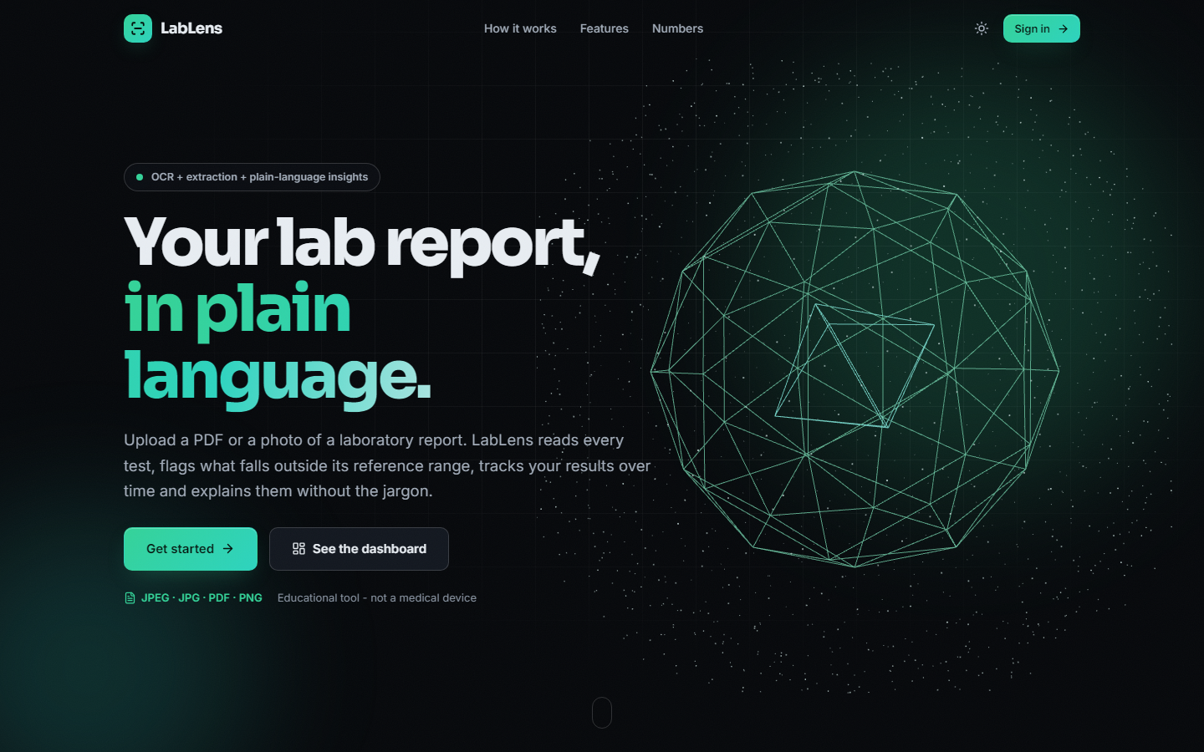
Figure 30: Landing page, dark theme: the headline, the accepted formats (PDF, JPG, JPEG, PNG) and the notice that this is an educational tool
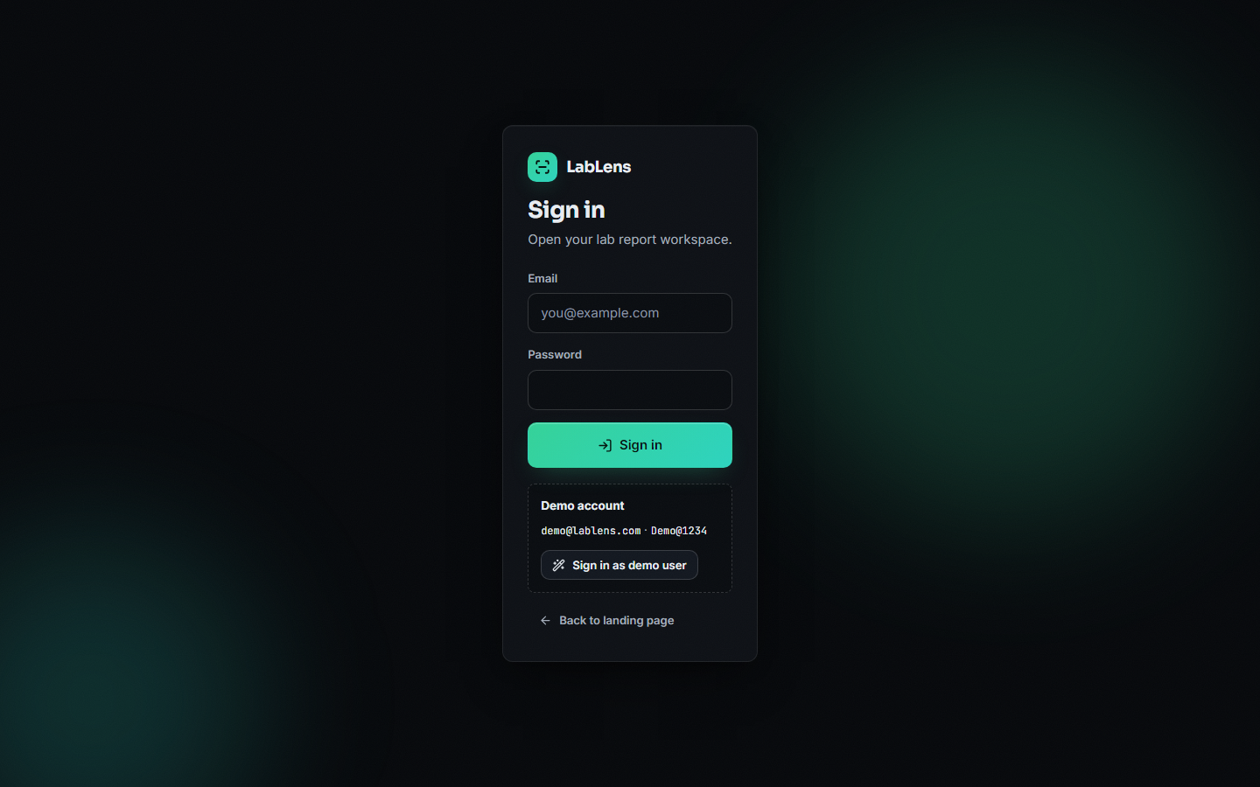
Figure 31: Sign-in screen with the demo account box and the one-click demo sign-in
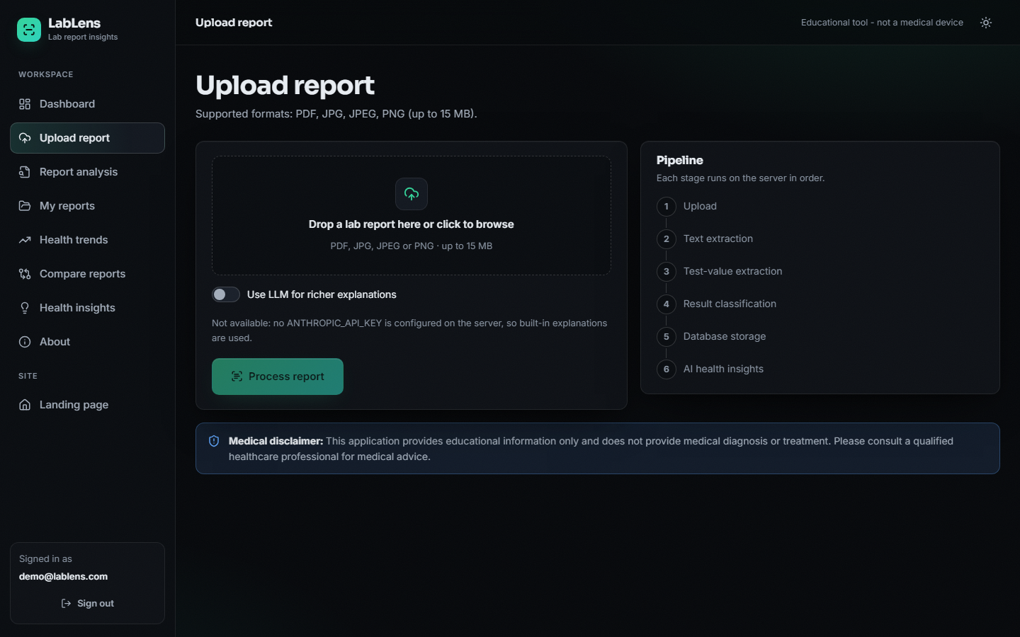
Figure 32: Upload screen before a file is chosen: drop zone, the disabled LLM switch with its explanation, and the six-stage pipeline list
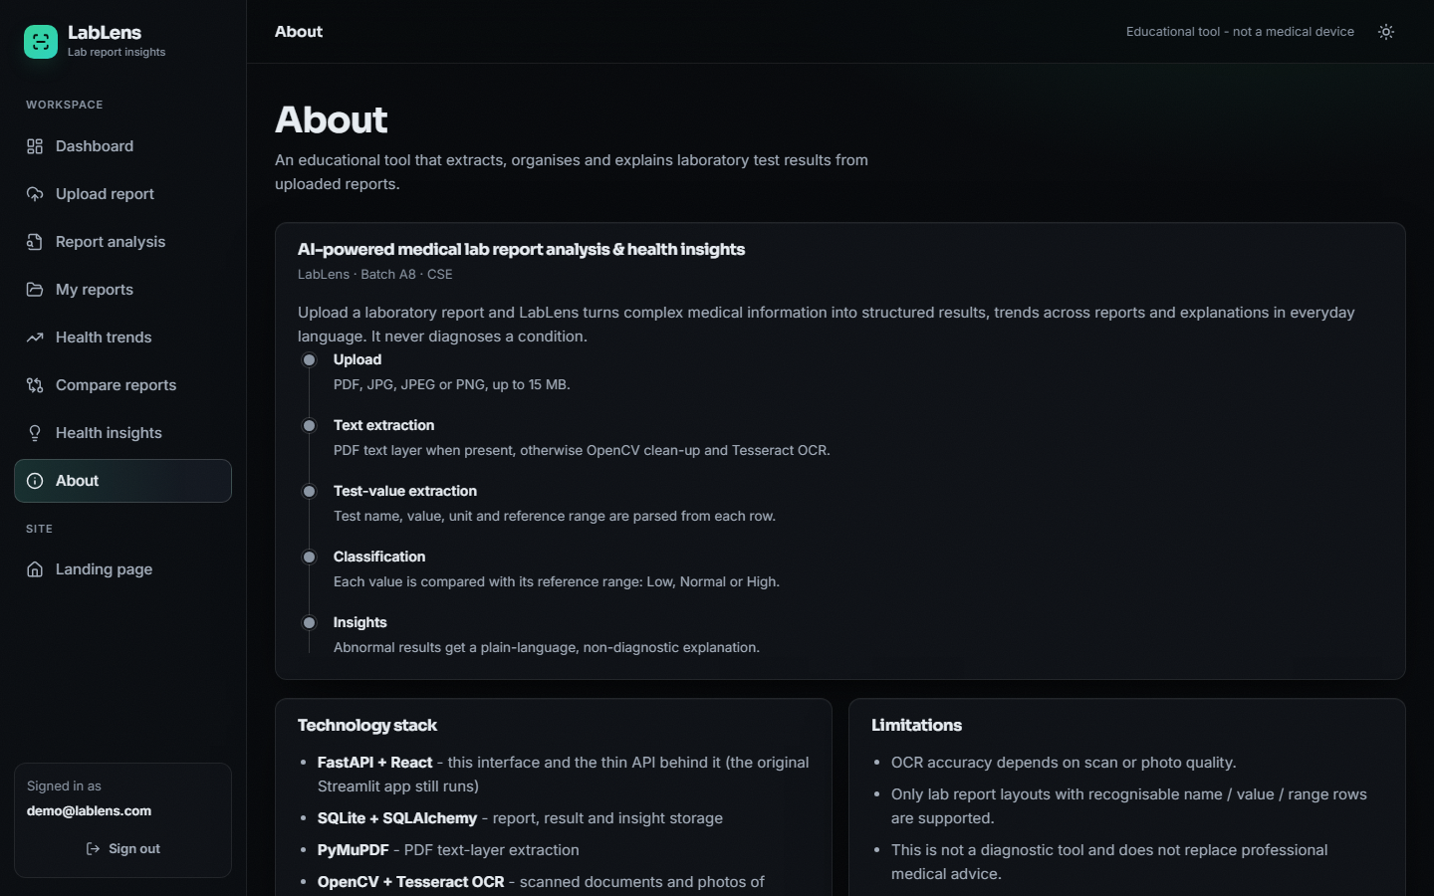
Figure 33: About screen: the five pipeline stages, the technology stack and the stated limitations
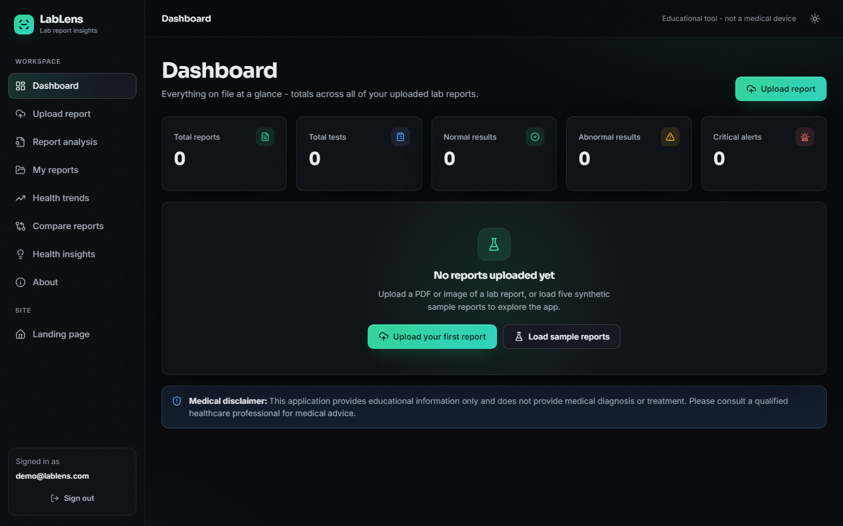
Figure 34: Dashboard of an empty library: zero totals and the two ways to begin, uploading a report or loading five sample reports

